# Game Design Document

Portal Mario

Team Glados

## Team Members

|  |  |  |
| --- | --- | --- |
| **Name** | **Roles** | **E-mail & GitHub ID** |
| *Nimit Sandeep Jhunjhunwala* | *Team Captain, Level Design, Play Tester, Game Mechanics* | [*njhunjhu@usc.edu*](mailto:njhunjhu@usc.edu)[*nimitjjw*](https://github.com/nimitjjw) |
| *Jack Lin* | *Level Design, Guidance, Analytics, Code Reviewer* | [*clin4185@usc.edu*](mailto:clin4185@usc.edu)[*blueskyson*](https://github.com/blueskyson) |
| *Harsh Modi* | *Product Manager, Game Analytics, Guidance, Game Interface* | [*harshdee@usc.edu*](mailto:harshdee@usc.edu)[*harshmodi15*](https://github.com/harshmodi15) |
| *Aditya Rouniyar* | *Stenographer, Game Component, Guidance* | [*rouniyar@usc.edu*](mailto:rouniyar@usc.edu)[*Aditya-Rouniyar*](https://github.com/aditya-rouniyar) |
| *Zhuohang Qin* | *Mechanic design and implemention, QA, Guidance* | [*qinzhuoh@usc.edu*](mailto:Email5@usc.edu)[*fmwizard*](https://github.com/fmwizard) |
| *Mina Sung* | *Game components, Game feel, Guidance, Documentation* | [*eleanoms@usc.edu*](mailto:eleanoms@usc.edu)  [*minasung7*](https://github.com/minasung7) |

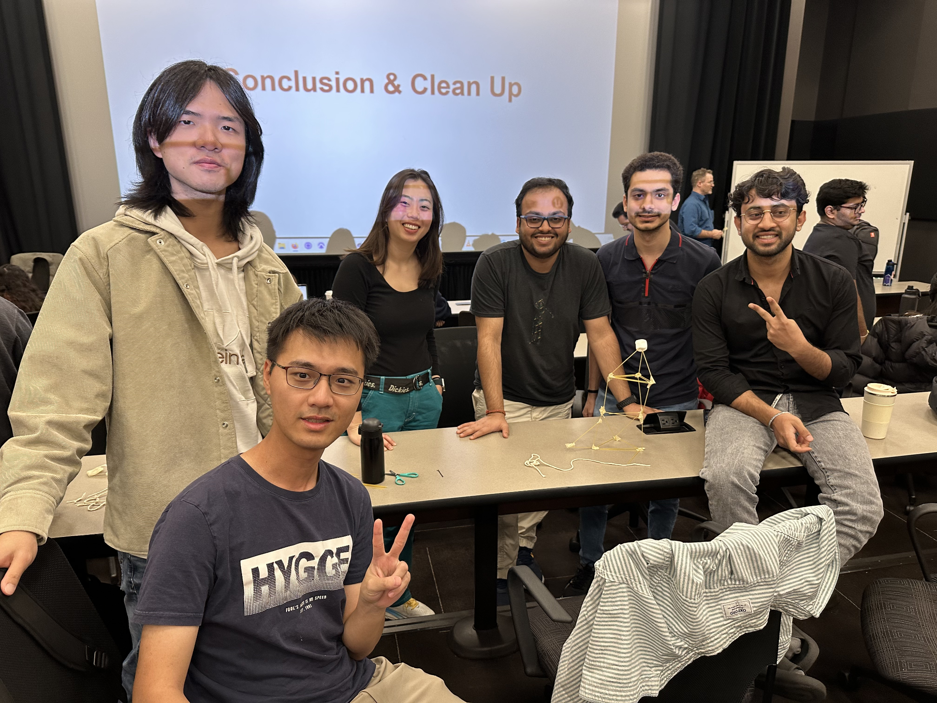

## Important References

|  |  |
| --- | --- |
| GitHub Repository for GitHub Pages Host | [*https://github.com/blueskyson/portal-mario-alpha-progress*](https://github.com/blueskyson/portal-mario-alpha-progress) |
| Unity Project GitHub Repository | [*https://github.com/CSCI-526-Spring-2025/csci-526-final-project-team-glados*](https://github.com/CSCI-526-Spring-2025/csci-526-final-project-team-glados) |
| Playable Alpha Progress Check Build | [*https://blueskyson.github.io/portal-mario-alpha-progress/*](https://blueskyson.github.io/portal-mario-alpha-progress/) |
| Playable Alpha Build | [*https://harshmodi15.github.io/csci-526-final-project-team-glados/*](https://harshmodi15.github.io/csci-526-final-project-team-glados/) |
| Alpha Gameplay Video | [*https://www.youtube.com/watch?v=Q7kpMifnBxM*](https://www.youtube.com/watch?v=Q7kpMifnBxM) |
| Alpha Survey | [*https://docs.google.com/spreadsheets/d/1gBaCkakx3CNTOH4u6G1MEsZGej3CBiNwRLTVbBVYON8/edit?usp=sharing*](https://docs.google.com/spreadsheets/d/1gBaCkakx3CNTOH4u6G1MEsZGej3CBiNwRLTVbBVYON8/edit?usp=sharing) |
| Playable Beta Playtest 1 Build | [*https://harshmodi15.github.io/csci-526-final-project-team-glados/*](https://harshmodi15.github.io/csci-526-final-project-team-glados/) |
| Playable Beta Playtest 2 Build | [*https://minasung7.github.io/CSCI526/Final_Project_Builds/Beta_Playtest_2/*](https://minasung7.github.io/CSCI526/Final_Project_Builds/Beta_Playtest_2/) |
| Playable Beta Build | [*https://minasung7.github.io/CSCI526/Final_Project_Builds/Beta_Prototype/*](https://minasung7.github.io/CSCI526/Final_Project_Builds/Beta_Prototype/) |
| Beta Gameplay Video | [*https://www.youtube.com/watch?v=kaVFFe_f1cE*](https://www.youtube.com/watch?v=kaVFFe_f1cE) |
| Beta Survey | [*https://docs.google.com/forms/d/e/1FAIpQLSfss9T1YhPcyG_iLAStQN1uEdbrl71q3EnOiouC7WXrndoqZQ/viewform?usp=header*](https://docs.google.com/forms/d/e/1FAIpQLSfss9T1YhPcyG_iLAStQN1uEdbrl71q3EnOiouC7WXrndoqZQ/viewform?usp=header) |
| Playable Gold Playtest 1 Build | [*https://minasung7.github.io/CSCI526/Final_Project_Builds/Gold_Playtest1/*](https://minasung7.github.io/CSCI526/Final_Project_Builds/Gold_Playtest1/) |
| Playable Gold Playtest 2 Build | [*https://minasung7.github.io/CSCI526/Final_Project_Builds/Gold_Playtest2/*](https://minasung7.github.io/CSCI526/Final_Project_Builds/Gold_Playtest2/) |
| Playable Gold Build | [*https://minasung7.github.io/CSCI526/Final_Project_Builds/Gold/*](https://minasung7.github.io/CSCI526/Final_Project_Builds/Gold/) |
| Gold Gameplay Video | [*https://www.youtube.com/watch?v=m0XUzOMundo*](https://www.youtube.com/watch?v=m0XUzOMundo) |

# Game Introduction

## Logline

(2D-platformer + Multi-Tool Gun)  
A 2D platformer where players navigate classic side-scrolling levels with a unique multi-tool gun that allows players to shoot teleportation portals, mirrors, and ally portals in order to overcome obstacles and defeat enemies in creative ways.

## Player Goals / Win Conditions

* Clear levels by getting to the goal

## Game Description

Portal Mario is a 2D platformer that challenges players to navigate levels using a multi-tool gun that can place teleportation portals, ally portals, and mirrors.Teleportation portals can teleport players, objects, allies, and certain enemies. Ally portals can engulf enemies, convert it to the player’s side, and eject the newly made (and controllable) ally. Finally, mirrors can allow the player to place portals with a reflection to reach places they couldn’t before. Players must move left, right, and jump while using their tool gun to create portals, defeating enemies and avoiding hazards.

The game introduces a multi-tool gun, paired with a variety of surfaces that adds depth to traditional platforming, requiring players to think creatively about movement and enemy interactions while progressing through increasingly complex levels.

## Controls

Movement: A, D

Jump: Space/W

Placing Portal: Left Click, Right Click

Placing Mirror: E

Capture an Enemy to convert them into an ally: C

Release Enemy from Ally Portal: C (only after capturing an enemy/ally)

Switch control between player and ally: Left Shift

Reveal/Hide hint popups: X

# Detailed Design

## Game Mechanics (How to Play)

**Movement mechanic:** Use the keyboard keys to move (A, D, SpaceBar/W)

**Aim Helping Mechanic**: Use mouse to help the player to aim the portals

**Shooting Mechanic**:

* Mouse left and right click to aim and shoot portals
* “E” key to shoot mirrors which can reflect the line of sight
* “C” key to shoot Ally Portal

**Ally mechanic:**

* “C” key to release converted enemy from Ally Portal
* Use Left shift to switch control between ally and player, use same movement controls as player (A, D, W/Space)

**Killing Mechanic:** Enemy combat with multiple ways to eliminate enemies: contact, laser, falling, converting enemies into allies to fight for you

## Game Mechanic Research

Harsh

|  |  |
| --- | --- |
| **Game Title** | Super Mario Bros |
| **Mechanic/System** | Contact based Enemy Combat Mechanics |
| **Interest** | Killing the enemies can help in clearing your way to the goal easier and faster encouraging timing and precise movements to complete the level |
| **Interaction with other mechanics** | Killing an enemy can help you gain power-ups which can help the player attack the enemies while walking making it less challenging for a certain time. It also acts as a platform for players sometimes to reach higher levels. |
| **Innovation** | Players can use one enemy to kill another enemy using portals. Not only kill, but they can even teleport them to other places. They can use various objects as well in addition to stomping to kill enemies and clear their path to reach the goal as fast as possible. |

Jack

|  |  |
| --- | --- |
| **Game Title** | Portal 2 |
| **Mechanic/System** | Portal Gun and Teleportation |
| **Interest** | Placing two interconnected portals and traveling between them is a unique gameplay mechanic that encourages players to think in unconventional ways. |
| **Interaction with other mechanics** | Elements like lasers, gels, light bridges expands the range of possible solutions, making puzzles feel fresh and varied. |
| **Innovation** | Players can strategically use portals, mirrors, and boxes to overcome enemies and navigate hazards, integrating combat tactics with puzzle-solving. |

Mina

|  |  |
| --- | --- |
| **Game Title** | Tanks! On Wii |
| **Mechanic/System** | Ricochet bullets |
| **Interest** | Since the player is shooting portal guns to traverse levels, having the portal trajectory being able to ricochet off surfaces would be an interesting level design mechanic |
| **Interaction with other mechanics** | Ricochet bullets allow the tanks to shoot angled in such a way that ricochet bullets could kill enemy tanks in addition to direct hits |
| **Innovation** | Mirrors that allow ricochet can allow for ricochet portals as well as ricochet lasers that will hence kill enemies with the potential to kill the player. |

Qin

|  |  |
| --- | --- |
| **Game Title** | Pokemon |
| **Mechanic/System** | Capture system of Poké Balls |
| **Interest** | Converting adversaries into controllable allies is one of the most important appeals of Poké Balls. It adds layers of depth to combat by turning threats into resources. |
| **Interaction with other mechanics** | Capturing enemies and converting it to the player’s side allows for the player to no longer be “defenseless” and engage in battles with other enemies. Moreover, it supports long-distance transportation within the game scene better than traditional teleportation portals. |
| **Innovation** | In exploring creative applications for the portal, I conceptualized it as a more general 'gate' to draw inspiration from various sources. For example, in D&D, spell 'Gate' can be used to summon ally creatures. While summoning entirely new entities can be intriguing, it would be too unbalanced for our game. So, why not summon entities that already exist within the scene? Building on this idea, a gate mechanism that functions similarly to Pokémon—capturing enemies and releasing them as controllable creatures for the player—naturally emerges. This integration perfectly aligns with the overall theme of our game and extends it—the portal. |

Nimit

|  |  |
| --- | --- |
| **Game Title** | Hollow Knight |
| **Mechanic/System** | Different surfaces lead to different traversal aspects |
| **Interest** | As in many 2D platformers, traversal is made too simple by having only safe surfaces to walk on. As part of the development of the puzzle, including different surfaces with different effects would change a normal traversal. |
| **Interaction with other mechanics** | Some surfaces are deadly to the player while others the player cannot stick to and therefore climb. Some are breakable as well. |
| **Innovation** | Surfaces often have multiple effects therefore some surfaces such as mirrors can be breakable since they are fragile, however they are also reflective which can affect the player’s gameplay and innovation. Moreover, while the player has been provided a powerful tool gun, its power must be limited such that it cannot be used freely and on any surface. |

Aditya

|  |  |
| --- | --- |
| **Game Title** | JetPack Joyride |
| **Mechanic/System** | Laser Mechanics |
| **Interest** | Having obstacles in an action goal-reaching game is a crucial part of gameplay. This makes it harder for players to reach the goal, allowing them to think more carefully and immerse themselves in the game to strategize their way to success. |
| **Interaction with other mechanics** | Lasers work as an obstacle for the player, forcing them to maneuver carefully. However, when manipulated with other mechanics in the game, lasers can also be used as a weapon to eliminate enemies, adding another layer of strategic depth. |
| **Innovation** | Lasers are usually used as an obstacle, so players should use portals or other mechanics to find a way past them. However, players could also harness their powers to manipulate the lasers, turning them into a weapon to eliminate enemies, making them both a challenge and an advantage in gameplay. |

## Matrices

### Twist & Mechanics Matrix

| **Mechanics** | **Description** | **Interaction with Twist** | **Affected Genre Elements** | **Supports** |
| --- | --- | --- | --- | --- |
| Portal Gun (Core mechanic) | A gun that can shoot two portal gates that transport players and items that enter either end. Players can use portals to traverse the level as well as kill enemies through enhanced mobility in combat. | Portals can be used to transport nearly any game object within the level to help solve problems and reach the goal; this includes teleportation of the ally as well | Shooting, Combat, Player and object movement | - |
| Mirror Gun | A gun that fires a mirror panel which reflects lasers and rays. | By combining mirror placement with traditional portal mechanics, the game challenges players to manipulate beams and angles. Results in spawning ally in hard to reach places if required | Shooting, Platforming, Strategy | Portal gun, ally gun, Environmental Interaction |
| Realistic Enemy | Enemies also follow the general rules of physics, just like the other game entities. Different kinds of enemies possess different attributes/strength | Purple enemies die when they come in contact with the ally while the red enemies are dealt with 1 hit point. | Combat, Strategy, Immersive Sim | Portal gun, ally gun, Environmental Interaction |
| Environmental Interaction | Environmental special elements such as spikes, gaps, and lasers | Environmental elements can be strategically utilized by players to defeat enemies. | Combat, Player Movement, Strategy | Portal gun |
| Enemy Capturing (Ally gun) | Players can capture enemies, convert them to friendly allies, and release them to fight other enemies | Capturing enemies and combining them with the use of mirrors and portals changes the way players can approach the level | Combat, Strategy, Secondary player | Portal gun, Realistic enemy |

### Mechanic Interaction Matrix

|  |  |  |  |  |  |
| --- | --- | --- | --- | --- | --- |
| Subject / Object | Portal-based combat | Mirror Gun | Realistic Enemies | Environmental Interaction | Enemy capturing |
| Portal-based combat | - |  |  |  |  |
| Mirror Gun | Players can use a mirror to reflect their aiming line of sight, allowing them to create portals around obstacles that would otherwise block their view. | - |  |  |  |
| Realistic Enemies | Players teleport enemies to hit other enemies' weak points. | Players can attach a mirror to one side of a box and use it as a shield to reflect enemy lasers back at them to kill those enemies. | - |  |  |
| Environmental Interaction | Enemies can be teleported into hazardous environmental areas to eliminate them. | Lasers in the environment can also be reflected by mirrors. | Various environmental hazards affect enemies as well. | - |  |
| Enemy Capturing | Players can make the ally move through portals and fight on their behalf. | Aim for player capturing can reflect through mirrors. If a special shooting type enemy is captured, their projectile reflects as well (implemented but not included in the gold prototype). | Different types of small enemies can be converted to allies. | Ally is subjected to all environmental surfaces that the player is subjected to. | - |

### Single Mechanic Challenge Matrix (Beta)

|  |  |  |  |  |  |
| --- | --- | --- | --- | --- | --- |
| **Challenge** | **Location** | **Difficulty** | **Player Must Learn** | **Instructions** | **Required Skills** |
| Movement (right/left/jump) | Tutorial 1 | Tutorial | How to move and jump to continue towards the goal | Graphic showing A, D, Space/W for left/right/jump | None |
| Learning to use portal | Tutorial 1 | Tutorial | How to use the portal to teleport through surfaces | Dead-end forces player to use the portal to proceed | Basic portal placement |
| Portal gun | Tutorial 1 | Tutorial | How to use portal gun | Graphics/animations show right and left clicks to create portals. | None |
| Killing enemies | Tutorial 1 | Tutorial | How to kill enemies | Animation shows player jumping on the head of a purple enemy to eliminate it. Enemies must be eliminated to get to the goal | Basics of moving and jumping |
| Ally gun | Tutorial 2 | Tutorial | How to convert and control an enemy using the ally portal | Animations and popup text lead player through the steps | Fundamental understanding of movement and gun control |
| Basic Platform Traversal | Level 1 | Medium | How to jump through levels and use moving platforms to move through the level | Platform timing relies on player intuition and trial-error. | Basics of moving and jumping, portal gun navigation |
| Maneuvering boxes | Level 1 | Easy | How to move boxes using the portal mechanic and by pushing | Animation showing a box falling through a portal | Portal gun navigation |
| Tall purple enemies | Level 1 | Medium | How to eliminate tall enemies by using environmental or portal tools | None | Basics of portal guns and how to kill enemies |
| Accelerating boxes for eliminating enemies | Level 1 | Hard | How to accelerate boxes to kill red enemies with one hit | Animation showing accelerated box through vertically aligned portals. Subsequent portal placed to launch accelerated box | Basics of portal guns, understanding of physics |
| Leveraging and avoiding lasers | Level 1 & 2 | Medium | How to avoid, block, and turn off lasers | Player is given the visual queues to figure it out--boxes or buttons. Optional hint offers advice on how to solve. | Box and ally maneuvering |
| Mirror gun with portal and ally gun | Level 2 | Medium | How to utilize mirror to reflect line of sight | Animation showing pressing E and a mirror reflecting the line of sight | Understanding of gun mechanics |
| Ceiling enemies | Level 2 | Medium | How to avoid or kill ceiling enemies whose head can’t be targeted since they’re on the ceiling | None (optional hint) | Understanding of gun mechanics |
| Breakable glass platform | Level 2 | Medium | Functionality of the dark cyan platform that disappears after flashing | None (intuitive with visual flashing) | Intermediate platform traversal skills |
| No portal zone | Level 2 | Easy | Gray surfaces do not allow portal placement | None (same color of spikes that don’t allow placement and learn by trial) | None |
| Advanced platform traversal | Level 2 | Hard | How to leverage all mechanics to pass through levels | None | Proficient skills in all mechanics |

*Reference:* [*Example Matrices*](https://docs.google.com/document/d/1saPTstKnoyX_fzHZc2TFGGDGqQP3IHBxhxlAPLyloQ0/edit)

### 

### 

### Tutorialization implementation for Mechanics (Beta)

We've implemented two optional tutorial levels to thoroughly teach players the primary mechanics and the twist of the game. The exact implementation is as follows:

* Tutorial Level 1: The Basics
  + Movement
    - Basic movements introduced with a graphic showing which key correlates to which movement (A, D, Space/W)
    - Forces player to jump over various obstacles (step, spikes, gap) in order to learn side to side and jump movement
  + Portals
    - Players encounter fixed blue/orange portals that must be used to progress. The player should now understand that the blue and orange rectangles teleport.
    - After traversing, players collect a collectible that signifies gaining access to the portal gun
    - Animations show that left and right click allows players to place their own portals. Players must use/create their own portals to continue the level.
  + Enemies
    - Purple enemies are introduced with an animation showing how to defeat them by jumping on top.
    - Red enemies appear after that, and the player is encouraged to figure out how they are different.
    - Player must eliminate both enemies for a path to the goal to appear. This ensures players understand how to kill enemies through head hits.
* Tutorial Level 2: Ally Portal
  + Start by forcing players to collect the ally gun collectible that looks similar to the portal gun collectible and alerting the player that it was collected.
  + Animation shows how to use it by pressing “C” under an enemy.
  + After the player captures the enemy and moves through the level a little further, another animation shows how to release the ally using “C” again.
  + Once the ally is released, pop-up text teaches switching between player and ally using Left Shift.
  + Level continues with challenges that teaches the capabilities of ally:
    - Ally can be used as a stepping stool to jump over obstacles.
    - Ally can traverse spikes so the player can ride the ally over treacherous zones
    - Ally can fight other enemies by sacrificing itself
    - Player can possibly see other ally mechanics:
      * Can only have one active ally at a time
      * Allies can also pass through portals

In addition to the tutorial levels, some mechanics are introduced later in the game to add to game complexity and to not overwhelm players with too many controls at once:

* Level 1:
  + Use animation to teach player how to use accelerated box as a powered projectile that kills red enemies with one hit
* Level 2:
  + Mirror Gun
    - Player collects mirror gun collectible
    - Use animation in the scene to teach player how to use mirror (pressing "E")
    - Short tutorial of using the new mirror gun to progress
  + Teach player that lasers can be blocked by boxes by nearly forcing them to block to continue forward
  + Lasers can be turned off by button pressing by placing a button in a place so obvious they want to touch it
  + Breakable platform flashes and disappears when stepped on, simple to learn
  + Gray no portal zone can’t allow portal placement, learn by trying

## 

## 

## 

## 

## 

## 

## Sketches and Diagrams

### Gameplay Loop

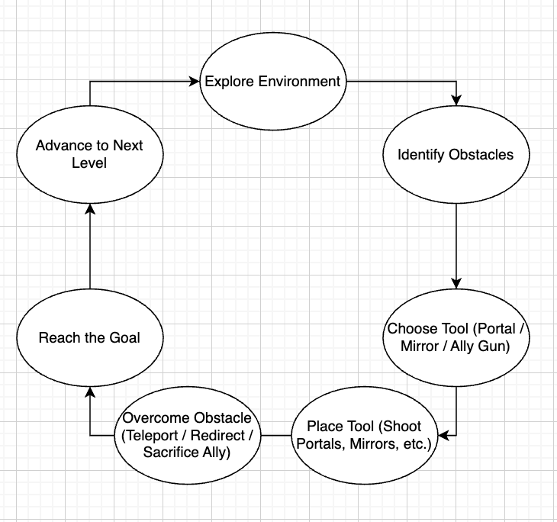

### Mechanic/Level Sketches

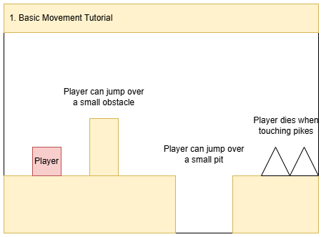

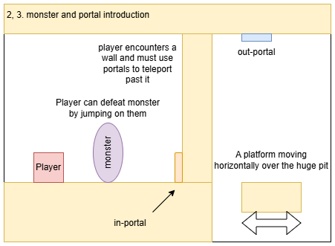

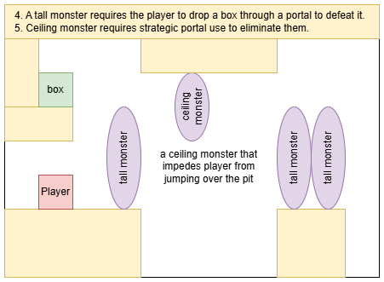

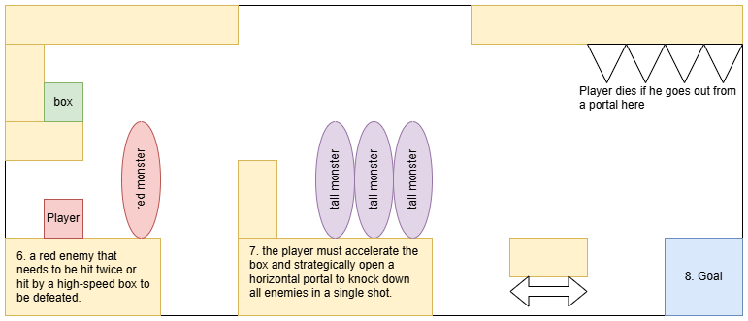

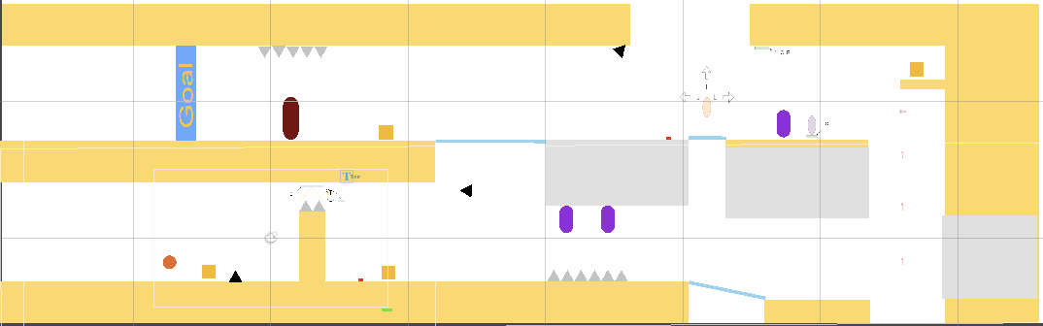

### Level Designs (Beta)

Basics Tutorial: Player learns movement, portal, and enemy basics

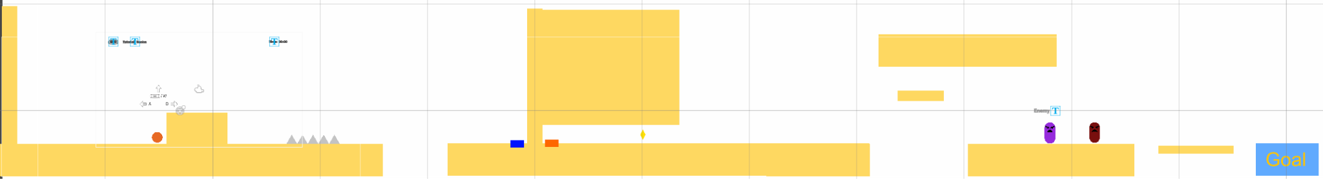

Ally Tutorial: Player learns how to use the ally gun

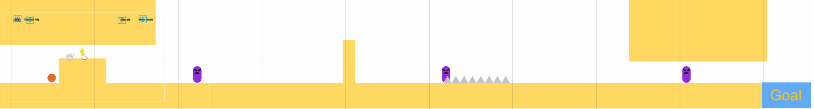

Level 1: Player learns to traverse levels and combining learned mechanics while learning some new game elements

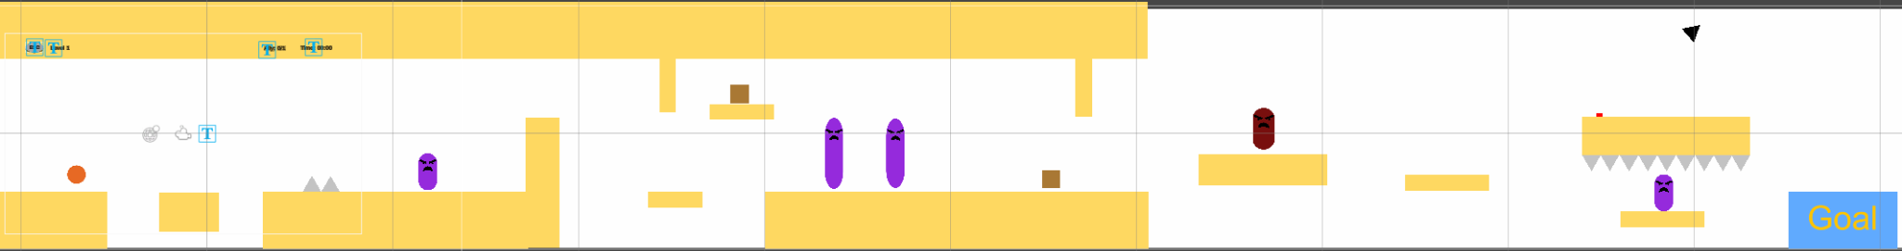

Level 2: Player continues through new levels with new mechanics and old

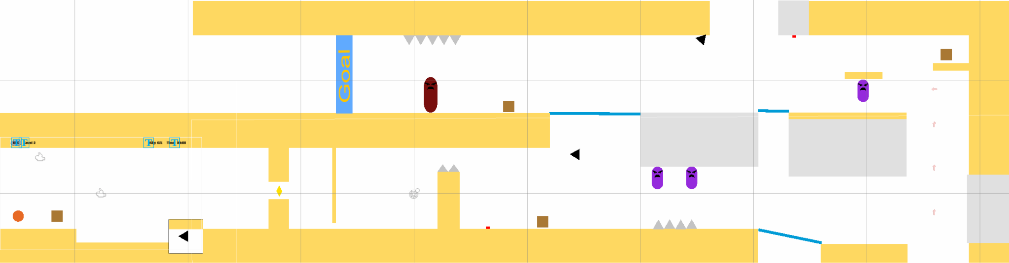

### Concept Art

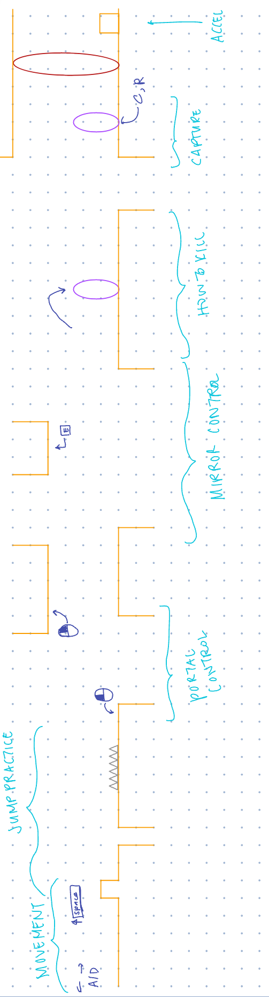

## Game UI - (Beta)

#### Menus

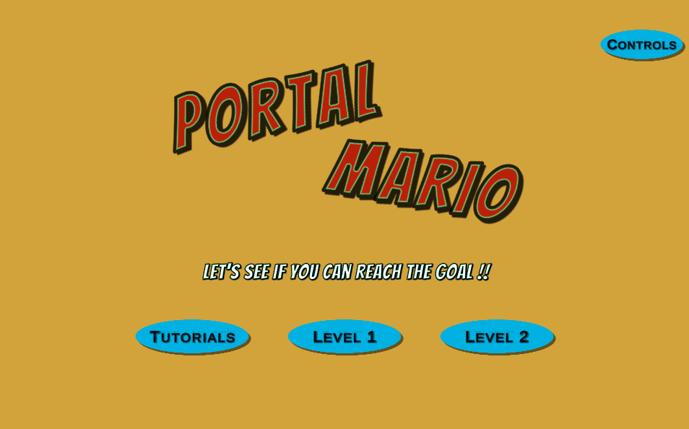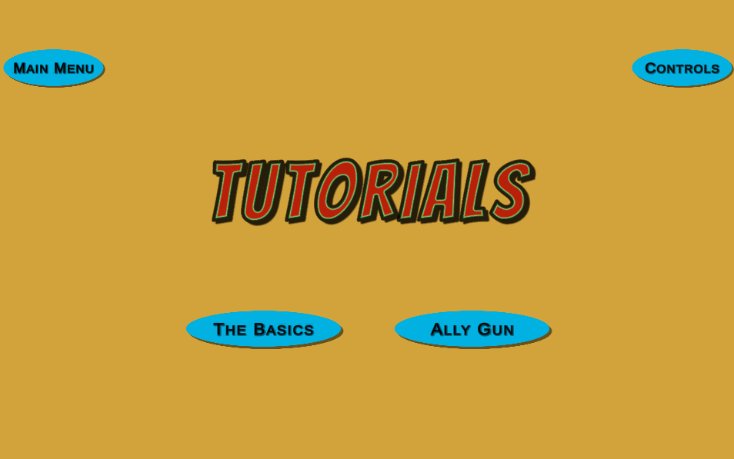

#### HUD

- Pause (esc) button and level label

**

- Pause Menu: retry, resume, main menu, and controls button

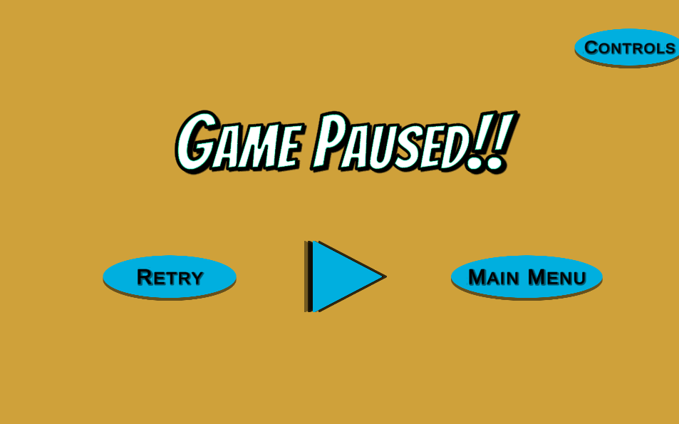

* Controls menu

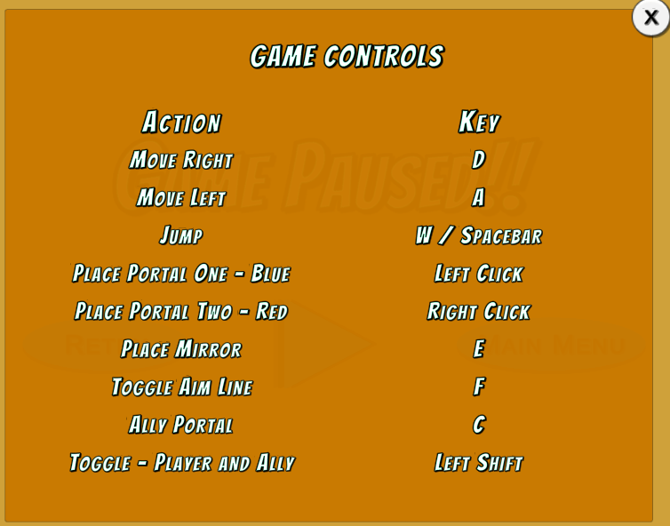

* Timer in top right



* Ally HUD: tells whether there is an ally in play or not  
  
* Hint Popup HUD: pops up if the player is stuck on a puzzle for a certain amount of time. Shows a hint if the player presses X  
  

UI Flowchart

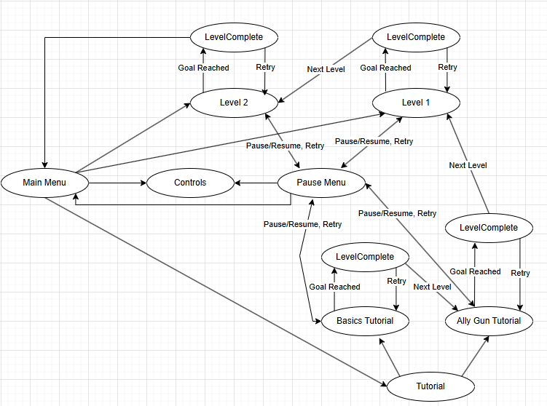

# 

# 

# 

# Analytics

## Link to Firebase: [https://portalmario-cs526-default-rtdb.firebaseio.com](https://console.firebase.google.com/u/0/project/portalmario-cs526/database/portalmario-cs526-default-rtdb/data/~2F)

## Methodology Used:

1. Data Collection:
   * Send game data as JSON body to Firebase Realtime Database whenever a level starts/ends or the player respawns.
   * Download data from Firebase and convert them into a .XLSX file.
2. Data Visualization:
   * Used pandas to parse through data collected from Firebase
   * Used matplotlib and seaborn to generate barcharts, histograms, scatter plots to visualize each metric.

## Metrics Used:

**Metric #1**: *Level Completion Efficiency*

**Description:** This metric helps in evaluating performance and engagement for the game by tracking level completion rate, time taken, death & retry counts across each level for all players.

**Graphs:**

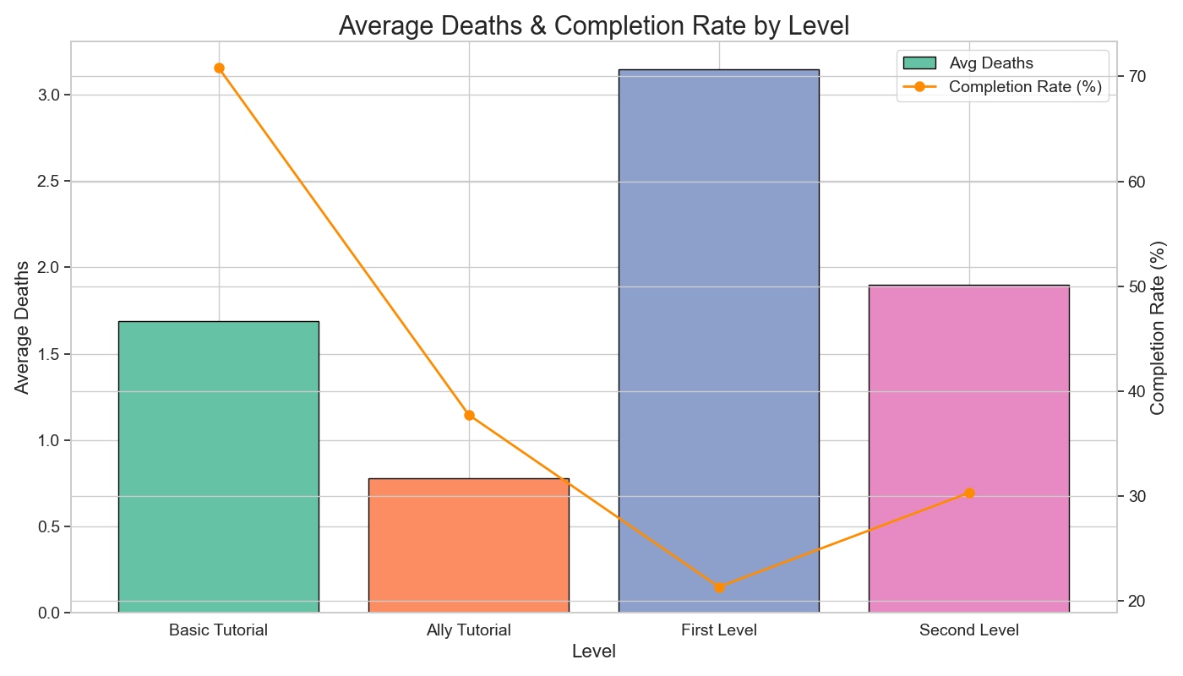

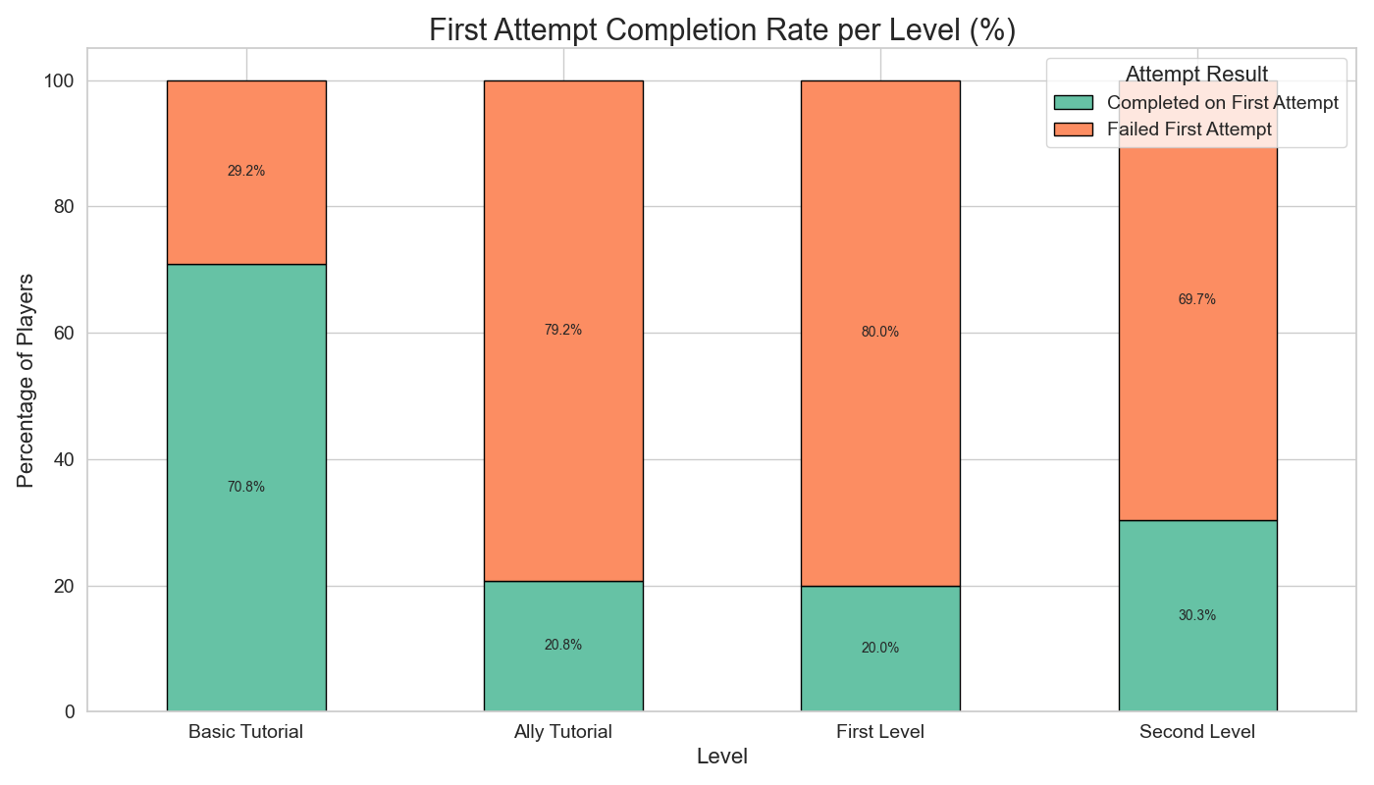

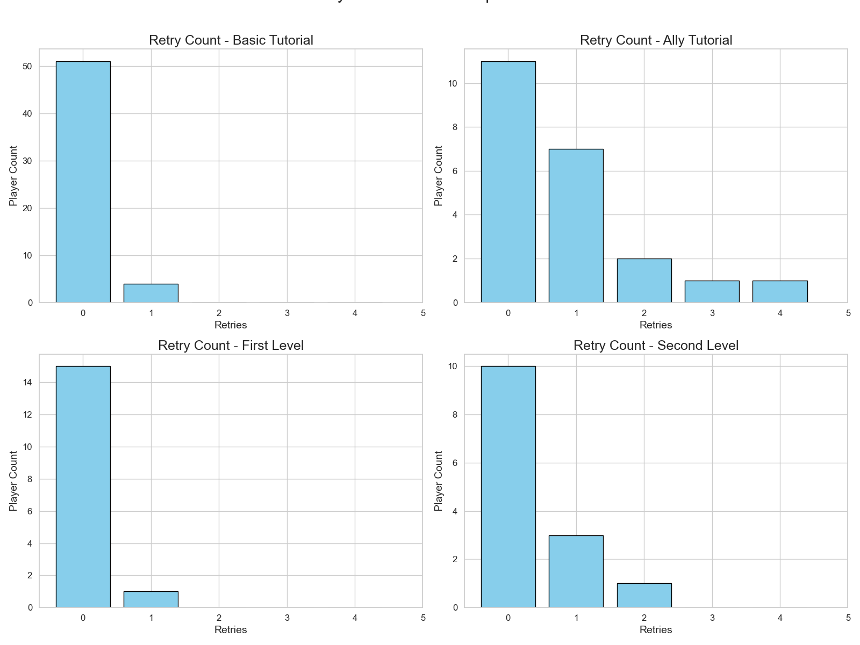

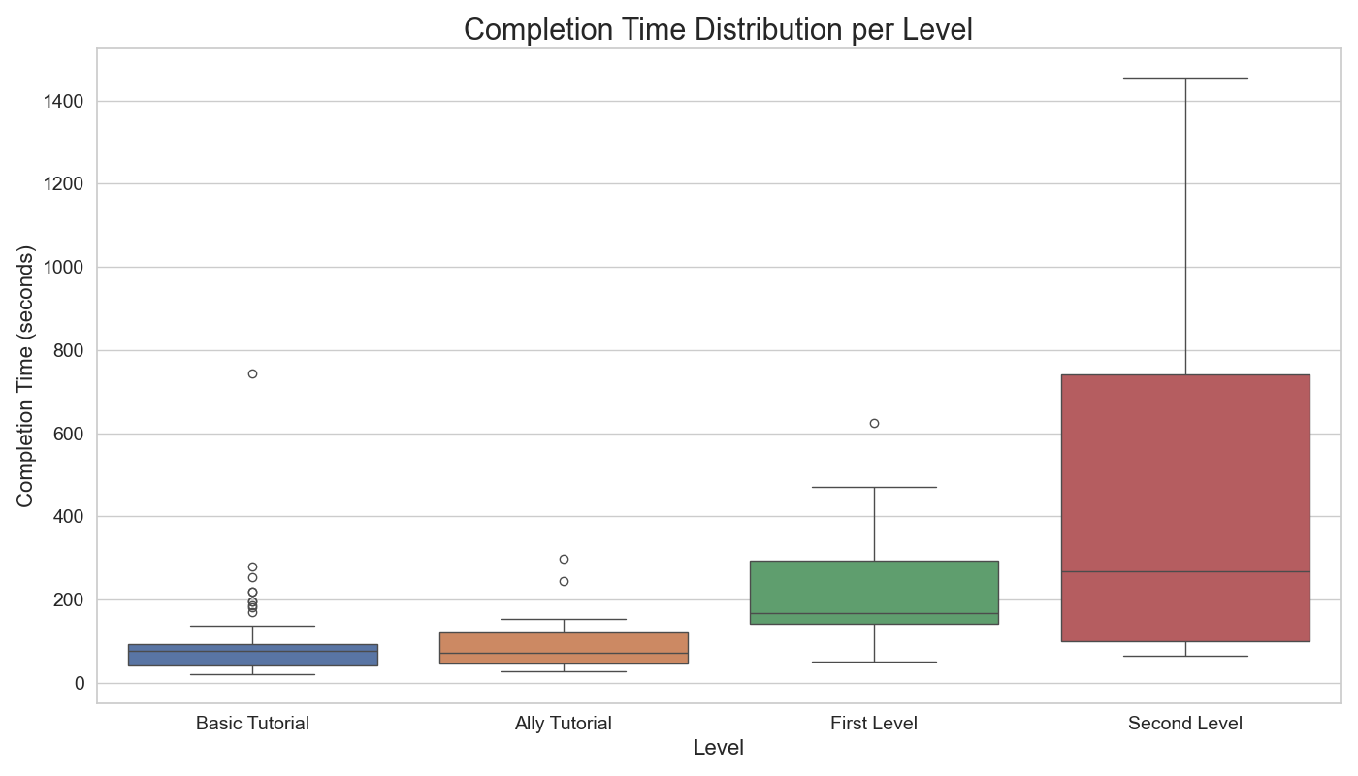

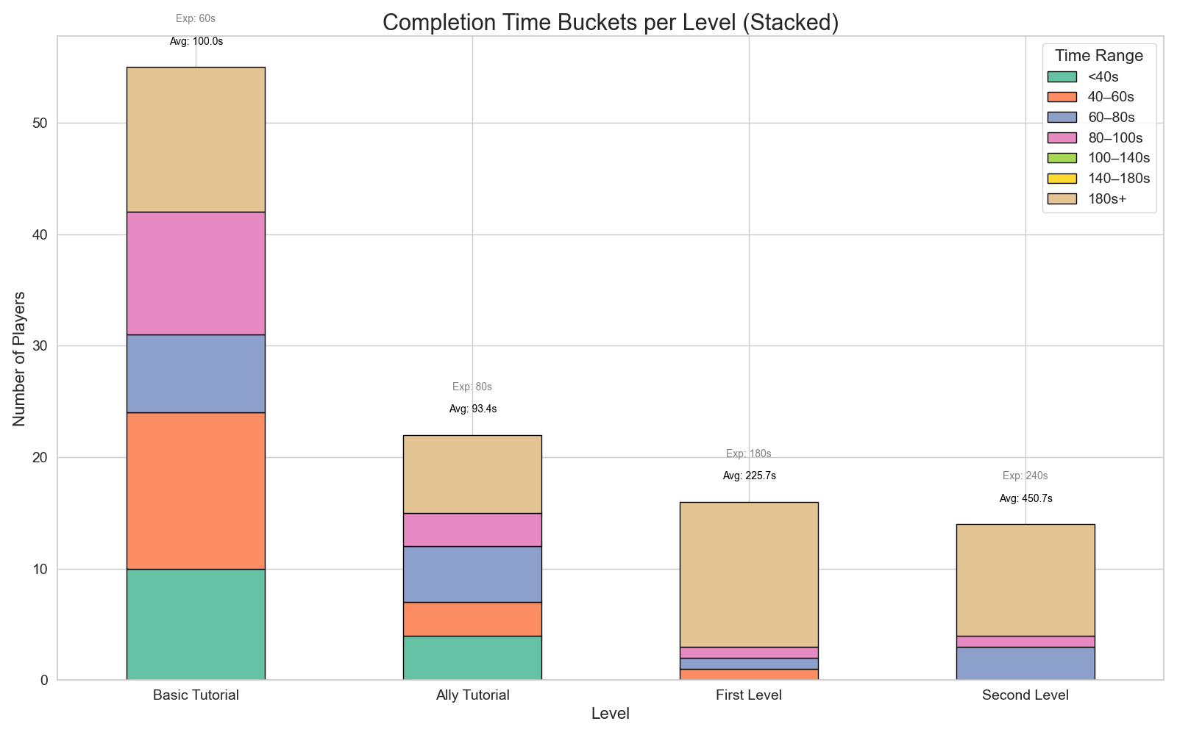

Note: The above graph shows the “expected” time i.e. average level completion time of 10 plays per level

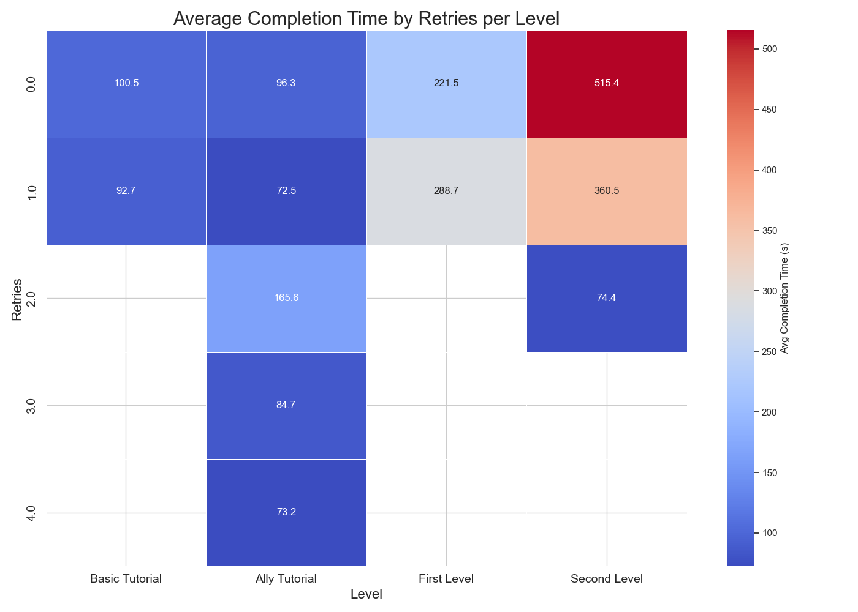

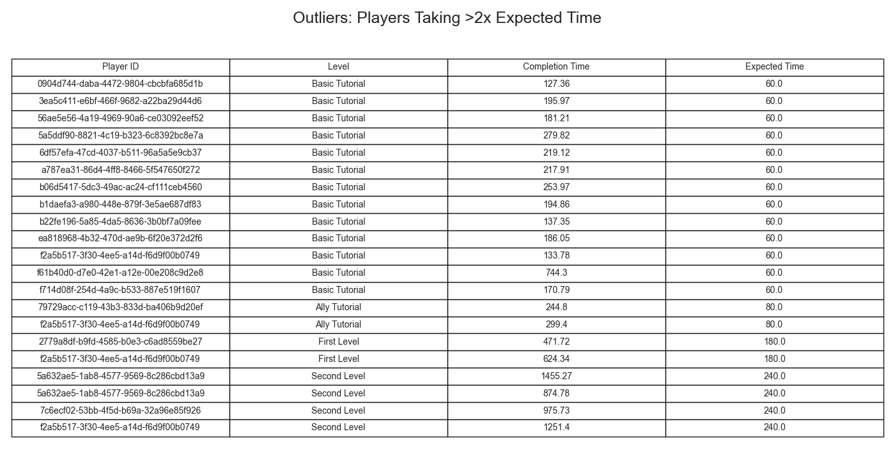

Additional Graph: It states the outliers which take twice the “expected” time for a particular level

**Justification:** Tracking level completion, death & retry counts, and completion time helps us evaluate player progress, pacing of the level and difficulty balance across the levels. Low completion rates or high deaths may indicate a level is too hard or confusing. Comparing player completion times to the average time as well as the developer’s expected time further reveals whether levels are taking longer than intended, helping in fine-tune difficulty for a better experience for players. Tracking retry behavior also reflects player engagement and persistence.

**Interpretation:**

* **High Death Count & Low Completion Rate:** Indicates the level may be too difficult or frustrating. Players are dying frequently and many fail to complete the level, suggesting it may need restructuring.
* **High Death Count & High Completion Rate:** Indicates the level is challenging but fun. Players are motivated to push through and complete it despite difficulties, which suggests good engagement.
* **Low Death Count & Low Completion Rate:** Indicates the level might be confusing or unengaging. Players are not dying often, but they’re also not finishing, possibly quitting early due to unclear ways forward.
* **Low Death Count & High Completion Rate:** Indicates the level is too easy. While completion is high, the lack of challenge may lead to reduced engagement or boredom over time.
* **Retry Count:** Suggests how engaged and challenged players feel. A moderate retry count with consistent completions can signal that players are interested in improving and overcoming obstacles.
* **Completion Time:** Suggests insight into pacing and efficiency. Comparing individual completion times with the average can help identify outliers. It can also be compared with expected time to understand how complex or how easy players feel than intended. Additionally, comparing average completion times between each level can offer insight into differences in level difficulty between each level.
* **Average Time:** Suggests if the level is balanced or not. Comparing the average time taken with expected time can help in finding issues in that particular level and also comparing with average time taken for other levels, can help if the difficulty increase in level is balanced or skewed.

**Hypothesis:**

1. If players are more likely to complete Level 0 on their first attempt compared to Level 1 or Level 2, then it indicates the presence of a learning curve and successful initial onboarding.
2. If the tutorial level has a high death count, then it may suggest ineffective tutorialization or unclear instructions that hinder early player understanding.
3. If a level shows higher average retry counts alongside a reasonable completion rate, then it can be inferred that the level is engaging and encourages players to persist through challenges.
4. If a player’s completion time is significantly higher than the average or expected time, then it suggests confusion or inefficiency in level design that may need clarity or simplification.
5. If the average time to complete levels increases with level number, then it indicates that level difficulty is scaling as intended, showing progression in challenge.

**Metric #2**: *Portal Mechanic Engagement*

**Description:** This metric measures how players interact with the portal system, which is our core mechanic. It includes data on the total number of portals used, how often players, boxes, and enemies traverse through portals, and whether players understand acceleration-based mechanics.

**Graphs:**

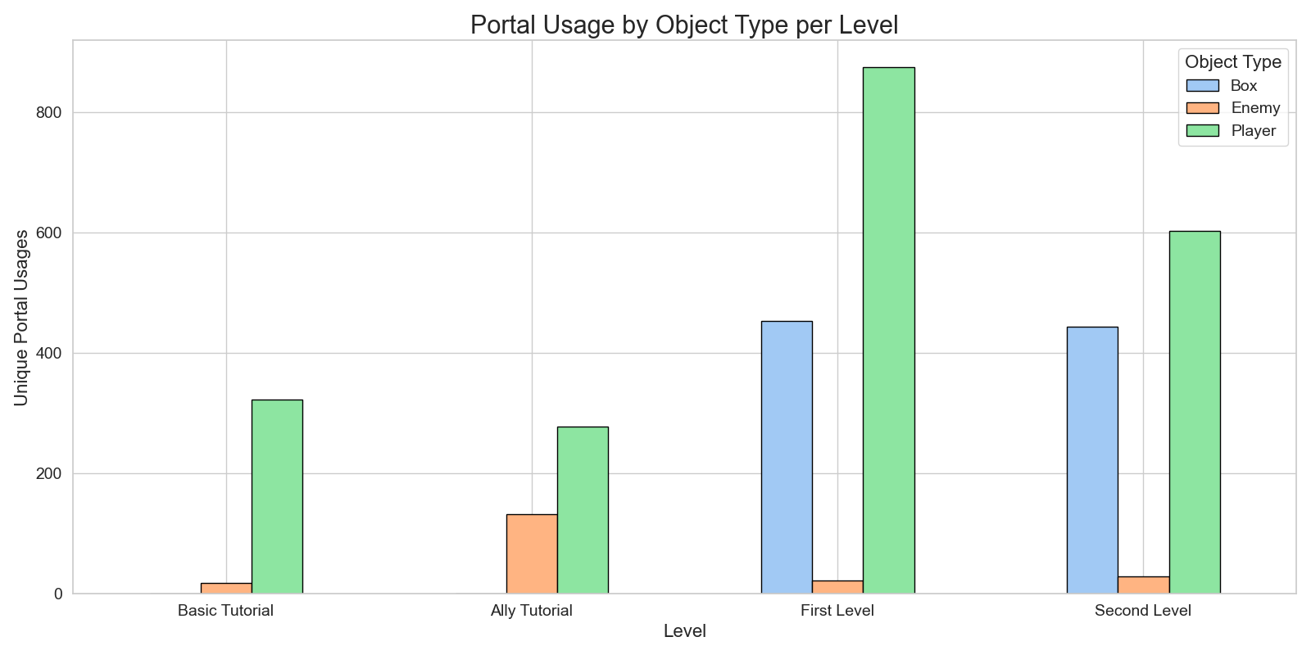

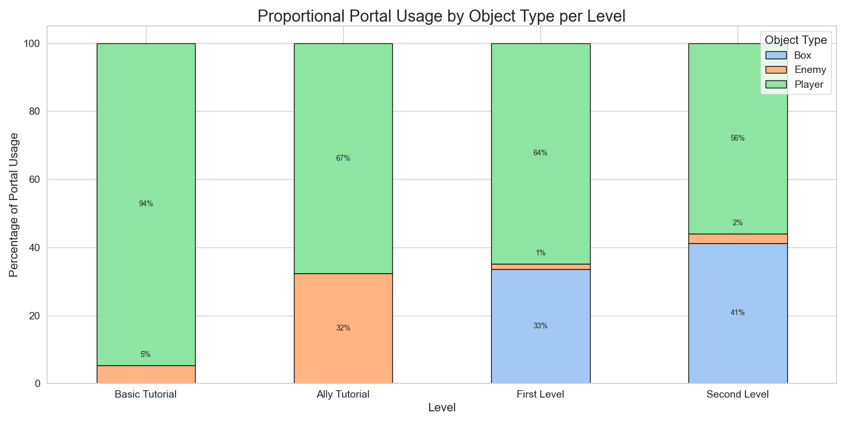

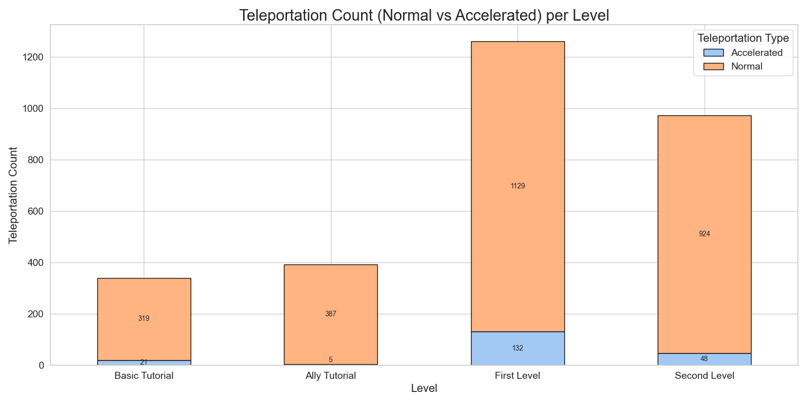

Note: Heatmaps track the location of every portal that the players enter through (not specific to color of portal)

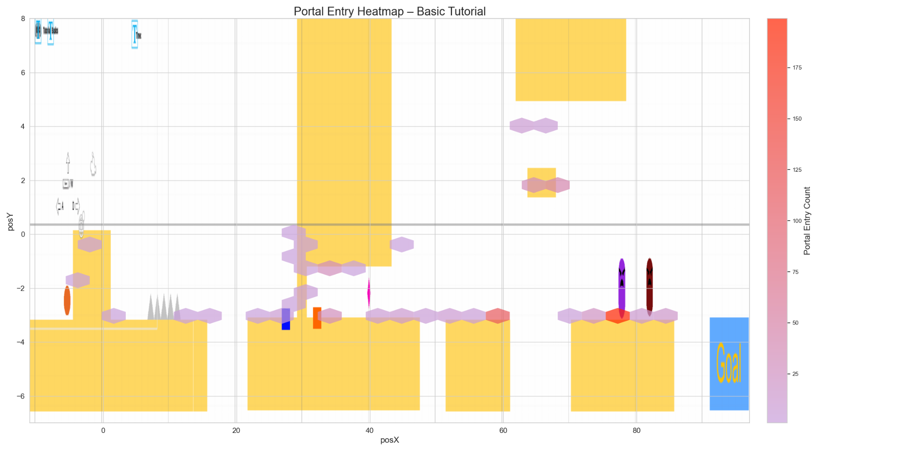

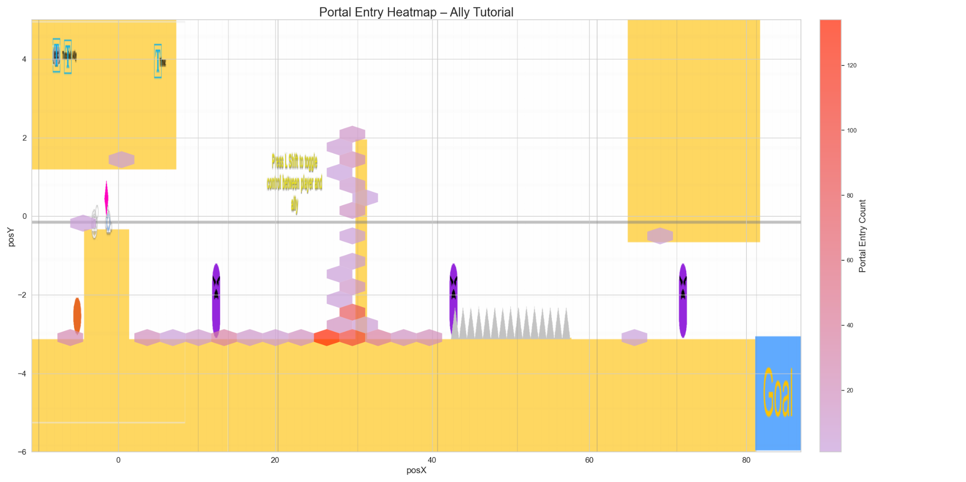

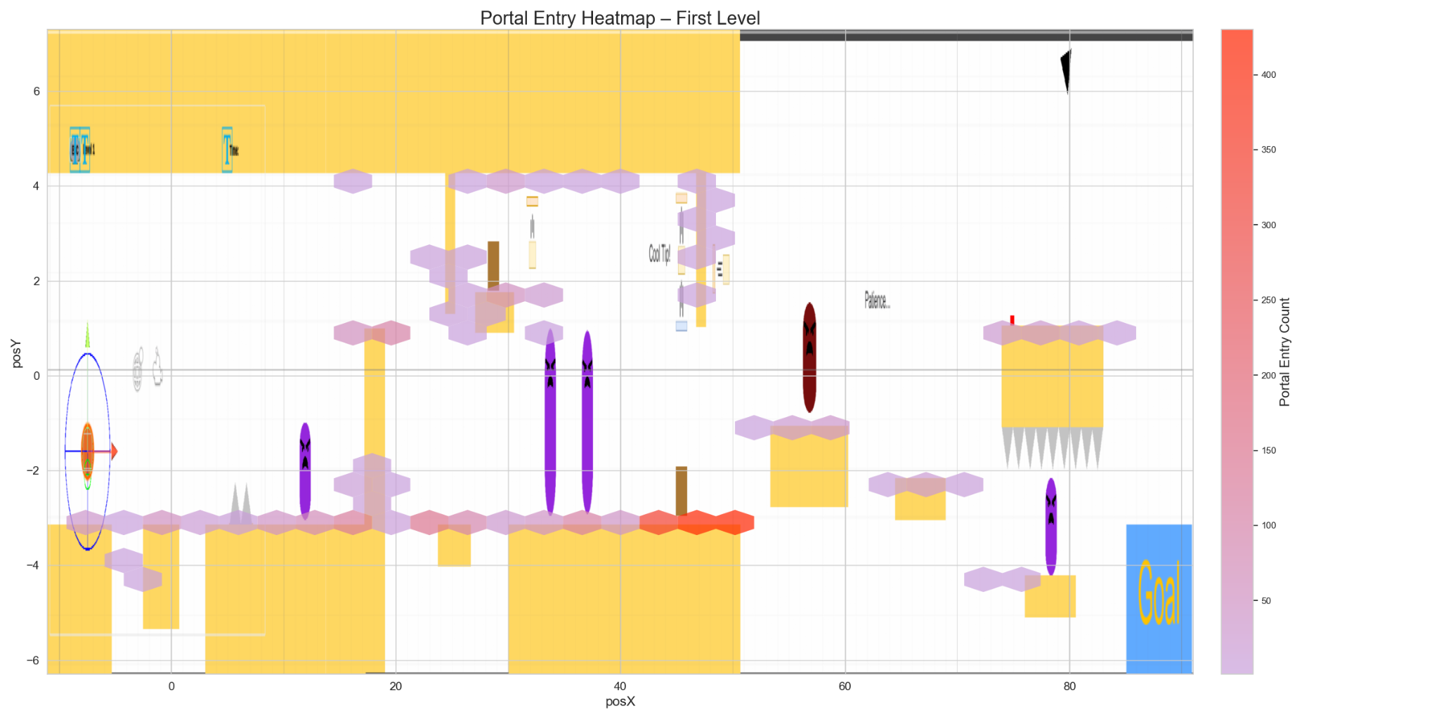

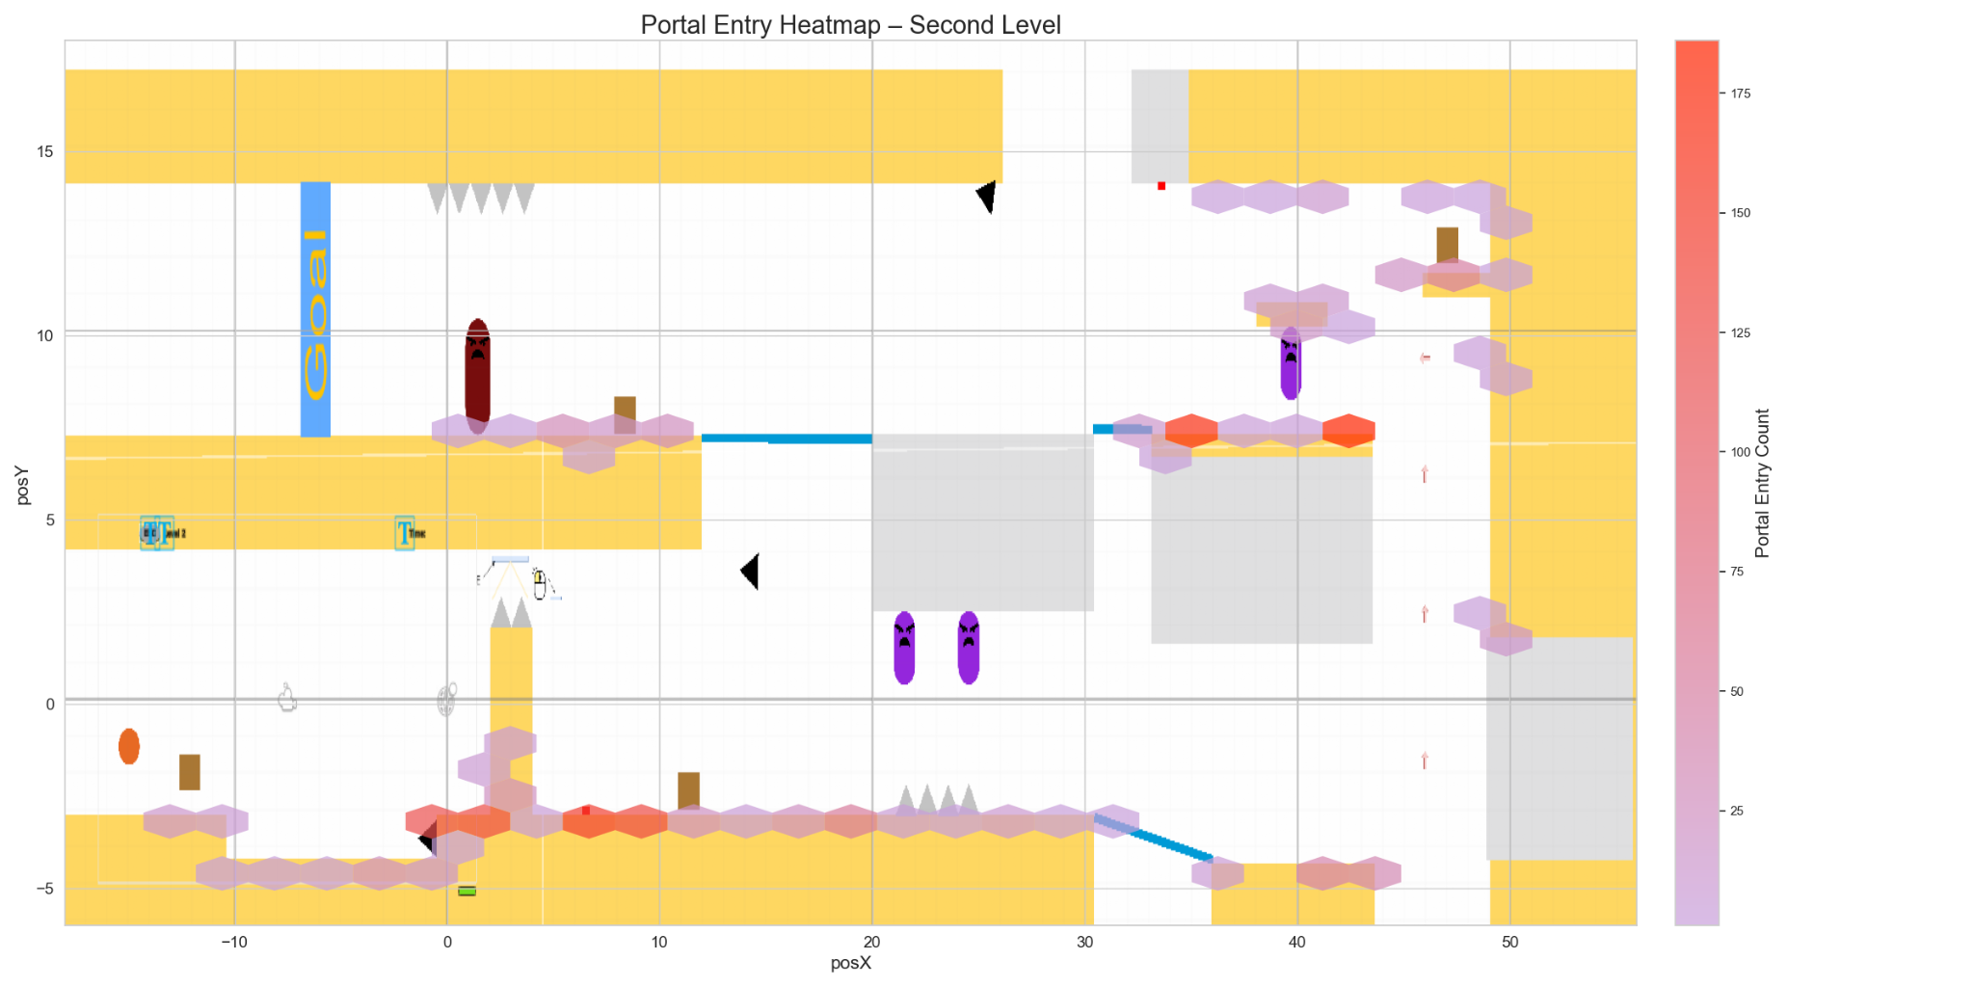

Note: The "stuck" here refers to the situation where the player is doing the portal traversal more than 3 times, other than the acceleration situation & thus concluded to be stuck in a portal traversal loop.

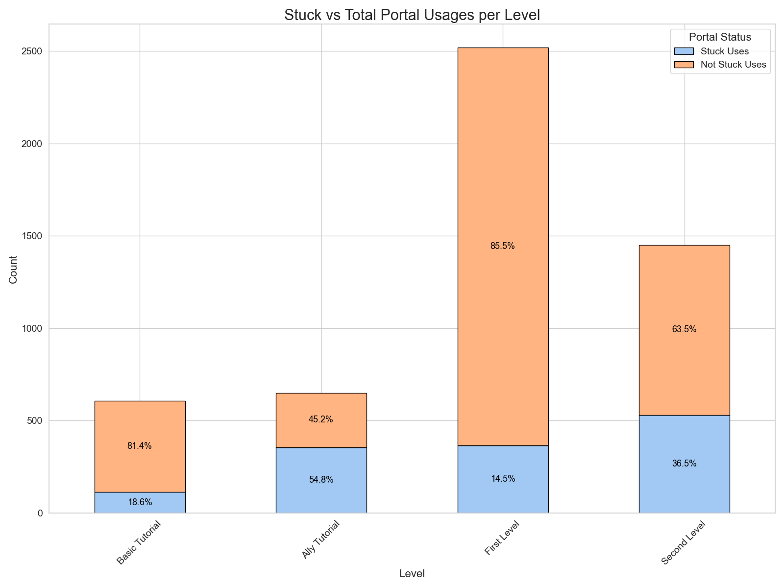

**Justification:** Portals are the core mechanic of our game, it’s crucial to understand how players interact with them. Tracking portal usage, what objects they traverse through them and how often they are used helps us evaluate whether players understand and rely on this mechanic. If players avoid or misuse portals, it may signal confusion, ineffective instructions, or level layouts that don’t encourage creative portal use.

**Interpretation:**

* **Low Portal Usage Count:** Suggests that players are not fully understanding the portal mechanic or are finding ways to bypass it.
* **High Portal Usage for Player but Low Object Traversal:** Suggests players are using portals for personal movement but are not understanding they can use them for other objects that can assist in puzzle solutions.
* **High Player Exit Velocity with Increased Deaths:** Suggests that portals are being used in high-speed sequences, potentially leading to unexpected player deaths. This can point to the need for an accelerated player to become hard to control.
* **Usage Increases as Levels Progress:** SuggestPlayers are becoming comfortable with the mechanic as game progresses with also increase in required usage of portal to complete the level suggesting good scale for core mechanic.

**Hypothesis:**

1. If portal traversal frequency and usage increases across levels, then it indicates growing player mastery of the core mechanic and proper scaling of mechanic complexity.
2. If players avoid acceleration-based portal usage (rapid multiple traversals), then it may suggest that either the mechanic is unintuitive or players are hesitant due to loss of control.
3. If players frequently get stuck in non-accelerated portal loops (i.e., repeat traversals >3 times), it may indicate that portal placement or exit orientation is unintuitive, or that players lack sufficient feedback to regain control after traversal. High stuck rates may reflect mechanic confusion rather than puzzle difficulty.

**Metric #3**: *Player Death Reasons and Patterns*

**Description:** This metric tracks the reasons behind player deaths throughout the game, including causes like lasers, enemies, traps, or falling off the map. Along with the reason, we also get the exact position and timestamp of each death event.

**Graphs:**

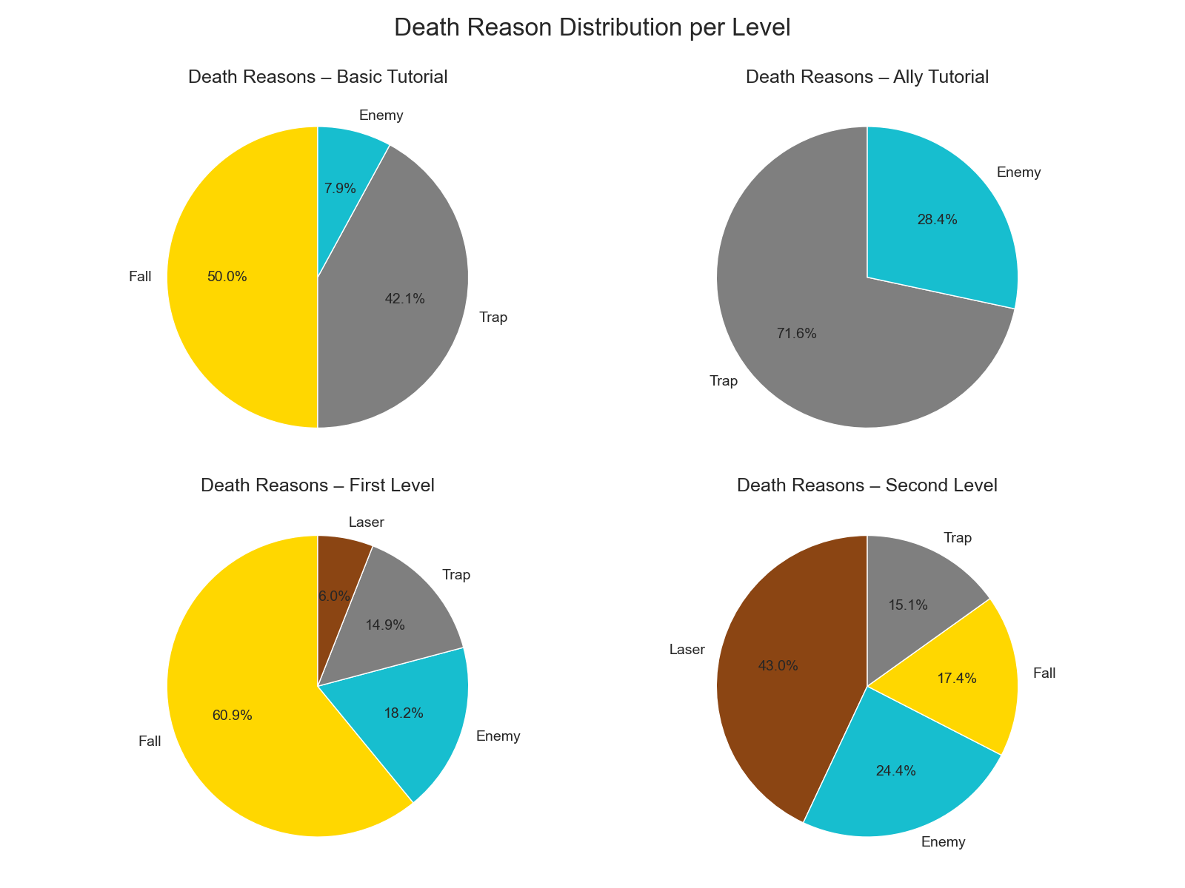

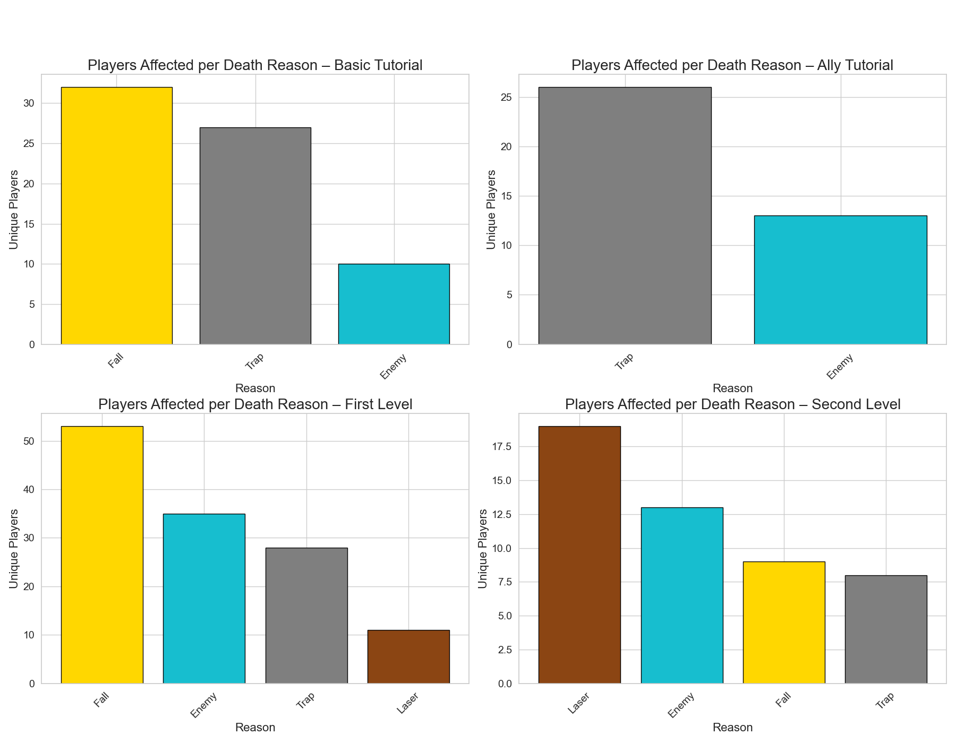

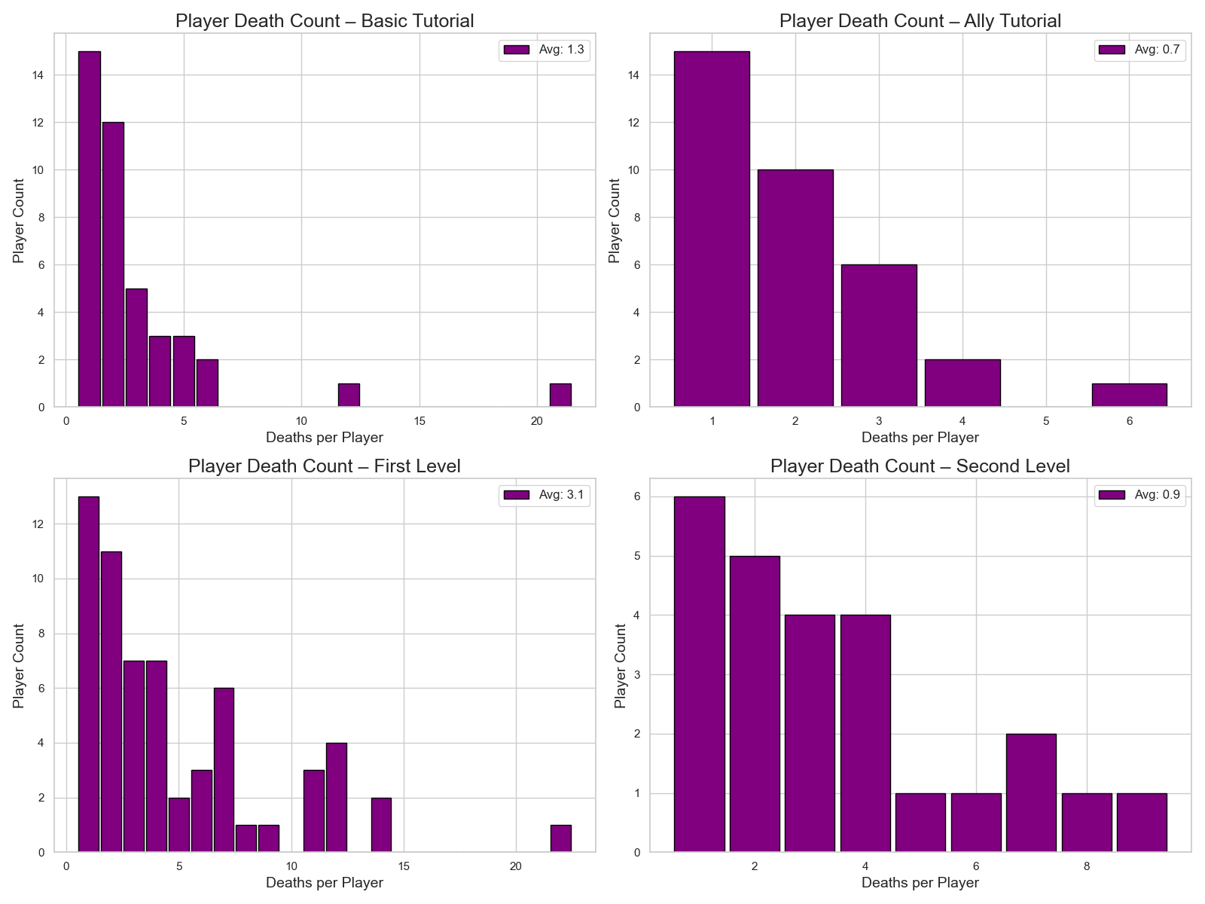

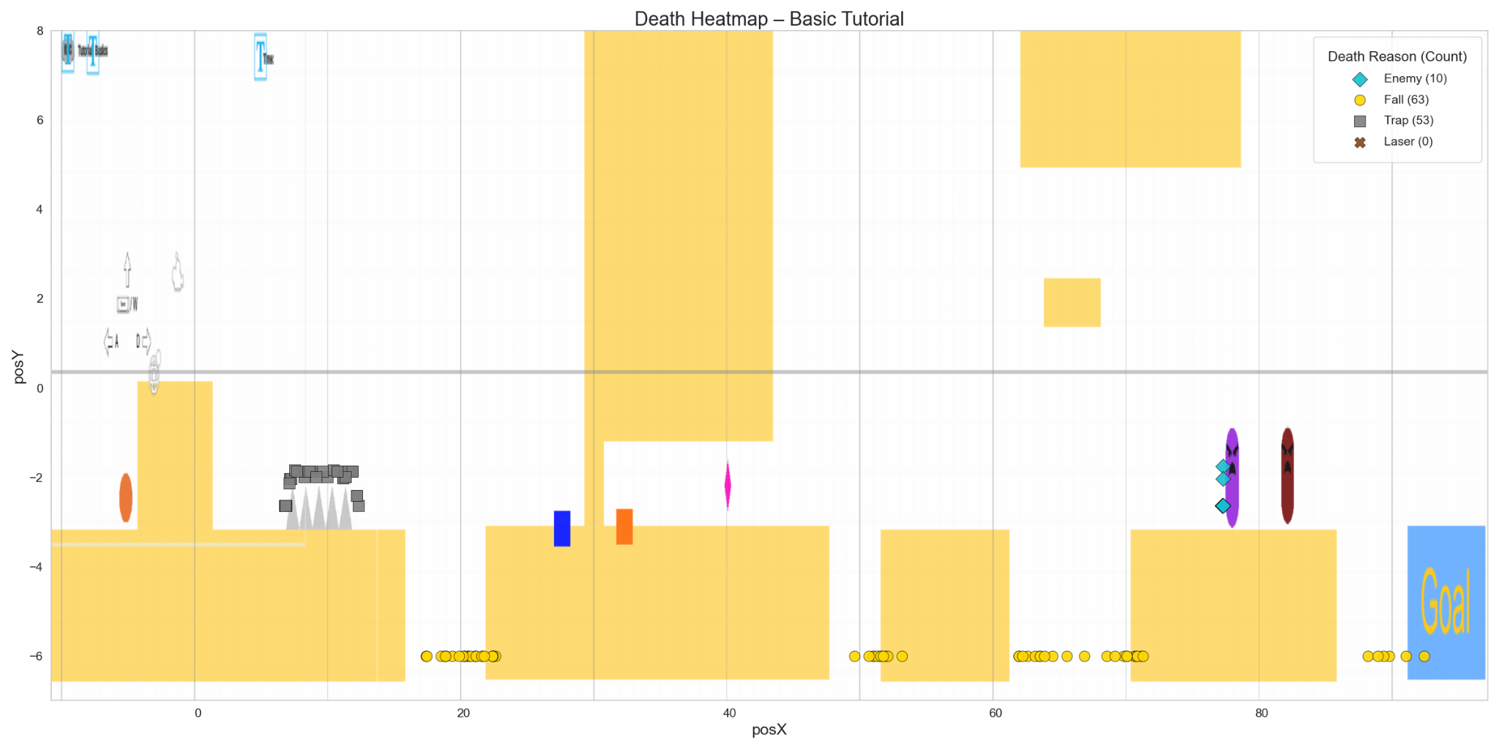

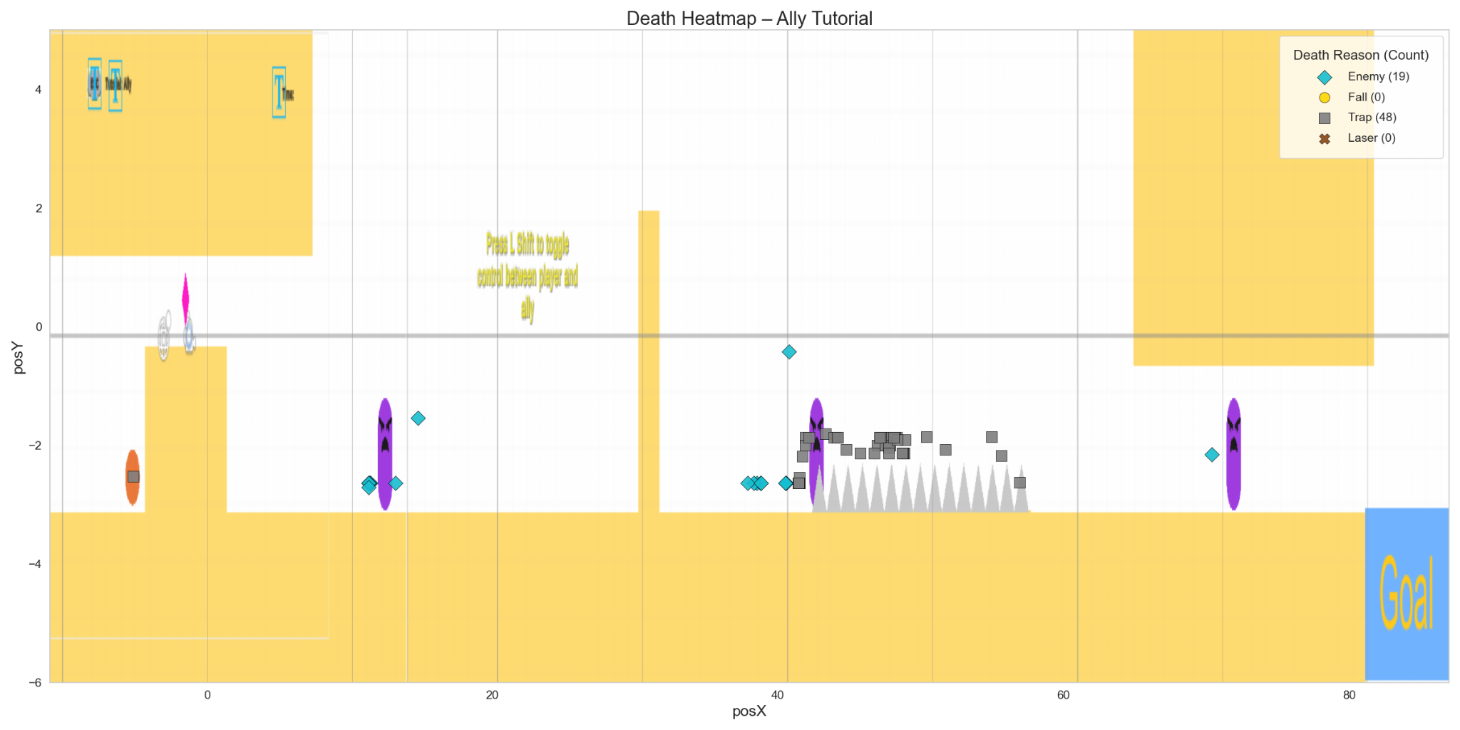

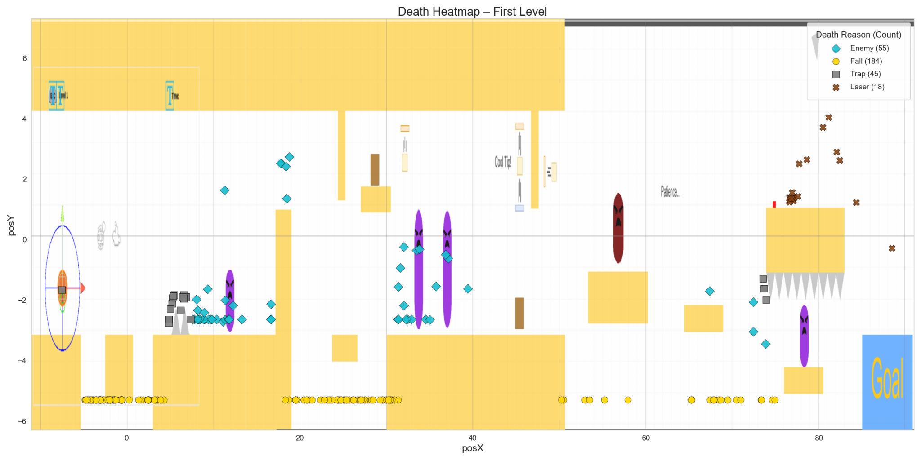

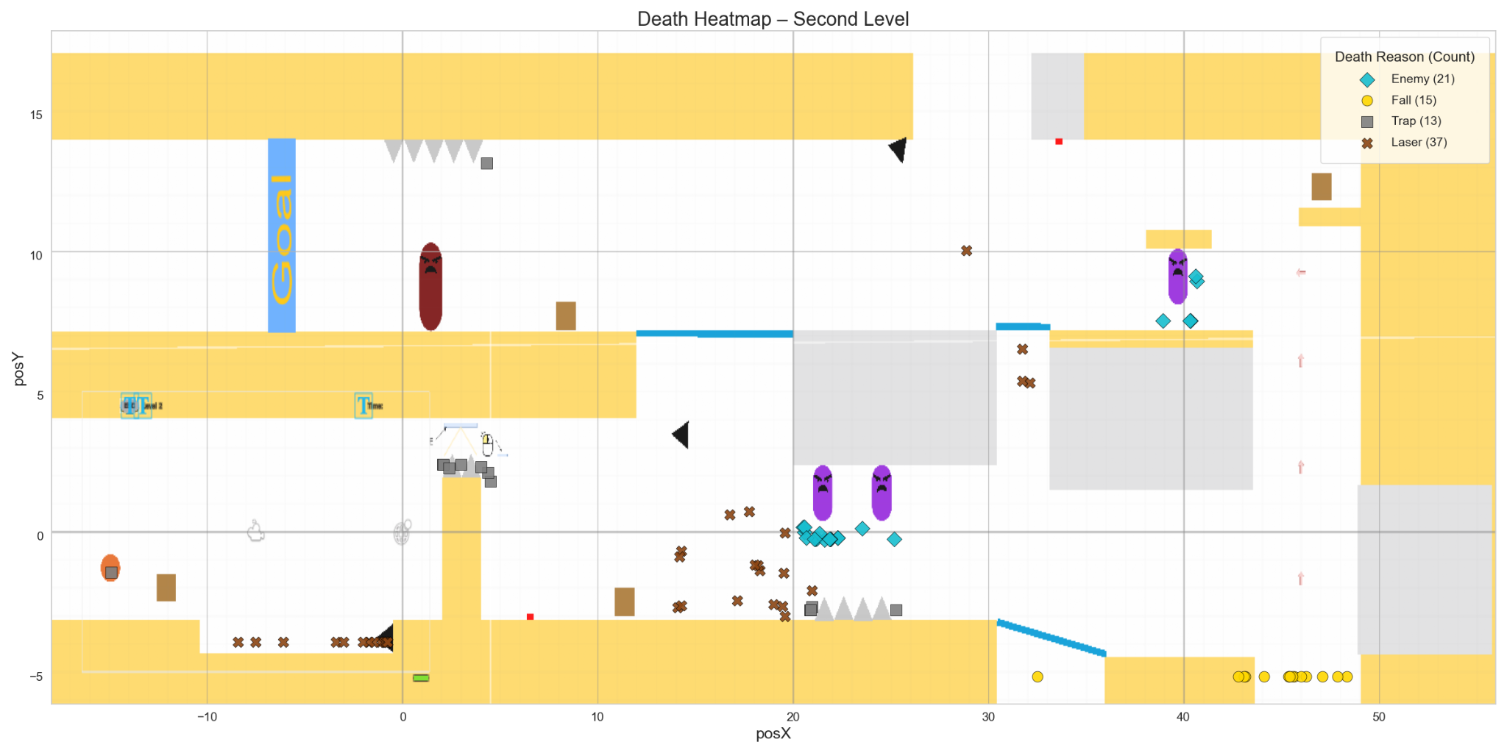

**Justification:** Understanding the cause, location, and timestamp of a player's death helps identify frustrating or overly difficult sections in the game. Frequent deaths in specific areas or due to specific mechanics may indicate poor design clarity, difficulty imbalance, or a need for tutorial reinforcement to ensure the game feels challenging but fun enough.

**Interpretation:**

* **Frequent Deaths in One Area:** Suggests players might feel that part of the level may be confusing, buggy, or poorly designed, making it difficult for players to pass that.
* **High Deaths Caused by Same Reason:** Suggests players might not understand that type of obstacle which may be either due to lack of clarity or difficulty.
* **Multiple Death Reasons Spread Evenly:** Suggests level and enemy difficulty is evenly distributed across the level and perhaps a good level design.

**Hypothesis:**

1. If most deaths are caused by a single obstacle type (e.g., enemy, trap, laser), it may indicate a lack of clarity or an unbalanced challenge associated with that mechanic, suggesting the need for better teaching moments or design tweaks.
2. If players die more than 5 times in the tutorial level, then they are unlikely to complete future levels, indicating a need to simplify or clarify the early learning curve.
3. If a high number of deaths are caused by falling across levels, then better visual cues or boundary design may be needed to reduce unintended drops.

**Metric #4**: *Way in which Enemy is Killed*

**Description:** This metric focuses on how players deal with enemies in the game. For every enemy defeated, we log the enemy type (purple or red enemy), the way the enemy is defeated, the timestamp, and the location of the kill.

**Graphs:**

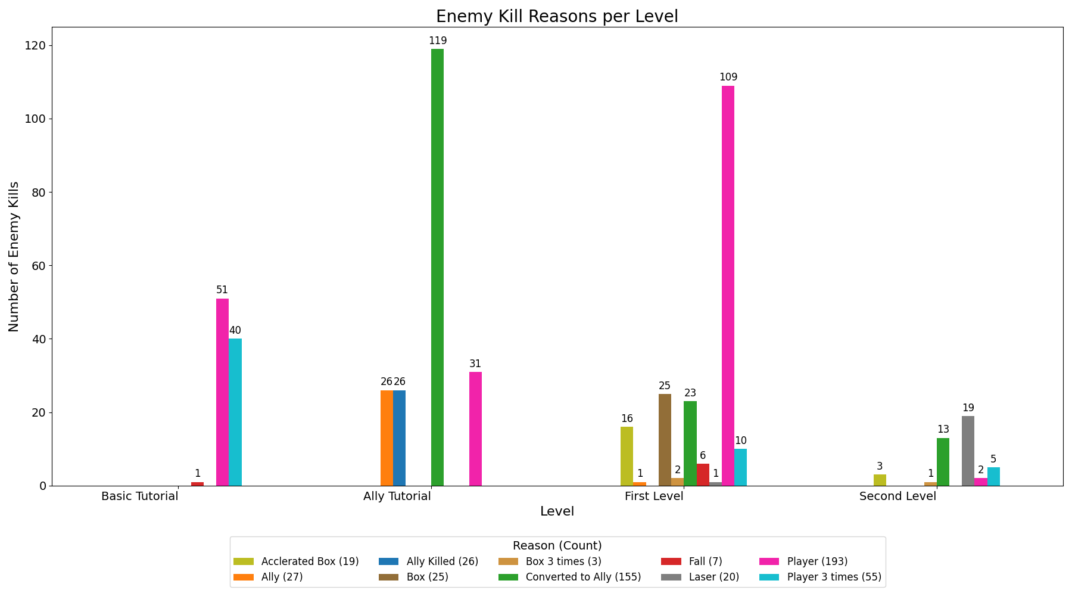



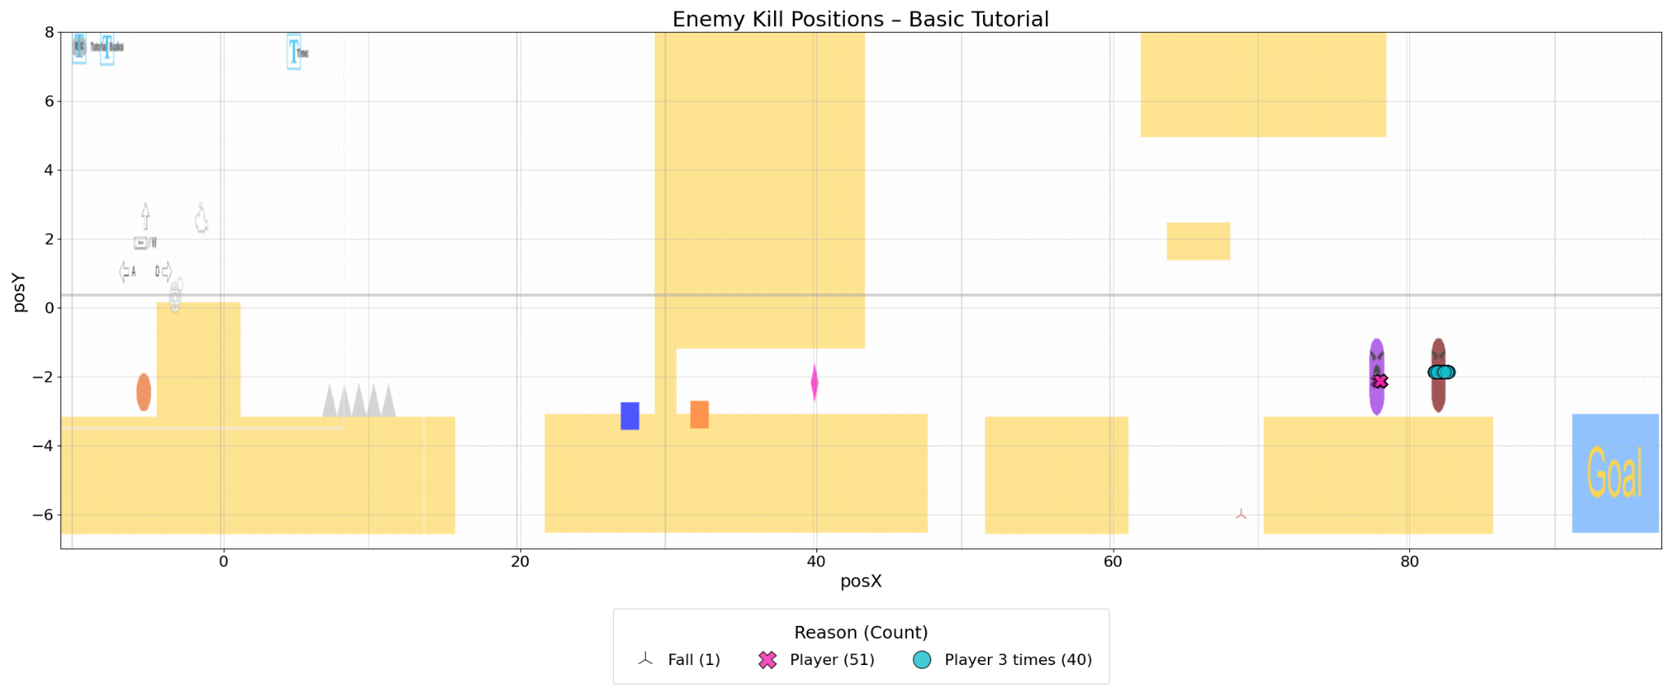

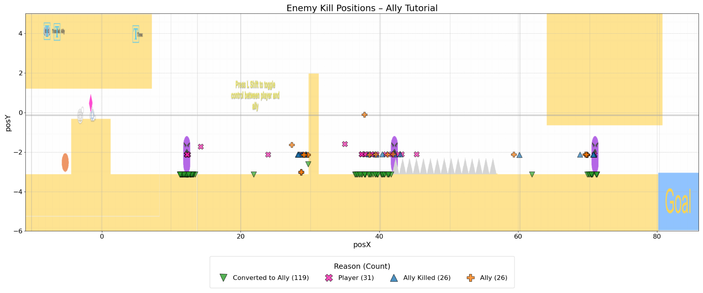

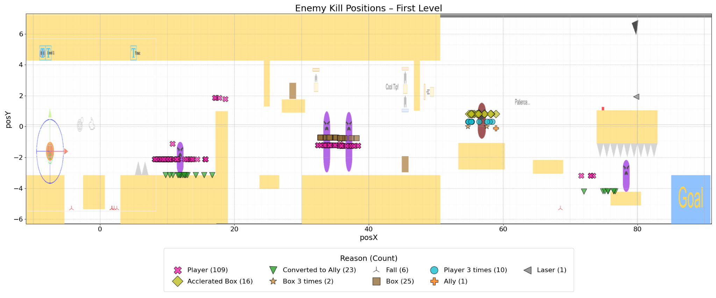

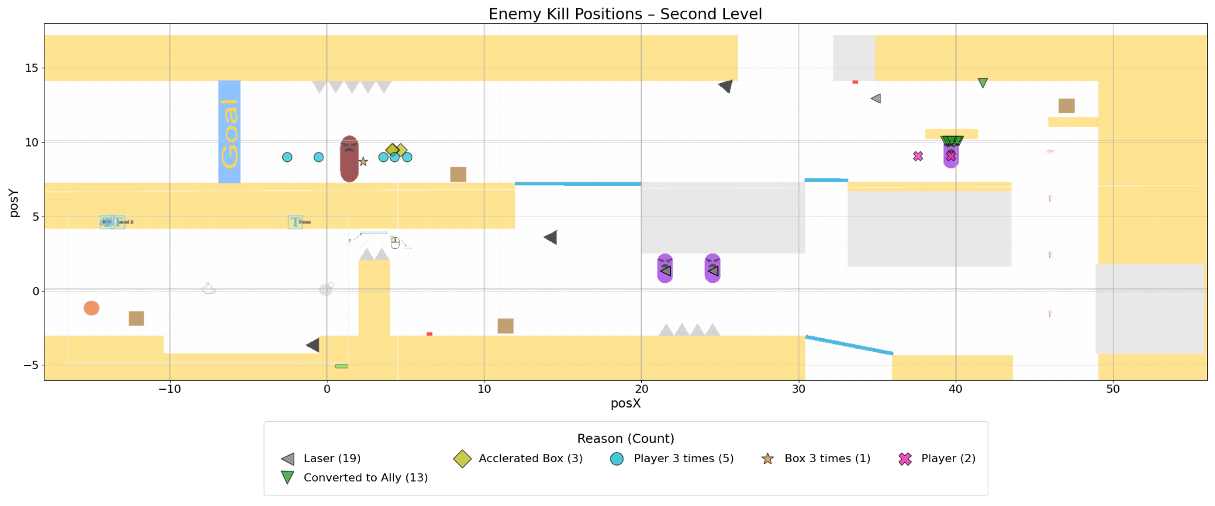

**Justification:**

Tracking how enemies are defeated helps us understand which mechanics players prefer, and whether our combat systems are intuitive and understandable. If some methods (like accelerated box or using ally) are rarely used, it might mean they are hard to discover or ineffective. On the other hand, overuse of a single method might indicate imbalance, which can be used to improve combat tutorials & design, and also add hints if many people are not able to use a particular method.

**Interpretation:**

* **Enemies are primarily Killed by Boxes or Players:** Implies that players are actively engaging with basic mechanics, suggesting they’ve understood basic strategies but are not able to understand acceleration features for fast killing.
* **Enemies are not Killed using Lasers:** Implies that either players are unaware of laser-based kills or find it difficult to set up laser kills using the mirror.
* **Enemies are Hardly Converted into Ally:** Implies that players are either unaware of the ally mechanic, find it difficult to control, or feel other mechanics are more useful to clear the level than the ally. This could indicate a need for better controls, hints, or more puzzle solving around ally mechanics.
* **Number of Enemies Killed in Each Level are lesser than Total Present:** Implies that players are easily able to bypass enemies through jumping over them or skipping them using portals, which implies good understanding of movement mechanics or very easy obstacles placement.
* **Red Enemies are not often killed:** Implies that red enemies are fulfilling their role as high-difficulty opponents. However, this could also imply that they are too difficult and they have overly punishing mechanics.

**Hypothesis:**

1. If enemies are consistently being defeated in the same way across players, then there is an imbalance in mechanic effectiveness or clarity.
2. If red enemies are most often defeated using accelerated boxes, then it suggests players are discovering the intended advanced kill strategy effectively.
3. If most enemies are bypassed or ignored instead of being killed, then it indicates that enemy placement may not be meaningful or threatening enough to force interaction.

## 

## Beta Survey

Link to Beta Survey: <https://docs.google.com/forms/d/e/1FAIpQLSfss9T1YhPcyG_iLAStQN1uEdbrl71q3EnOiouC7WXrndoqZQ/viewform?usp=header>

### Custom beta survey questions

**Question #1:** *How did the level progression feel in terms of puzzle difficulty?*

* This question is designed to gather information about the player's perception of difficulty scaling and the effectiveness of puzzle design across levels.

**Question #2:** *Rank how useful you think each mechanic was through the entirety of the game*

* This question is designed to gather information about the perceived relevance and impact of each game mechanic on gameplay and problem-solving.

**Question #3:** *On a scale of 1-5, how likely are you to replay the game once all levels are completed?*

* This question is designed to gather information about overall player engagement and the game's replayability potential (whether the puzzles were intriguing enough for players to attempt solving in different ways).

# 

# 

# Weekly Prototype Descriptions

*Describe each of your weekly prototypes here, noting additions, changes, and improvements. It is important to keep this updated every week. Add a few* ***screenshots*** *from each week's development.*

**Week-6 (2/18-2/24):**

* Created team
* Brainstormed new ideas for developing alpha prototype
* Researched on mechanics

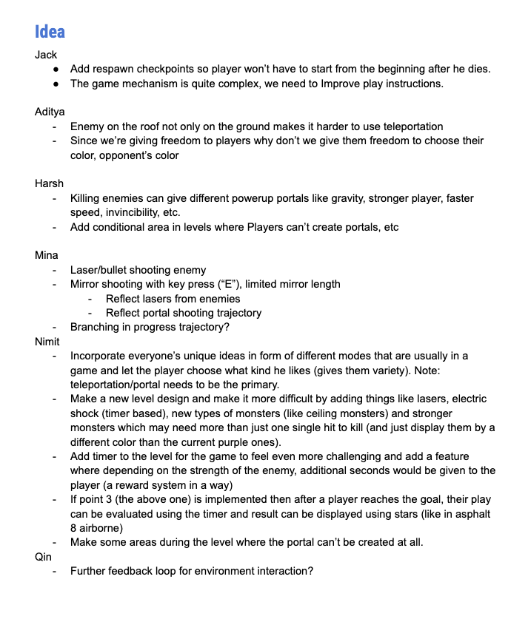

**Week-7 (2/25-3/3):**

* Designed mirror gun which allows shooting one mirror at a time with “E” key
* Adjusted line of sight to accommodate hitting mirrors
* Added mirror quality that makes it breakable when weight is on it
* Designed and implemented lasers that can oscillate, be blocked, reflect on mirrors, and be turned off by continuous button pressing; lasers can kill enemies and player
* Added new powered up enemy that can be killed by 3 hits or accelerated box hits
* Designed and implemented new levels that more thoroughly incorporate the above changes
* Included main menu and in game menu popup hierarchy

Main Menu:

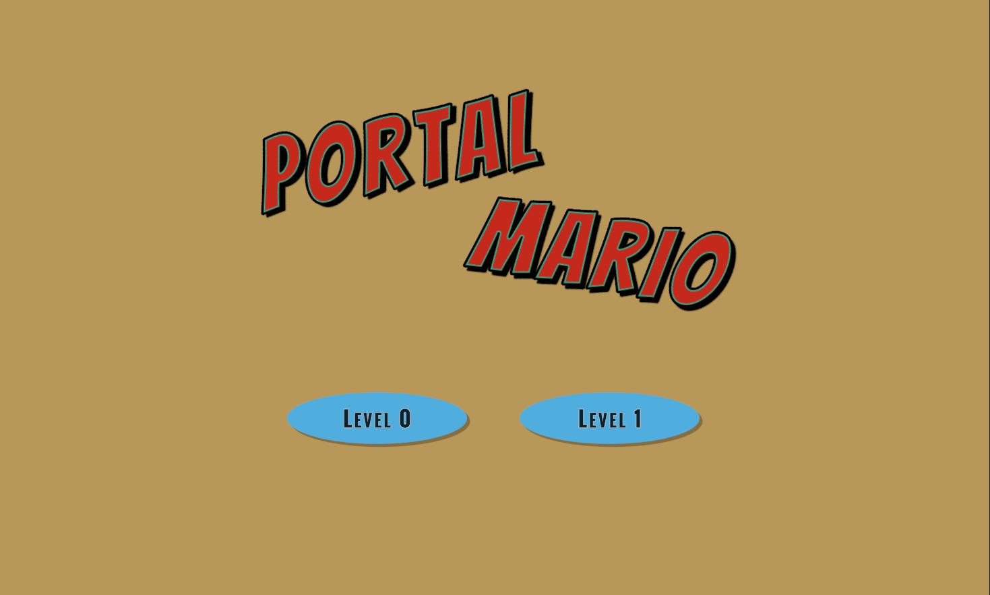

Level 1 Design:

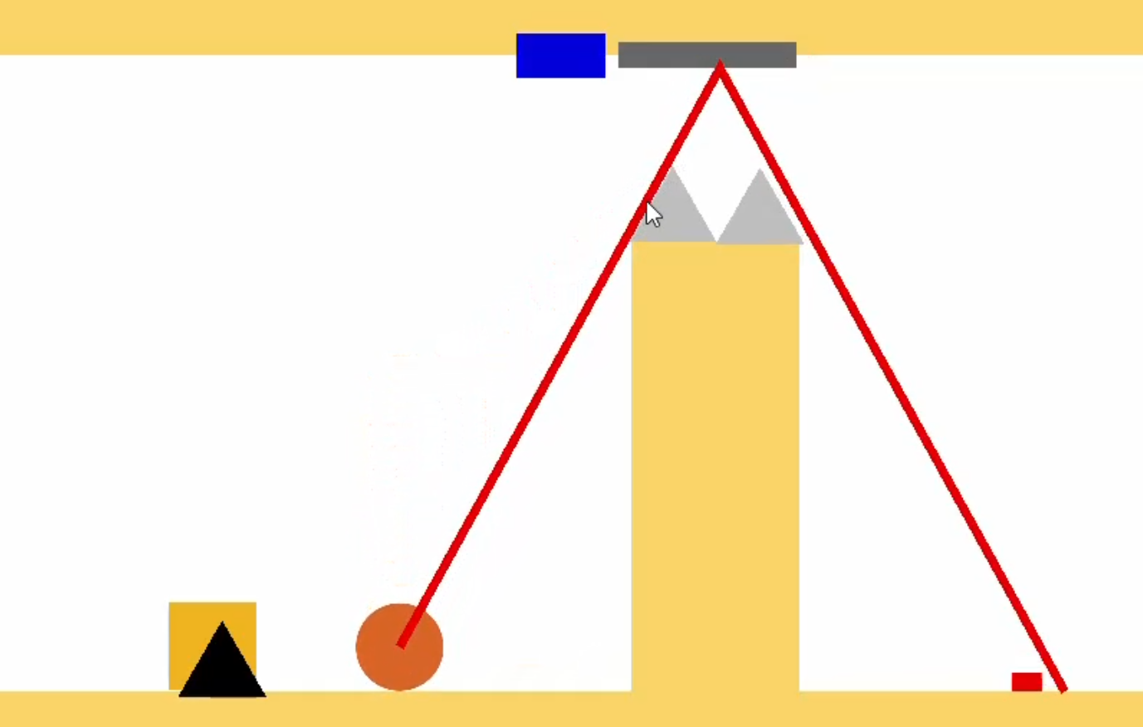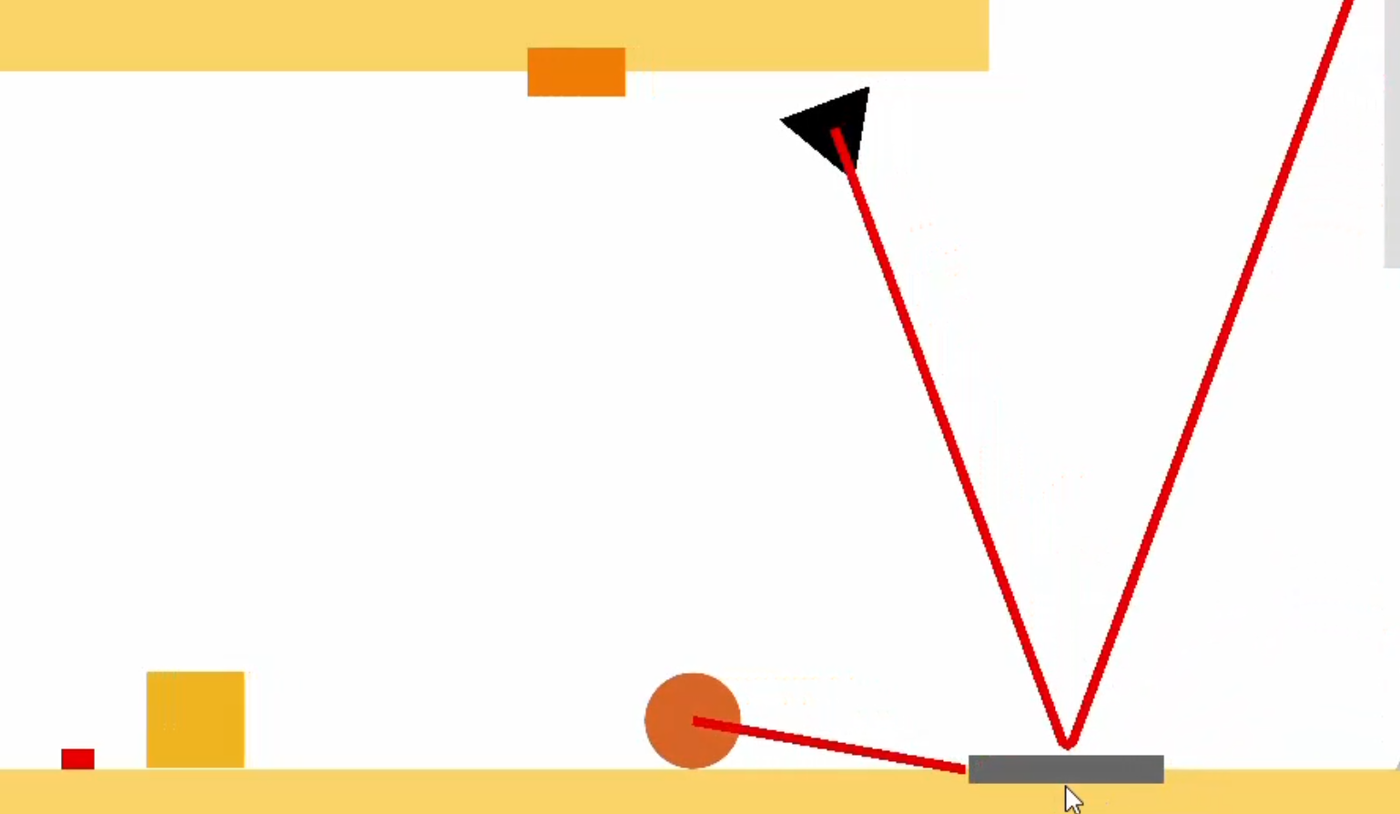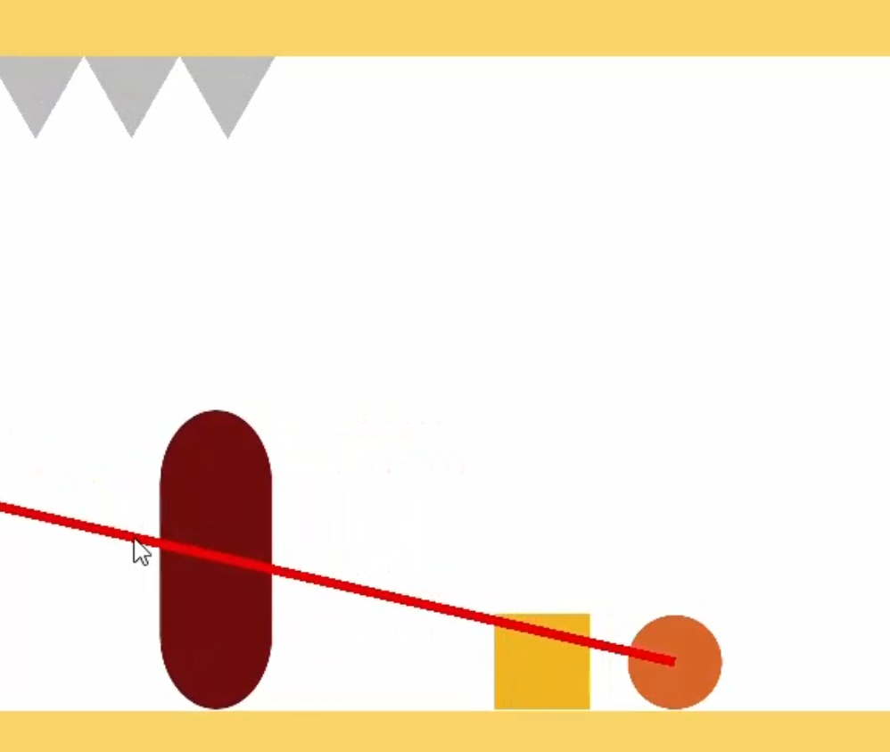

**Week-8 (3/4-3/10):**

* Shortened level 0 as tutorial level
* Small fixes:
  + Created prefabs for common gameObjects
  + Increased box masses to help with box maneuverability
  + No longer can create mirrors through a mirror reflection
  + Fixed camera follow for when player respawns
  + Removed active portals when player respawns
  + Fixed speed threshold for killing red enemy
* Fixed red enemy to change color accordingly after each hit
* Updated UI and timer
* Created baseline game analytic collection
* Created data visualization for the first analytic
* Implemented new enemy capture mechanic
* Adjusted level 1 to accommodate all new changes
* Updated and researched 2 new game mechanics to replace incorrect ones according to feedback
* Added a preview camera for out-of-sight aiming point when using a mirror

Main Menu (with Controls):

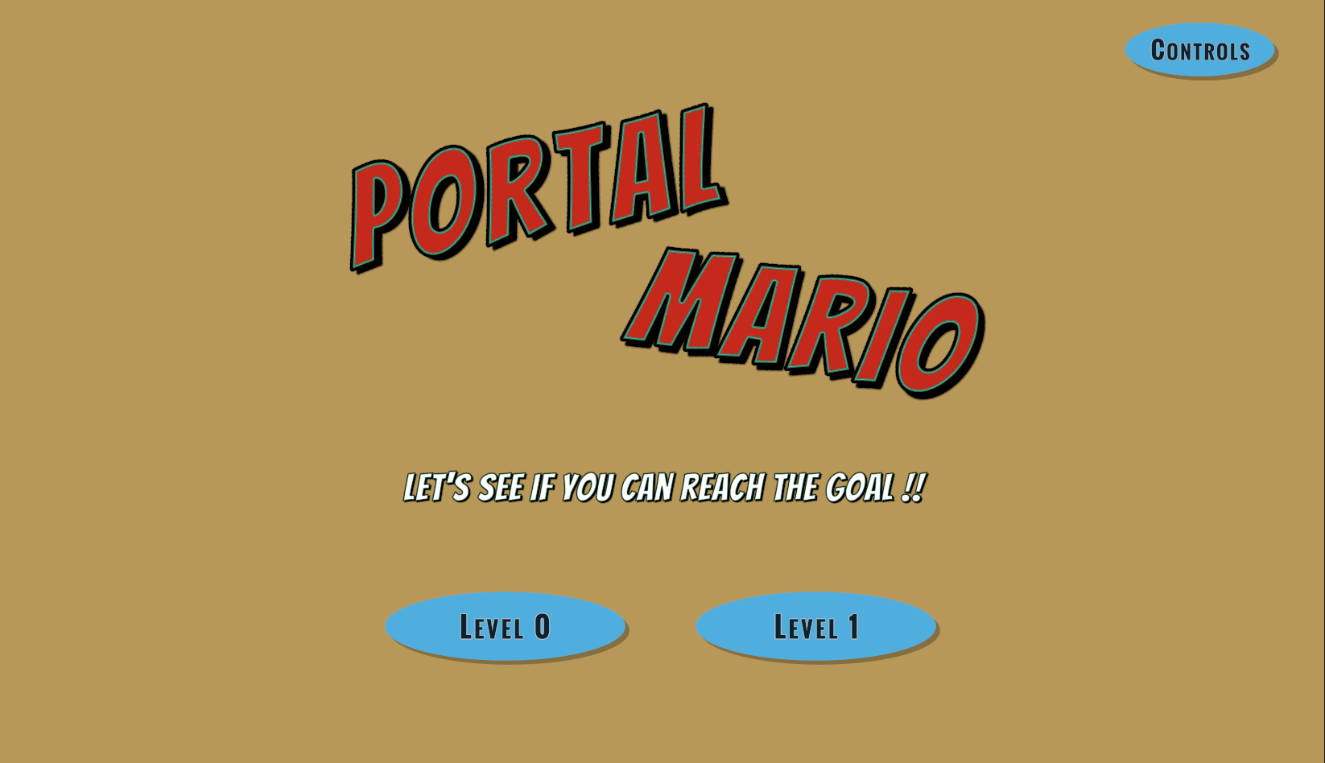

Game Controls Menu:

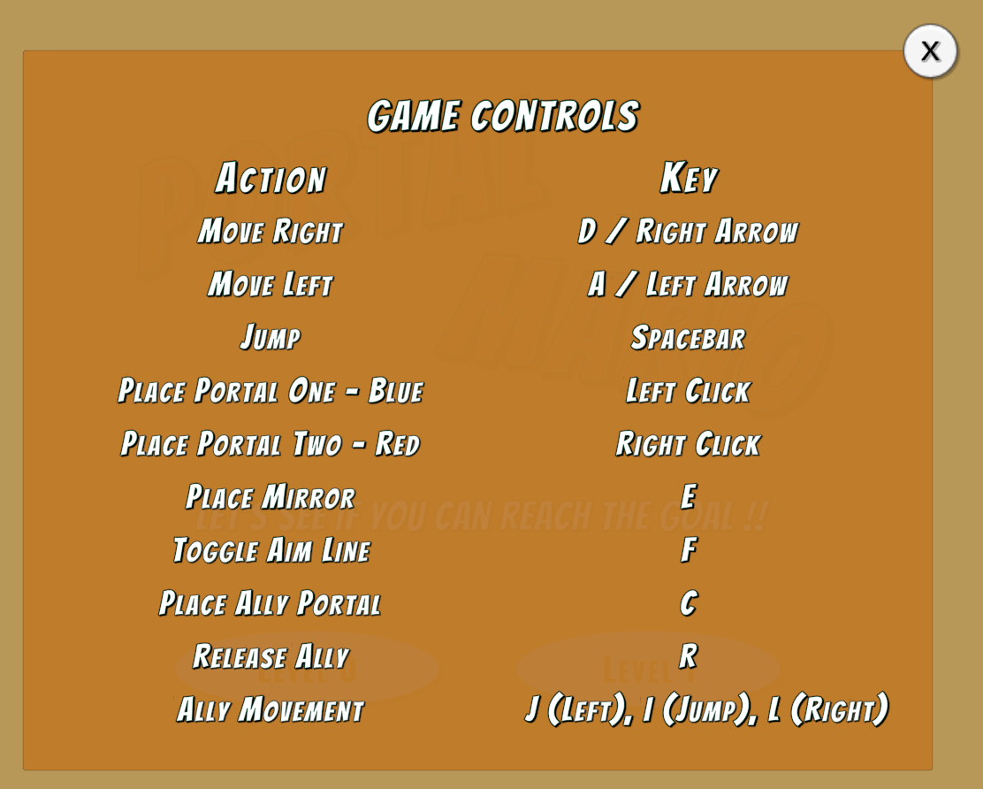

Level 1 Design:



Ally Portal:

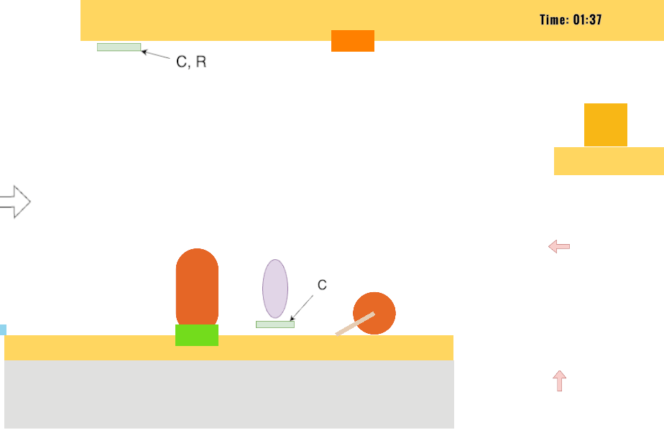

**Week-9 (3/11-3/17):**

* Brainstorming due to alpha prototype feedback
  + Created first draft of tutorial  
    
  + How to make levels easier
  + Adjust game analytic collection
  + Pause menu mechanics
* Fix wall climbing
* Fix null exceptions in FirebaseManager, RedEnemy tags, and box-killing of purple enemies

**Week-10 (3/18-3/24):**

* Spring break

**Week-11 (3/25-3/31):**

* Adjustments for visibility of gameobjects etc
  + Adjust aspect ratio and instruction placement
  + Adjust camera-min
* Add zero friction material to prevent player sticking to walls
* Create new prefabs
* Preventing out-of-sight portals
* General bug fixes
* Stop line of sight at spikes and lasers  
  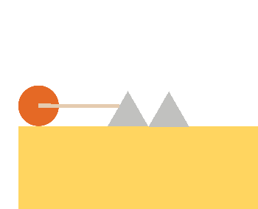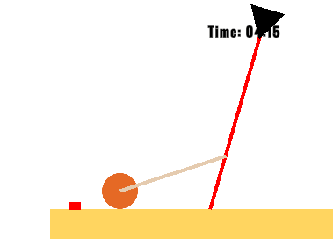
* UI
  + lvl1&2 completion scenes  
    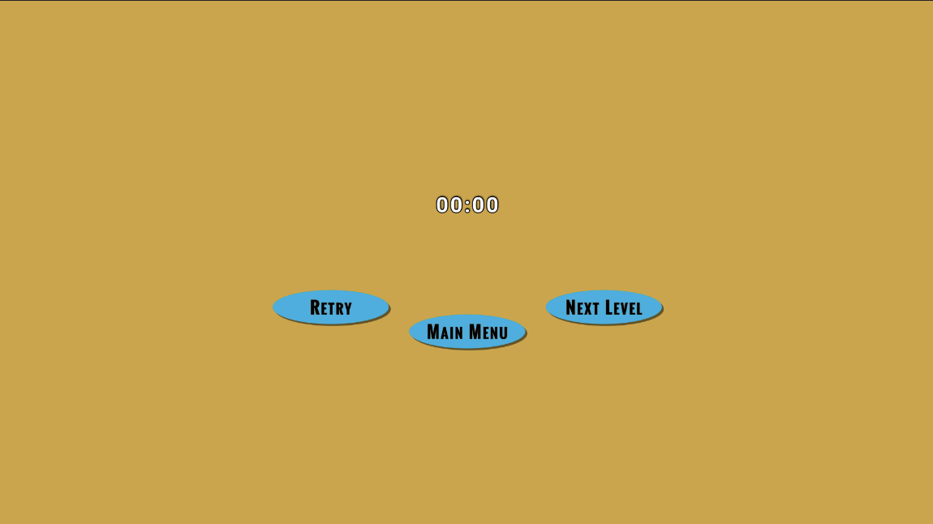
  + Pause menu for lvl0
* Create tutorial level  
  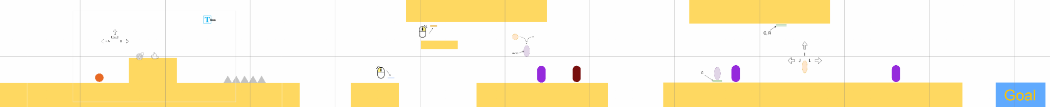
* Adjust level hierarchy due to addition of tutorial (and adjusted numbering for firebase)
* Analytics
  + Brainstormed fixes and adjustments due to alpha feedback on planned analytics

**Week-12 (4/1-4/7):**

* Tutorial changes
  + Split tutorial into two levels because ally mechanic is complicated
  + Added collectibles that signify gaining access to certain guns
  + 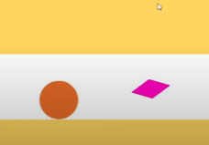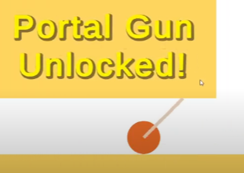
  + Add animations and text popups to lead player
  + 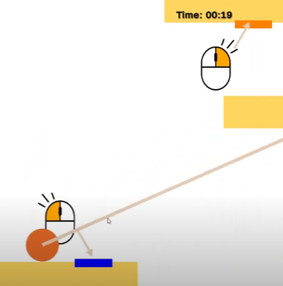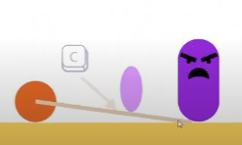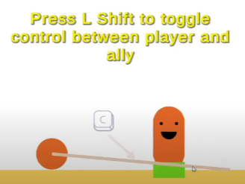
* UI Changes
  + Changed UI screens according to the level layout changes  
    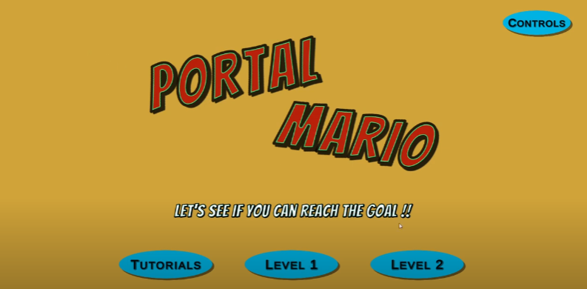
  + Include a tutorial menu  
    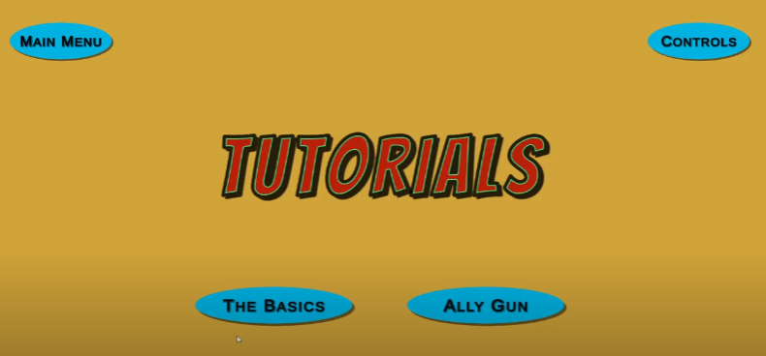
  + Added full pause button functionality  
    **
* Ally changes
  + Changed ally mechanic so that Left Shift is used to toggle between player and ally
  + Disable linerenderer while the player is not active
  + Add faces to ally and enemy to more clearly show difference  
    
  + Ally damages red enemy partially
  + Ally stays alive even when player dies
* Bounce effect for when hitting enemies on the head
* Made the goal a no portal zone
* Bugs/gameplay improvements:
  + Breakable glass platform respawns with player respawn
  + Portal creation on and under spikes bug fixed
  + Add W for jump
  + Refactor take damage for better metric collection
* Metrics
  + Adjust firebase to accommodate our newly defined metrics
  + Adjust data extraction to csv file script
  + Create data visualization pipelines for each of the metrics

**Week-13 (4/8-4/14):**

* Create hint zones that will reveal hints after the player spends a certain amount of time in the hint zone to help progression
* Add hint prefab for hint zones  
  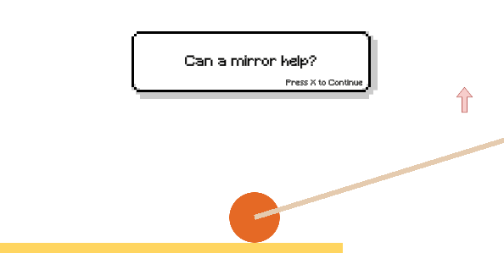
* Add checkpoints  
  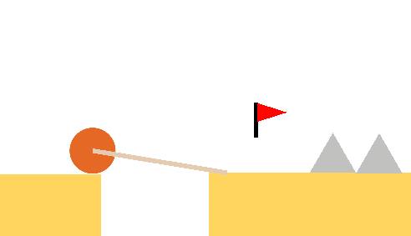
* Disable portals/allies/mirror until they’re introduced
* Miscellaneous bugs
  + Analytics buts
  + Font size for completion text
  + Controls menu
  + Add trap walls
  + Remove green portal on respawn
  + Decrease spike size
  + Enemy flying bug on ally tutorial

**Week-14 (4/15-4/21):**

* Adjust all graphics to be animations
* Change mirror tutorialization to match tutorial’s tutorialization  
    
  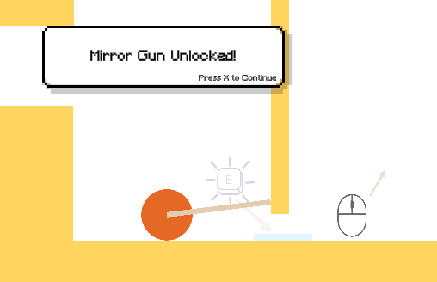
* Add hints to puzzles where players are getting stuck
* Change aesthetic of checkpoint  
  
* Make camera follow ally if ally is being controlled
* Add Ally HUD  
  
* Miscellaneous bugs and small changes
  + Decrease enemy speed
  + Stop mirror creation on traps
  + Remove portal and mirror from breakable platform when it disappears
  + Adjust hit boxes
  + Ally dies by laser
  + Ally can jump off head of player
  + Ally portal can’t be created out of bounds

**Week-15 (4/22-4/28):**

* Update data visualization
* ESC button can be clicked as well
* Decrease size of spikes
* Portals can be removed by clicking on them
* Hints are smaller
* Hint jitter that results from following player is fixed
* Dismiss hints with X
* Hints more concise
* Optional Hinting employed (press x to reveal)  
  
* Add animation for sucking up and release ally  
  
* Miscellaneous Bugs
  + Fix laser reflection bug
  + Fix infinite jumping of ally bug in ally tutorial
  + Adjust animation opacity

# Weekly Progress

| **Week Number** | **Team Member** | |
| --- | --- | --- |
| **Week 6** | **Nimit Sandeep** | **Jack Lin** |
| Researched adding time mechanic  Managed the team and kept the team engaged with each other through meetings and expressing their thoughts on the game. | Researched portal mechanic |
| **Harsh Modi** | **Aditya Rouniyar** |
| Researched contact based combat mechanic | Researched Laser Mechanic |
| **Zhouhang Qin** | **Mina Sung** |
| Design and reflect on the feedback loop of existing mechanism combinations. to support a more emergent gameplay experience.  Enemy teleporting  [fc761e3](https://github.com/CSCI-526-Spring-2025/csci-526-final-project-team-glados/commit/fc761e32a7054349fec404ed3668659b9b558b14) | Researched ricochet bullet mechanic |
| **Week 7**  **(2/25-3/3)** | **Nimit Sandeep** | **Jack Lin** |
| Glass Platform  [43e9a21](https://github.com/CSCI-526-Spring-2025/csci-526-final-project-team-glados/commit/43e9a216fdf045908c51d833b496c0fd2c43920c) | Level Design  [5e4f0db](https://github.com/CSCI-526-Spring-2025/csci-526-final-project-team-glados/commit/5e4f0dbdfec9b33dbe0e1912b330441bf1e856fd)  [ef4148b](https://github.com/CSCI-526-Spring-2025/csci-526-final-project-team-glados/commit/ef4148bbc9d2df0a1bfed0b3ce2bf998320ac9b5) |
| **Harsh Modi** | **Aditya Rouniyar** |
| Main Menu & Timer  [3252d8c](https://github.com/CSCI-526-Spring-2025/csci-526-final-project-team-glados/commit/3252d8cc2fabfbf8ba4cabd94ce2d48c92df6bfb),  [04b54db](https://github.com/CSCI-526-Spring-2025/csci-526-final-project-team-glados/commit/04b54dbc1681e9b1d13fb9d7928a9cd5bafada5e),  [99b32f1](https://github.com/CSCI-526-Spring-2025/csci-526-final-project-team-glados/commit/99b32f1dbec4efffb535083ef2f575764acc2512) | Red Enemy Prefab  [C8311bb](https://github.com/CSCI-526-Spring-2025/csci-526-final-project-team-glados/commit/c8311bb84820217dc933b47db6ea96a07510fb10)  Red Enemy kill script  [D06b0c4](https://github.com/CSCI-526-Spring-2025/csci-526-final-project-team-glados/commit/d06b0c4f160c12b6d4ca0947f350a11a54f7a42b)  [9d88a8](https://github.com/CSCI-526-Spring-2025/csci-526-final-project-team-glados/commit/9d88a8a977613708815bf91d875f1c0b069a1d5e) |
| **Zhouhang Qin** | **Mina Sung** |
| Shooting mirror;  [4cb03c5](https://github.com/CSCI-526-Spring-2025/csci-526-final-project-team-glados/commit/4cb03c52b4697862bdfc944061c0d9f8efa75c91)  Adjusted the mirror attachment mechanism and added interaction features between lasers and entities  [904785eb02ae9cf37c825abe8d48740da1f5c0e7](https://github.com/CSCI-526-Spring-2025/csci-526-final-project-team-glados/pull/5/commits/904785eb02ae9cf37c825abe8d48740da1f5c0e7) | Line of sight reflects on mirrors  [c881921](https://github.com/CSCI-526-Spring-2025/csci-526-final-project-team-glados/commit/c8819216524491603a5ee48ca945b54f70b0ea9e)  Init laser functionality with button controls  [a8ddfec](https://github.com/CSCI-526-Spring-2025/csci-526-final-project-team-glados/commit/a8ddfecc11ce709e79cc2cf54a3d54c4f401ee5c) |
| **Week 8**  **(3/3-3/10)** | **Nimit Sandeep** | **Jack Lin** |
| Updated level 1 design: [82adae9](https://github.com/CSCI-526-Spring-2025/csci-526-final-project-team-glados/commit/82adae90b714e9344632172d64358bfe15c7b9b3) [105c1d5](https://github.com/CSCI-526-Spring-2025/csci-526-final-project-team-glados/commit/105c1d524cb2a13adb2e927cddd77f726e631ec9)  Created glass prefab and prevent wall climbing: [c123e54](https://github.com/CSCI-526-Spring-2025/csci-526-final-project-team-glados/commit/c123e54f2b0e48eb12126dcbdcd21c3691397822)  Added instructions for lvl 1 & controls menu modified:  [9afc221](https://github.com/CSCI-526-Spring-2025/csci-526-final-project-team-glados/commit/9afc221870d7ff6dda0f376d60a0e95a73366bd7) [892d148](https://github.com/CSCI-526-Spring-2025/csci-526-final-project-team-glados/commit/892d14871999b116ce843276d591b7ce2e2ab116) | Update level 0 design:  [Ded6e8a](https://github.com/CSCI-526-Spring-2025/csci-526-final-project-team-glados/commit/ded6e8ac3fb3c7ecf1c852025cbcba6df4b768cb)  Add a preview camera for out-of-sight aiming point:  [A98bc5d](https://github.com/CSCI-526-Spring-2025/csci-526-final-project-team-glados/commit/a98bc5d12076986abc85250b69f10872b3148a2e)  Send data to firebase when player respawns:  [6b47b53](https://github.com/CSCI-526-Spring-2025/csci-526-final-project-team-glados/commit/6b47b5335e5fcb74e05d60805dba559180130d2c), |
| **Harsh Modi** | **Aditya Rouniyar** |
| Fix UI and timer  [5246cd8](https://github.com/CSCI-526-Spring-2025/csci-526-final-project-team-glados/commit/5246cd8a010b6357a2b23c16ad8b1e8db3df067e)  Implement data analytics  [*6630a0a*](https://github.com/CSCI-526-Spring-2025/csci-526-final-project-team-glados/commit/6630a0ae9b0cfb25907b166ee544d3bc7c20ca6f)*,* [*a4696f5*](https://github.com/CSCI-526-Spring-2025/csci-526-final-project-team-glados/commit/a4696f5bccef86a53b6896e0218182ece8a54a74) | Change color for RedEnemy  [5eabeec](https://github.com/CSCI-526-Spring-2025/csci-526-final-project-team-glados/commit/5eabeecdd8070a96b0575c9c3930ad5b74e99e2e)  Adding the 3 box hit to kill the enemy  [Ffac763](https://github.com/CSCI-526-Spring-2025/csci-526-final-project-team-glados/commit/ffac763e802e895018fafa8a897eed16a606ba9c)  Adding the Tag to the Red enemy [83ed905](https://github.com/CSCI-526-Spring-2025/csci-526-final-project-team-glados/commit/83ed9057839fb2a1b10815733cf3f026b2c1ceca) |
| **Zhouhang Qin** | **Mina Sung** |
| Fixed shooting issues like shooting through laser  [dad2066](https://github.com/CSCI-526-Spring-2025/csci-526-final-project-team-glados/commit/dad2066c2dcde04e37128aca77a27b47abc5c04f)  Designed and implemented gun that can capture entities  [f4a692e](https://github.com/CSCI-526-Spring-2025/csci-526-final-project-team-glados/commit/f4a692e8cf7111317b7c87afc9512d0367d1374e)  Designed and implemented ally system  [*Df14e82*](https://github.com/CSCI-526-Spring-2025/csci-526-final-project-team-glados/commit/df14e8231e75974e17414330963cfbe20fb06fad)  [a79c4cd](https://github.com/CSCI-526-Spring-2025/csci-526-final-project-team-glados/commit/a79c4cd0d43cc692f12aff48026424f5d457f05b) | Created prefabs for common gameObjects, increased box masses to help with box maneuverability, disabled creation of mirrors through mirror reflection, fixed camera follow for when player respawns, remove active portals when player respawns  [F767531](https://github.com/CSCI-526-Spring-2025/csci-526-final-project-team-glados/commit/f76753138c99c1002cfcaad939a3b93abb883b63)  First data visualization code  [1157564](https://github.com/CSCI-526-Spring-2025/csci-526-final-project-team-glados/commit/11575646304ba83072c84ce4c929fde7021937e3) |
| **Week 9 (3/11-3/17)** | **Nimit Sandeep** | **Jack Lin** |
| Brainstormed how to make levels easier due to playtest feedback | Fix null exception caused by FirebaseManager  [273209e](https://github.com/CSCI-526-Spring-2025/csci-526-final-project-team-glados/commit/273209ea346f8d060b283f31ad5a2b24db4363ac)  Fix RedEnemy tags  [Afab1b6](https://github.com/CSCI-526-Spring-2025/csci-526-final-project-team-glados/commit/afab1b6a7009ee0bccd6074cab7879cf002914d5)  Fix box-killing of purple enemy  [d6d758e](https://github.com/CSCI-526-Spring-2025/csci-526-final-project-team-glados/commit/d6d758ec8bc3915d35e2806ca756c289a914cfc7) |
| **Harsh Modi** | **Aditya Rouniyar** |
| Brainstormed game analytics | Worked through pause menu mechanics |
| **Zhouhang Qin** | **Mina Sung** |
| Fix wall climbing  [28ec377](https://github.com/CSCI-526-Spring-2025/csci-526-final-project-team-glados/commit/28ec3777321544337b62c9017d2ab95b7e631c8a) | Brainstormed and developed tutorial |
| **Week 10**  **(3/18-3/24)** | **Nimit Sandeep** | **Jack Lin** |
| Spring break, no commits | Spring break, no commits |
| **Harsh Modi** | **Aditya Rouniyar** |
| Spring break, no commits | Spring break, no commits |
| **Zhouhang Qin** | **Mina Sung** |
| Spring break, no commits | Spring break, no commits |
| **Week 11**  **(3/25-3/31)** | **Nimit Sandeep** | **Jack Lin** |
| Change aspect ratio of lvl0 camera and instruction placement  [7a34ead](https://github.com/CSCI-526-Spring-2025/csci-526-final-project-team-glados/commit/7a34ead8f7669bd95e998ce619a6c5a9fb4323e1)  added new 2d material zerofriction to prevent sticking of players on side walls, created new prefabs for easier usage during game design  [83bd6d9](https://github.com/CSCI-526-Spring-2025/csci-526-final-project-team-glados/commit/83bd6d93db5640832cda2a05d57bb44b581d0126) | Don’t allow out-of-sight portals, fix lvl 0 bugs  [D57f9bd](https://github.com/CSCI-526-Spring-2025/csci-526-final-project-team-glados/commit/d57f9bdb6e5a6441ed1ada9e705d556ae69a9a29)  Adjust CameraMinX in lvl2  [63e0058](https://github.com/CSCI-526-Spring-2025/csci-526-final-project-team-glados/commit/63e00585f9624c9ad07863c48ab5751573abe304) |
| **Harsh Modi** | **Aditya Rouniyar** |
| Update lvl0 and lvl1 completion scenes  [7d67553](https://github.com/CSCI-526-Spring-2025/csci-526-final-project-team-glados/commit/7d67553b509cf302e15fab7a53fa6e91a72c1b2a)  Started working on Data Collection for KeyPressData and Death Reason of Player.  [4488311](https://github.com/CSCI-526-Spring-2025/csci-526-final-project-team-glados/commit/4488311b747e46ab908cf79f1104782ad2eee6f4) | Added PauseMenu in levels  [fdf1a25](https://github.com/CSCI-526-Spring-2025/csci-526-final-project-team-glados/commit/fdf1a25d0cef031114140eaa2c32a79ffac2d6d1) |
| **Zhouhang Qin** | **Mina Sung** |
| Stop line of sight at spikes and lasers  [92c9a95](https://github.com/CSCI-526-Spring-2025/csci-526-final-project-team-glados/commit/92c9a956c57ce743f144d104d051e5e575fd042e)  Make sure that only creatures can be captured  [19d583d](https://github.com/CSCI-526-Spring-2025/csci-526-final-project-team-glados/commit/19d583d9e8f5f214001f5eac33301d4c59f1b7bf)  Ally is immune to the laser  [Bbfd585](https://github.com/CSCI-526-Spring-2025/csci-526-final-project-team-glados/commit/bbfd58533bc9e6d326b25a9965ddba623b51c3aa) | Created tutorial level  [e116438](https://github.com/CSCI-526-Spring-2025/csci-526-final-project-team-glados/commit/e116438c8fc50579d951b0861eaa4d67d7b8e454)  Update player material in all levels to prevent sticking; update level numbering to 0, 1, 2; Add tutorial goal trigger; change instruction images to match level progression; Add tutorial button on main menu; fixed button logic due to changing level numbers  [13f3c6d](https://github.com/CSCI-526-Spring-2025/csci-526-final-project-team-glados/commit/13f3c6da32f022ff2aed2cb14f113d62dce88b8f)  Add red enemy to tutorial  [546aaaa](https://github.com/CSCI-526-Spring-2025/csci-526-final-project-team-glados/commit/546aaaacc6bf3450c1a958a922496490398bb4cc) |
| **Week 12**  **(4/1-4/7)** | **Nimit Sandeep** | **Jack Lin** |
| breakable glass platform respawn with player respawn implemented, some lvl and ui changes based on gameplay feedback [4901878](https://github.com/CSCI-526-Spring-2025/csci-526-final-project-team-glados/commit/49018788d983f046c00502e15abaec349bfd82cc)  object reference error fixed in playercontroller, portal creation on and under spikes bug fixed, trapground prefab created [c6b18b0](https://github.com/CSCI-526-Spring-2025/csci-526-final-project-team-glados/commit/c6b18b00889ffce5d6ee790fa33c40c75ff30c9d)  bounce effect created when enemy is hit on head by player [6655455](https://github.com/CSCI-526-Spring-2025/csci-526-final-project-team-glados/commit/665545563357d0a0d91bd056414af2462193584b)  enemy ally conversion face bug fix, ally portal creation disabled on spikes, ui fixes, arrow key bindings removed from both player ally, w added for jump in ally [d4d659e](https://github.com/CSCI-526-Spring-2025/csci-526-final-project-team-glados/commit/d4d659e31a7e8500187c14e1e413321068cd48c3) | Refactor TakeDamage to avoid repeating data collection [e1fbdd8](https://github.com/CSCI-526-Spring-2025/csci-526-final-project-team-glados/commit/e1fbdd88e0e0885c8a703b4be26328344d1d94e9), [836bff2](https://github.com/CSCI-526-Spring-2025/csci-526-final-project-team-glados/commit/836bff20be7c16029049889f3d36f769b188b755)  Add angry face to make enemy more obvious to recognize [99edee9](https://github.com/CSCI-526-Spring-2025/csci-526-final-project-team-glados/commit/99edee9e4ef9acb44448d8bdaa178b5c00bf453a)  Help L Shift toggling work and migrate all the conflicts of new features and new scenes [101bfae](https://github.com/CSCI-526-Spring-2025/csci-526-final-project-team-glados/commit/101bfaebdc3cf84a7ea46fe24583696c3f57e376), [46f613c](https://github.com/CSCI-526-Spring-2025/csci-526-final-project-team-glados/commit/46f613c47179d52e105168d557d6b2482fa7a947)  Add python script to draw portal metrics bar charts [9696cf5](https://github.com/CSCI-526-Spring-2025/csci-526-final-project-team-glados/commit/9696cf58b8625f6e060b4e1f58f5a5ab00f3fd82)  Add python script to draw enemy_kill metrics bar chart and scatter plots [cfb17b2](https://github.com/CSCI-526-Spring-2025/csci-526-final-project-team-glados/commit/cfb17b25f91b92274cbe3c2262035f4f6f17aa14) |
| **Harsh Modi** | **Aditya Rouniyar** |
| Added Data Collection for logging killing of Enemy, Portal Usage, Main Menu Preference  [619f278](https://github.com/CSCI-526-Spring-2025/csci-526-final-project-team-glados/commit/619f278f013bee2b5ee07c5bcd44876f83b315e0), [5860f78](https://github.com/CSCI-526-Spring-2025/csci-526-final-project-team-glados/commit/5860f786730b0eb526dc971caa59f03616fc1520)  Worked on Data Extraction and conversion to csv file from Firebase Database  [0e1545b](https://github.com/CSCI-526-Spring-2025/csci-526-final-project-team-glados/commit/0e1545be49287acb1ad69b3eb63118ffbdbf2b6b)  Improvements in UI for Level Completions and Main Menu  [27fdcc9](https://github.com/CSCI-526-Spring-2025/csci-526-final-project-team-glados/commit/27fdcc957b4c0126d2922f77409914fcedf332fd), [f6e89ef](https://github.com/CSCI-526-Spring-2025/csci-526-final-project-team-glados/commit/f6e89ef8f4e8aa894ca83f22b71871cd5ec0458a)  Fixed Bugs related to Analytics  [1d5076d](https://github.com/CSCI-526-Spring-2025/csci-526-final-project-team-glados/commit/1d5076d1b06dc099b469cf2b216e22cc467e8321), [a647793](https://github.com/CSCI-526-Spring-2025/csci-526-final-project-team-glados/commit/a6477937fc1a3eb6a04b95e90970e3fcb7f1d945)  Worked on Data Preprocessing and Data VIsualization for two metrics  [8c4a593](https://github.com/CSCI-526-Spring-2025/csci-526-final-project-team-glados/commit/8c4a593c2a661c13fc20ce457bee7b134db8410e) | Added the Pause Menu to the Updated Levels in the game  Fixed the Pause menu bugs [Da74ef3](https://github.com/CSCI-526-Spring-2025/csci-526-final-project-team-glados/commit/da74ef34b0592e72f7d2d6abe3a7175943ed6516), [D597f29](https://github.com/CSCI-526-Spring-2025/csci-526-final-project-team-glados/commit/d597f29dc596208cfd9c62b36e586f67674f02d6), [6e05b7f](https://github.com/CSCI-526-Spring-2025/csci-526-final-project-team-glados/commit/6e05b7f8a41b06c00f7bee33217c6b2860e8fcb0)  Added another way to jump [7529850](https://github.com/CSCI-526-Spring-2025/csci-526-final-project-team-glados/commit/75298509235f4e1d4bec2805a19d5b0ff8c681ac)  Made the goal gameobject a no portal zone [c6ce731](https://github.com/CSCI-526-Spring-2025/csci-526-final-project-team-glados/commit/c6ce73119eedc665d75472ff530dce341a84039f) |
| **Zhouhang Qin** | **Mina Sung** |
| fixed bug that if you place the first portal under the player and then the other one elsewhere, the player doesn’t automatically get teleported; implemented the feature that player can directly press C to release ally instead of using both C and R  [4639335](https://github.com/CSCI-526-Spring-2025/csci-526-final-project-team-glados/commit/4639335f2e62a86d877d8f79353eb0739d8c023d)  Ally damage to special red enemy  [050074c](https://github.com/CSCI-526-Spring-2025/csci-526-final-project-team-glados/commit/050074ca85b9b899916d9a64a5df767c4bbdc32f)  Fixed the issue that when ally get released at wall corner  [76a7db5](https://github.com/CSCI-526-Spring-2025/csci-526-final-project-team-glados/commit/76a7db5cc70d0e490812ceb452f859b51a363d5f)  Ally will stay alive and return to the capture portal even when the player dies  [C5f4627](https://github.com/CSCI-526-Spring-2025/csci-526-final-project-team-glados/commit/c5f4627eb40409c6d44c6c01d15c158aef40c280)  Fixed that mirror moves when box collides with it, and that when a mirror is generated on a moving platform  [fff3c86](https://github.com/CSCI-526-Spring-2025/csci-526-final-project-team-glados/commit/fff3c866a15c5a8652c6f1c79878fe68ae5238f9) | Implemented both tutorial levels; Init attempt to manage player/ally switching; Implemented collectible guns and respective popups  [619f278](https://github.com/CSCI-526-Spring-2025/csci-526-final-project-team-glados/commit/e05a3de75283048ded5919f3b941ded4bae10cb3)  Change player material and disable linerenderer when player is not active; Attempt to make player ride the ally while it is inactive  [101bfae](https://github.com/CSCI-526-Spring-2025/csci-526-final-project-team-glados/commit/36de8a4b8c5d5b5228d5ef545addeefc470b0e2c)  Make collectibles spin and changed to more eyecatching color; Animate instruction images; Fix friction so player can ride ally's head; increase popup instructions for ally control  [36de8a4](https://github.com/CSCI-526-Spring-2025/csci-526-final-project-team-glados/commit/71263a40694216644fb5a2a7d7a652834461b3fd)  Changed level UI to accommodate new tutorial menu and 2 tutorials, level end triggers, buttons, etc; Adjust firebase levels to -1, 0, 1, 2  [199b0fd](https://github.com/CSCI-526-Spring-2025/csci-526-final-project-team-glados/commit/317accd23222a839c057d1c32b5a2b7cd1ec6506)  Decrease ally jump force; adjust cage.cs so allies don't keep enemy ai movement while the ally is not being controlled; made second enemy in allyTutorial move over spikes as a hint but add timed popup text in case; fix left shift instruction to show at the ally release time  [036c431](https://github.com/CSCI-526-Spring-2025/csci-526-final-project-team-glados/commit/036c4314c9f85032c82788f9344b454c2badd575) |
| **Week 13**  **(4/8-4/14)** | **Nimit Sandeep** | **Jack Lin** |
| ally tutorial second enemy bug fix of ghost like properties - flying off the map when jump and passing through walls & spike halt bug fixed ; updated lshift toggle instruction for better understanding [aba19a0](https://github.com/CSCI-526-Spring-2025/csci-526-final-project-team-glados/commit/aba19a0c1e2e7046f454fa2819eaf63a7f972fb8) | Add Checkpoints [32e4267](https://github.com/CSCI-526-Spring-2025/csci-526-final-project-team-glados/commit/44c4f634582a6608d39b0c2b7427970978e55af1), [44c4f63](https://github.com/CSCI-526-Spring-2025/csci-526-final-project-team-glados/commit/44c4f634582a6608d39b0c2b7427970978e55af1)  Disable portals/ally/mirror until they’re introduced [186603a](https://github.com/CSCI-526-Spring-2025/csci-526-final-project-team-glados/commit/186603a053608d9bd2f4a2c7e406fb811822183d) |
| **Harsh Modi** | **Aditya Rouniyar** |
| Analyzed survey feedback received from beta;  Brainstormed commonly faced issues by the playtesters while playing the game,  Updated data and graphs from the beta data,  [f3b7d7b](https://github.com/CSCI-526-Spring-2025/csci-526-final-project-team-glados/commit/f3b7d7b40022d1b00a41d0fbbffffd3cb5018db3) | Modified the spikes in levels  [8fc4b04](https://github.com/CSCI-526-Spring-2025/csci-526-final-project-team-glados/commit/8fc4b04983aa38eb55481713218443d0c590106d) |
| **Zhouhang Qin** | **Mina Sung** |
| fixed the bug when initally only one portal is placed  [38502b2](https://github.com/CSCI-526-Spring-2025/csci-526-final-project-team-glados/commit/38502b201fefe1b6bab192a4b0ff275f4d109638)  thin ground layer on ally tutorial  [F83f096](https://github.com/CSCI-526-Spring-2025/csci-526-final-project-team-glados/commit/f83f09671093cda8817e4486e7bc4f3115aab613) | Add hintzone and bubble popup prefab, Instantiate in ally tutorial for validation  [6f286ae](https://github.com/CSCI-526-Spring-2025/csci-526-final-project-team-glados/commit/20c9b20c6acc4d5ff3abda090011f903f61b0b8d), [20c9b20](https://github.com/CSCI-526-Spring-2025/csci-526-final-project-team-glados/commit/cd01cf8b9f0eee96ab8ab2f57c1689b13604c834), [cd01cf8](https://github.com/CSCI-526-Spring-2025/csci-526-final-project-team-glados/commit/cd01cf8b9f0eee96ab8ab2f57c1689b13604c834) |
| **Week 14**  **(4/15-4/21)** | **Nimit Sandeep** | **Jack Lin** |
| lvl1 changes: updated acceleration animation instruction, added boxdrop animation, decreased red enemy speed, added no capture hint for red enemy, added lvl1 ending puzzle hint: [f3da3b0](https://github.com/CSCI-526-Spring-2025/csci-526-final-project-team-glados/commit/f3da3b0c5ec65b5c2af024573a1fd306fdf9f99a)  fixed mirror creation on traps bug, fixed bug where portals and mirror remained after breakable platform disappeared, lvl2: design change to make it pop up visibility friendly, laser overlapped by portal bug fix, updated hitbox of redenemy: [d9467f3](https://github.com/CSCI-526-Spring-2025/csci-526-final-project-team-glados/commit/d9467f3e1ab3c127a818a1559d78f7c69e7dc624)  mirror instruction animation update: [673ec53](https://github.com/CSCI-526-Spring-2025/csci-526-final-project-team-glados/commit/673ec534de6b60e6a50e2df3ffe0d17a515df2d1) | Replace flags with checkpoint areas [13242c3](https://github.com/CSCI-526-Spring-2025/csci-526-final-project-team-glados/commit/13242c3c44dff5f838230c2b071a1a18307ff4ac), [fc6f940](https://github.com/CSCI-526-Spring-2025/csci-526-final-project-team-glados/commit/fc6f9409f319b5e8c31badab05ae4da64f6d36a1)  If the player switches control to the ally, the camera should follow the ally [b706f51](https://github.com/CSCI-526-Spring-2025/csci-526-final-project-team-glados/commit/b706f5134afae4a106b8b56e5e621416f5491b11) |
| **Harsh Modi** | **Aditya Rouniyar** |
| Fixed scalability in level completion scene  [2ea3075](https://github.com/CSCI-526-Spring-2025/csci-526-final-project-team-glados/commit/2ea3075a10b7170dfa2d423f66b226ab357d7c58),  Fixed retry count bug issue for analytics and analyzed dry run for irregular tries to get more understanding  [845f96a](https://github.com/CSCI-526-Spring-2025/csci-526-final-project-team-glados/commit/845f96aa82dc2eb9035d30d847de3d532447849a)  Fixed bugs and updated UI InTutorial levels  [293feec](https://github.com/CSCI-526-Spring-2025/csci-526-final-project-team-glados/commit/293feecb52af8a85b21126e37936796cd7298b95), [6add4c4](https://github.com/CSCI-526-Spring-2025/csci-526-final-project-team-glados/commit/6add4c45df08c6b59a421cf096be0376718dcdf0)  Fixed hint zone location, build issues  [4f7a7ea](https://github.com/CSCI-526-Spring-2025/csci-526-final-project-team-glados/commit/4f7a7ea84645524dbc717670fe30c5ab66065eca), [e071977](https://github.com/CSCI-526-Spring-2025/csci-526-final-project-team-glados/commit/e07197720aaa2223e3dc5fff8317cb9f88ad95c4) | Adding the Ally Indicator in all the levels  [75c1f47](https://github.com/CSCI-526-Spring-2025/csci-526-final-project-team-glados/commit/75c1f47d5a262b7052a6ad2aecf6a0a3bf61f3d7), [e99689d](https://github.com/CSCI-526-Spring-2025/csci-526-final-project-team-glados/commit/e99689d0d56867b8202e154013d25066e08eaf3d), [f20c8b2](https://github.com/CSCI-526-Spring-2025/csci-526-final-project-team-glados/commit/f20c8b2565474f01e89c7cb3ad4ce58aaa69dff4) |
| **Zhouhang Qin** | **Mina Sung** |
| get rid of green portal when respawning; refactor ally capturing code to guarantee the correct destruction  [Bc05741](https://github.com/CSCI-526-Spring-2025/csci-526-final-project-team-glados/commit/bc057419dfe1f92f23f469f879c5f70fcb177434)  show a path after special enemy dies  [D9a8e44](https://github.com/CSCI-526-Spring-2025/csci-526-final-project-team-glados/commit/d9a8e446380556cd4b56aa280199e61c3992d882)  ally portal cannot be created out of bounding  [F127d87](https://github.com/CSCI-526-Spring-2025/csci-526-final-project-team-glados/commit/f127d87cb363ea09baa6c26b66c8f12cf011198f)  ally now can jump off head of player  [14dea54](https://github.com/CSCI-526-Spring-2025/csci-526-final-project-team-glados/commit/14dea546e997f6ffcf6ddc26e7d8902cb391505d) | Finalize hint prefab  [5eed746](https://github.com/CSCI-526-Spring-2025/csci-526-final-project-team-glados/commit/5eed746da2a843a486275e0b7d21b2e9cf6e7c52)  Hint popupmanger created to normalize all text popups to use the same prefab; add explanation to ally tutorials  [44517f3](https://github.com/CSCI-526-Spring-2025/csci-526-final-project-team-glados/commit/44517f354f2a96bcfbd464578d5b938d9c0e70bf)  Add more hintzones, minor level changes, tutorialize mirror to look like the rest of tutorial, adjust animations accordingly  [2c173f0](https://github.com/CSCI-526-Spring-2025/csci-526-final-project-team-glados/commit/2c173f01ecba5e8751bc92da8b90e535d2fce428), [2d43d9a](https://github.com/CSCI-526-Spring-2025/csci-526-final-project-team-glados/commit/2d43d9a44f0679cffc43c67cb6fb57dc1e667c8c), [9797d80](https://github.com/CSCI-526-Spring-2025/csci-526-final-project-team-glados/commit/9797d8055bdc89e709f3b406e792fa580ad6046a), [371faf4](https://github.com/CSCI-526-Spring-2025/csci-526-final-project-team-glados/commit/371faf418240d62040c5348672004899a4f97665)  Fix hintzone and laser intersection issue  [6bb45db](https://github.com/CSCI-526-Spring-2025/csci-526-final-project-team-glados/commit/6bb45db130fbe9764135d3bb0033eecfbb7eba02) |
| **Week 15**  **(4/22-4/28)** | **Nimit Sandeep** | **Jack Lin** |
| fixed infite jumping bug in ally tutorial, fixed hintpop prefab error bug, updated basic tutorial instruction opacity: [fb44092](https://github.com/CSCI-526-Spring-2025/csci-526-final-project-team-glados/commit/fb44092da006f9dd809c1b0254c8286803a0765a)  fixed the laser reflection and killing mechanism, minor lvl design bug fixes: [e7b5b1f](https://github.com/CSCI-526-Spring-2025/csci-526-final-project-team-glados/commit/e7b5b1f10b794c58c45d46bce929f76b4d26f00a) | fix hint jittering by setting player as canvas' parent [a564d48](https://github.com/CSCI-526-Spring-2025/csci-526-final-project-team-glados/commit/a564d48af1fb5ace47e79f0b0647326075750016)  Fix mirror reflection bug and record demo video [f074016](https://github.com/CSCI-526-Spring-2025/csci-526-final-project-team-glados/commit/f074016383d51b7adb5f7aa69032da429a8cfe6c) |
| **Harsh Modi** | **Aditya Rouniyar** |
| Added changes to Visualization  [cbbe687](https://github.com/CSCI-526-Spring-2025/csci-526-final-project-team-glados/commit/cbbe6879cffc90a171fd47ef77080c463ff69650), [fef0f68](https://github.com/CSCI-526-Spring-2025/csci-526-final-project-team-glados/commit/fef0f68a96eb201be9305c5dad08363fe0494000), [7c257ad](https://github.com/CSCI-526-Spring-2025/csci-526-final-project-team-glados/commit/7c257ad46cf87342889222808908ce35de86a6a5), [65069eb](https://github.com/CSCI-526-Spring-2025/csci-526-final-project-team-glados/commit/65060eb7f7d481f9f9a55c35e949583905955125)  Fixed bugs for ally and hint button  [be8b5d4,](https://github.com/CSCI-526-Spring-2025/csci-526-final-project-team-glados/commit/be8b5d4690bf4ad85edd00238e977d2f7f22480b) [4fb9708](https://github.com/CSCI-526-Spring-2025/csci-526-final-project-team-glados/commit/4fb97089603f07c522371e8ee03ce87c3b3e12f3), [c3db4b6](https://github.com/CSCI-526-Spring-2025/csci-526-final-project-team-glados/commit/c3db4b6f47936bbe7545182a162a084e7618ab42)  Updated Database Level (Location) for Firebase  [23b0b78](https://github.com/CSCI-526-Spring-2025/csci-526-final-project-team-glados/commit/23b0b787a6187e6a649e76bcb1cb535d8917f2a7) | Fixed the esc button [9692f71](https://github.com/CSCI-526-Spring-2025/csci-526-final-project-team-glados/commit/9692f7112e066c12ba3384fabef7c7778662bf5d)  Creating and making the portal disappear  [366330e](https://github.com/CSCI-526-Spring-2025/csci-526-final-project-team-glados/commit/366330eee7397f3b4e232cd7fcd169a635e61d39)  Decreasing the spikes height  [B1f8c12](https://github.com/CSCI-526-Spring-2025/csci-526-final-project-team-glados/commit/b1f8c1229e60c41a9dbc66b2539a49aec2a2de9f)  Fixed portal bug  [20641a9](https://github.com/CSCI-526-Spring-2025/csci-526-final-project-team-glados/commit/20641a9845662e59492a19448b523c722b021495)  [E37e7b4](https://github.com/CSCI-526-Spring-2025/csci-526-final-project-team-glados/commit/e37e7b4b5bf5f33bd4f66cbe1b2272119a84602b) |
| **Zhouhang Qin** | **Mina Sung** |
| Press X to show hint  [6ca5198](https://github.com/CSCI-526-Spring-2025/csci-526-final-project-team-glados/commit/6ca51980a49852f34be129e65041fb3633cf141d)  Animation for sucking up and releasing enemy/ally  [370c038](https://github.com/CSCI-526-Spring-2025/csci-526-final-project-team-glados/commit/370c03862d23fa1e0e5ae31ae0b385aca4101db9)  hintbutton prefab adjustment  [57d53a7](https://github.com/CSCI-526-Spring-2025/csci-526-final-project-team-glados/commit/57d53a7e501c4dd8277ae627ad56a9be1763f76e) | Adjust hint size, dismiss key changed to X, make hints shorter and more concise, disable unnecessary hints  [3ceecfc](https://github.com/CSCI-526-Spring-2025/csci-526-final-project-team-glados/commit/3ceecfc340930ef525c6a5a464331262b70e6d9b) |

# Review Notes

*Notes/feedback that you receive from staff and playtesters, as well as possible improvements you could make based on it. It is important that the stenographer makes note of these each week, but other team members should also keep track of incoming feedback.*

**[Alpha Playtest 1 - 03/04/2025]**

* It was difficult to navigate through using the portal. They got confused a lot.
* Adding a back to main menu button
* They were not able to understand the purpose of “F” button
* There should be a way to tell them the laser can kill the monster
* They were not able to understand all the button in the game especially JUMP
* The camera was not able to go back to the exact position it was, it is shifted a little bit forward

**[Alpha Milestone results]**

* In class, professor mentioned to consider having heatmaps of entire player’s movement and portal positions to determine how much time is spent in areas and if extensive time or unnecessary portals are placed this could be problematic with the game design
* Analytics
* 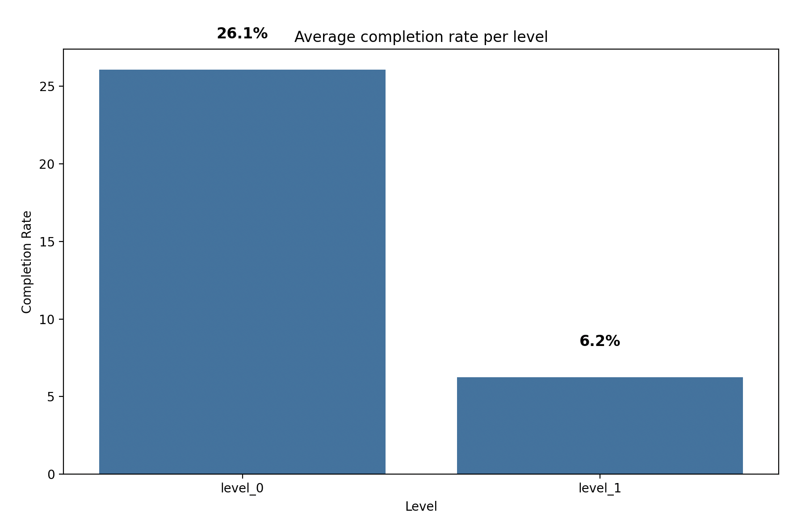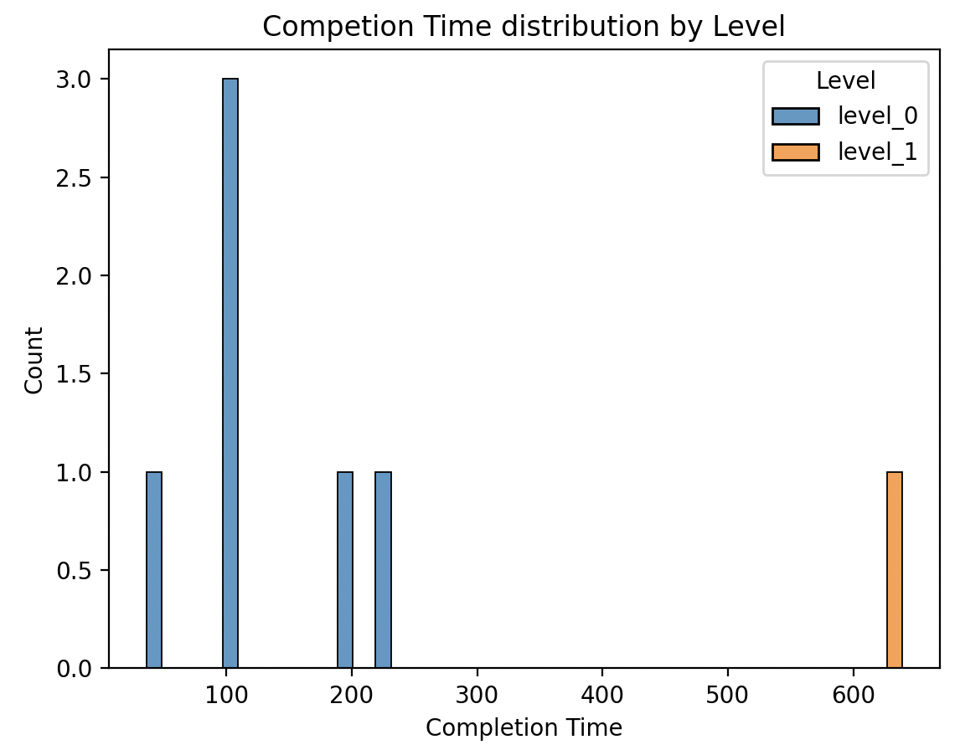

Only 26% of players who attempted level 0 completed it while 6% of players who attempted level 1 completed it. The time it took to complete level 1 was significantly higher than that of level 0.

* 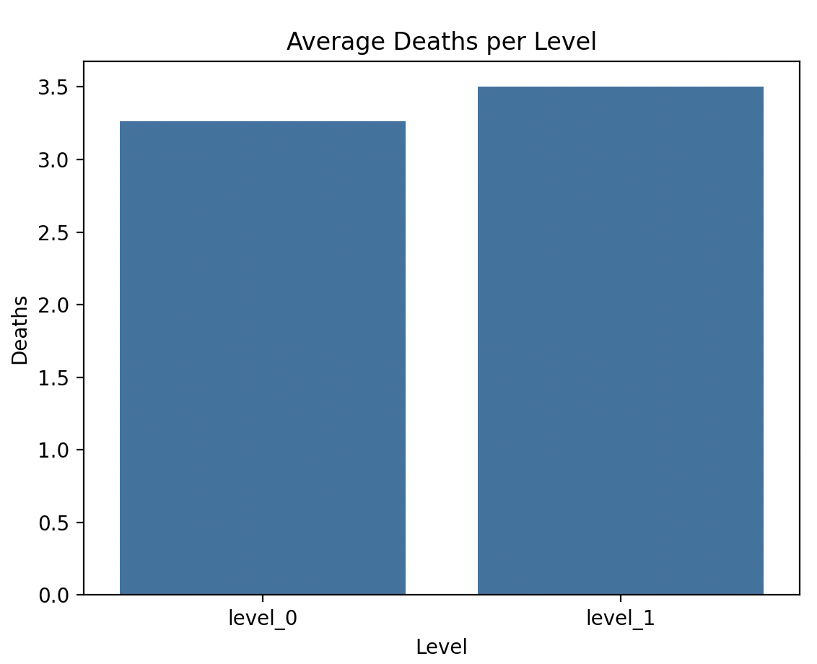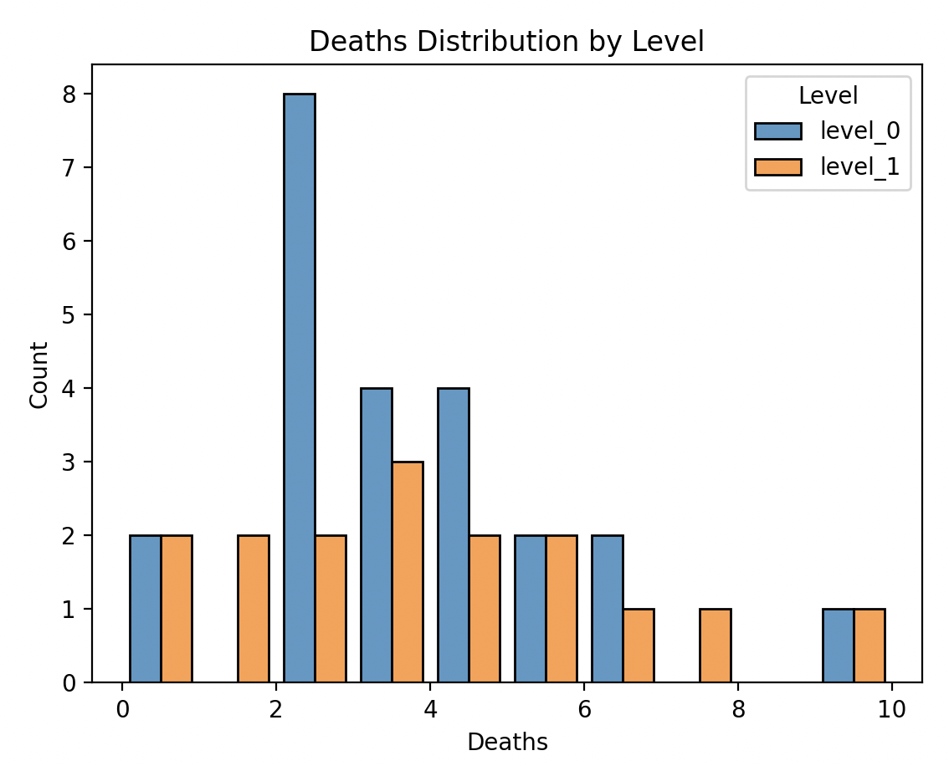
  + Overall, the average number of deaths per level was about equal, hovering around 3 deaths per level.
  + The number of deaths for level zero is more centralized around 3 deaths while for level 1, it is more scattered.
* 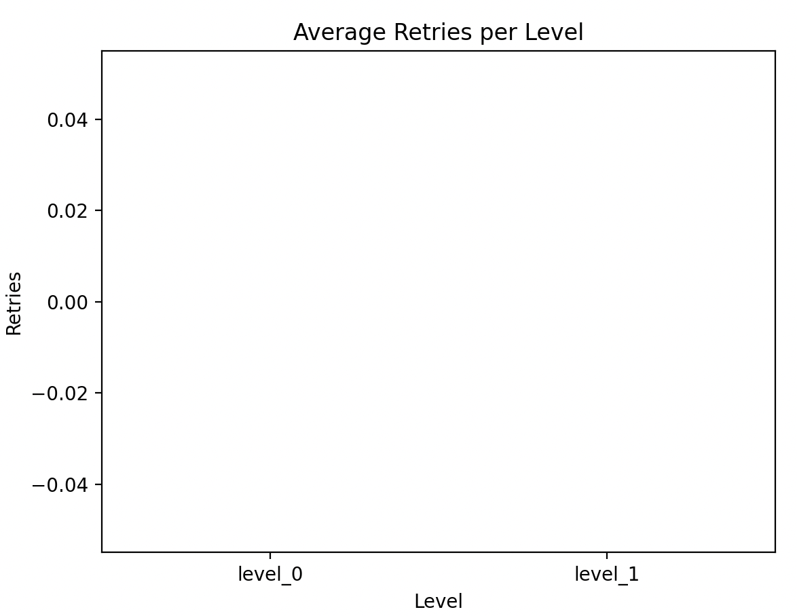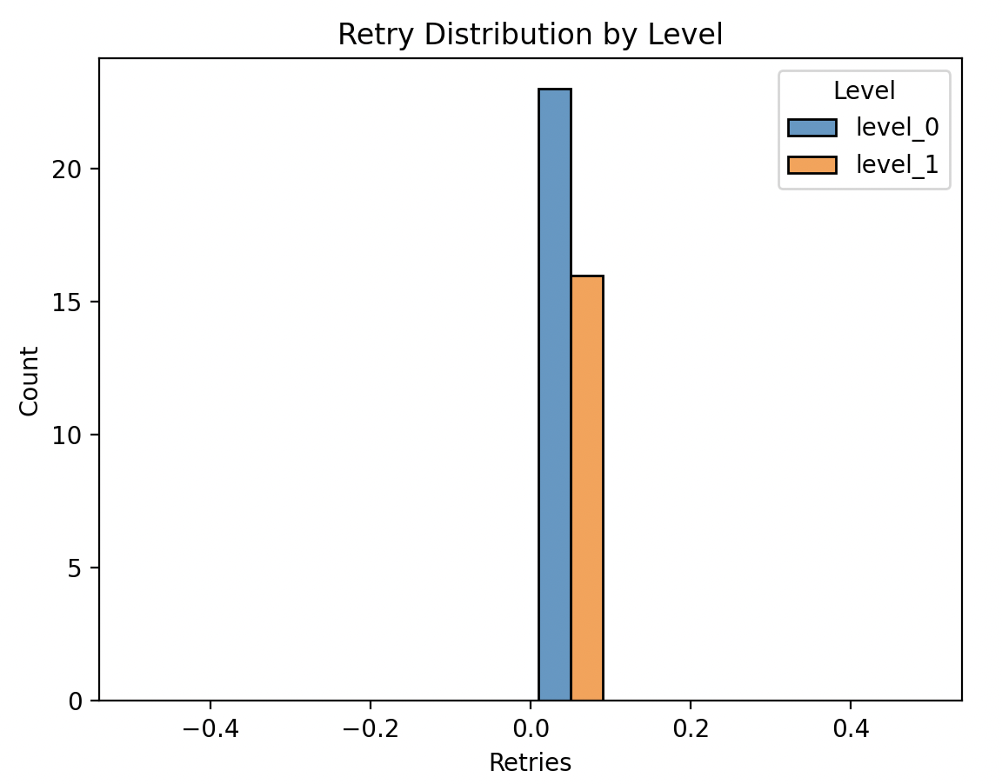
  + No one retried either of the levels. Not as many people attempted level 1.
* Survey
  + How easy was it to learn to play?
    - Very Difficult: 1
    - Somewhat difficult: 4
    - Neutral: 5
    - Somewhat easy: 2
    - Very easy: 0
  + All playtesters said the objective was something along the lines of reach the goal with some other side descriptions
  + Nearly everyone likes the portal mechanic, some like jumping on the heads
  + Portals were also confusing to many people

**[Beta Playtest 1- 03/25/2025]**

* Player were not able to understand how the enemy died
* Control were a little confusing like portal are instantaneous and doesn’t despawn
* There is a problem with the camera where because of the aspect ratio they can’t see the traps so less time to react
* In level 0, you can create a portal on the places not visible
* In level 1, if the box goes through the laser there is not way to get it and it doesn’t respawn so player has to reload the entire game
* The instructions are a bit far so it is hard for the player to focus/see
* There is no instruction that the player can’t create a portal through the laser
* It was harder for the player to identify the box

**[Beta Playtest 2 - 04/01/2025]**

* They were confused with the use case line of sight at the start of the game
* They were confused about how to kill the enemy
* They didn’t understand the art that was used to explain how to kill the enemy
* They couldn’t figure out the ally mechanic in the game
* Since couldn’t figure out the ally mechanic they were confused with C and R
* Similarly they couldn't understand the keys i j k used for
* They were confused if it was a two player or one player game because of the ally mechanics
* They didn’t understand if the purple enemy was enemy or collectible
* There weren’t multiple boxes to play around with to understand the killing of the enemy

**[Staff Feedback]**

* The mirror and the breakable platform have the same color
* The tutorial level should be implemented for players to understand all mechanics
* Additional goal seems to be more challenging than reaching the main goal
* Camera angle doesn’t change with the player or ally

**[Cross Playtest 1 - 04/15/2025]**

* **Lumbros Team Feedback**
  + Created ally before the animation prompt
  + Possibly missed the left shift toggle
  + Suggestions
    - Include text saying that you've captured the
  + Ally movement is not that useful (why would you need to move when you can teleport using the ally portal
  + Had trouble understanding the graphic in level 1 the first time playing
  + Successfully understood acceleration box
  + Ally falls back into portal when it walks over it
  + Difficult to find correct angle for mirror part, can make easier
  + Make smaller spikes on level 2
  + Button layer bad on level 2
* **NoTimeToDebug Team Feedback:**
* Playtester 1
  + Add face to kill enemy animation to make clear
  + Goal
  + Friction between player and ally might need to be fixed
  + Again the ally entering the ally portal when it reenters proximity
  + Include more introduction text
  + “You can only have one ally at a time”
  + Friction is difficult to navigate
  + Need to include a lot of text describing exactly what’s happening with the ally
* Playtester 2
* Teleportation in the tutorial (first part intro of portal) feels little jarring (suggestion: maybe camera pan
* Unable to understand the portal creation image instruction
* C is not disabled in the basics tutorial
* Player doesn’t understand the ally damage mechanism, which lacks instruction
* Kinda hard to understand which one you are controlling, the ally or the player
* Didn't know if they had the ally stored after respawn
* Maybe instead of collectible, keep the checkpoints in form of zones
* He tried to catch Red enemy using ally portal after converting it into purple
* Playtester 3:
* Enemy kill instruction Image felt like a collectible in basic tutorial
* Didn't know what kind of enemies can be converted into allies
* Didn’t understood acceleration Graphics
* She portaled box in front of spikes and she was not able to go ahead
* Image not that clear for mirror instruction
* **Air Jumpers Team Feedback:**
* Playtester 1:
* Captured both enemies without releasing the ally then cannot release even one and both enemies are gone
* Level 1 first enemy feels fast
* Didn't understand what enemies can be converted into ally
* Has to go back to get the ally if the player didnt die and respawn
* Didn't understand that the ally died after colliding with the red enemy
* Didn't understand the acceleration instruction in lvl 1
* Playtester 2:
* Not able to understand the ally mechanics : Got confused
* Green portal taking in the ally when playing makes it confusing
* Ally 1 to kill ally 2 and if they die have to restart in tutorial
* Using ally for everything instead of killing them
* Always use the portal makes it harder to understand if you can push the box
* Game is easier but the lot of features makes it overwhelming
* Playtester 3:
* Player tends to kill enemy when they need ally to go through the spikes in tutorial

* **Sarange and Hate Team Feedback:**
* Playtester 1:
* Right and left click makes it more confusing
* Tutorial Level easier to escape the enemy, need to kill the enemy
* Purple enemy and portal purple makes him confusing
* Animation near the purple instead not a little bit
* L shift to left shift
* More instruction to make the player understand that after toggle you can play the game
* Playtester 2:
* Kind of gets stuck in the loop in basic tutorial when on the right side of blue portal
* Had to use two hands to move and jump
* Enemy kill instruction confusion – felt like a collectible
* Can still create orange portal on tutorial 1 or 2 on goal
* Acceleration tip unclear
* Cant see the laser source in lvl 1 end
* Playtester 3:
* Enemy kill instruction confusion
* In ally tutorial, player tends to capture the last enemy instead of using ally to kill it

**[Cross Playtest 2 - 04/22/2025]**

* **It Takes Six Team Feedback**
* Playtester 1:
* Did not understand the portal instruction and mechanism in tutorial
* The beige line aim line instruction stays unless the player presses space even after moving forward to the enemy kill spot (maybe area too large?)
* Did not understand in one go the enemy kill animation. He thought need to jump over them.. And not kill them?
* The ally in ally tutorial right to the wall came out inverted and as a tall ally
* Did not notice the ally hud
* Good game, nice game. Initially was a bit confusing but otherwise it is a good game
* Playtester 2:
* Cannot understand the jump to kill animation
* Ally can jump continuously
* **InterLInk Team Feedback**
* Playtester 1:
* Recognize the jump to kill animation well
* For last part of level 1, killed the enemy so couldn’t use ally mechanism, but couldn’t find another solutions
* For level 2, the box near the laser is confusing
* **Team Seven Team Feedback**
* Playtester 1:
* Too much information at the spot with laser and box
* Playtester 2:
* Basic tutorial beige aim line hint too big, covers other thing if player doesn't press space
* Ally fly bug in ally tutorial
  + Ally can fly lol
  + Doesn't know who the control belong to a way to make them know which one belong to which after toggle
  + When the ally goes to green it disappear so makes it more confusing
  + Instructions removed after a certain time
  + Jump through the enemy from the animation
  + Someway to disable a portal after a certain time because they forgot they turned it on
* Playtester 3:
* Took time to understand the controls between ally and player (ally tutorial)
* Players forget and don't know the controls even in
* When hint active, space shouldn't jump the player
* Lvl1 hint not visible when player is near the box on the moving platform (near tall enemies)
* Mechanism is interesting. Interesting game
* **Dash of Colors Team Feedback**
* Playtester 1 (with mina):
  + - Opened controls panel from main menu (overwhelmed)
    - Basic Tutorial
      * Confusion between right and left click on portals
      * Understood graphic as jump over the enemy instead of on the head
    - Ally Tutorial
      * Spent a lot of time in a loop between blue and orange portal and ally kept going into ally portal
      * Confused on how to get over first wall, thought portals was the solution
      * Killed enemy, failed to get over spikes
* Playtester 2 (with nimt harsh and qin):
* Basic tutorial: Did not understand the mouse click instructions for portal creation
* Ally tutorial:
  + Killed the enemy instead of capturing it during the capture instruction….
  + Restarted the page itself to retry
  + Killed the enemy even though it said not to kill it
* Lvl 1:
  + Forgot how to teleport
  + Nimit told him to skip lvl 1 further since he was playing too slow and needed lvl 2 data and feedback
* Lvl 2
  + Couldn't understand to push the box to block the laser
  + Lower lvl laser button hidden behind the portal
* Some instructions are solid and some have less opacity

#### 

#### 

#### Hypothesized Issues from Feedback (Gold)

##### Hypothesized Issue #1

Players are getting frustrated after dying late in the level and having to restart from the beginning.

**Description**

Upon dying near the end of a level, players must restart from the very beginning, even after solving most of the puzzles. This lack of mid-level checkpoints leads to visible frustration, discouragement, and in some cases, rage quitting, particularly during late-game challenges.

**Significance**

Reducing player frustration is critical to maintaining engagement. Excessive repetition without meaningful progress risks players quitting mid-game, thus decreasing overall retention. A fair sense of progression and reward is essential for sustaining pacing, flow, and overall enjoyment.

**Feedback/Data Points**

* About 30% (18/69) of surveyed players explicitly stated that adding checkpoints would have significantly improved their gameplay experience.
* 5 players reported frustration at restarting from the beginning after dying near the end of a level, especially in longer or puzzle-heavy stages.
* Out of 100 total tries in Level 1, 80 ended in failure — with 20% of those deaths occurring near the end, including five directly above the goal. These players had to restart from the beginning, and several abandoned the level instead of retrying, resulting in incomplete sessions.
* Analytics from playtesting data showed that players who died within the final 20% of a level (especially Level 1 and Level 2) had a significantly higher quit rate within 15 seconds of respawning (can be seen from the data stored in the database).
* Sessions involving repeated deaths at specific challenges without a checkpoint (as seen in Level 1 and Level 2 data stored in the database) often ended after 2–3 consecutive deaths, suggesting burnout.

**Potential Fixes**

1. Add Static Checkpoints: Place fixed checkpoints before major puzzles in each level to prevent players from redoing entire sections after dying.
2. Dynamic Difficulty Adjustment: If a player dies repeatedly at the same section, slightly increase assistance (e.g., by providing extra boost or high jump or easier spawn to finish that particular puzzle) to reduce frustration.
3. Different Shortcuts Unlock: After repeated deaths in the same puzzle area, dynamically open a small shortcut (e.g., a portal or bridge) that allows the player to skip parts they’re not able to complete with a new simpler puzzle.
4. Checkpoint Gun: Create a mechanic where players can set their own checkpoint once per level or per puzzle to control their retry point.

**Implemented Solution**

We added static checkpoints after major puzzles in each level. This ensures that players do not have to repeat large sections upon dying, preserving their sense of progress and reducing frustration from excessive repetition.

We can test the effectiveness of these changes by tracking quit rates after late-game deaths, measuring retry counts at checkpoints, and surveying player frustration levels compared to pre-implementation data.

To highlight the changes, the following visuals show the player experience before and after implementing checkpoints:

Previous Version: No Checkpoints

In the original level design, no checkpoints were placed throughout the level:

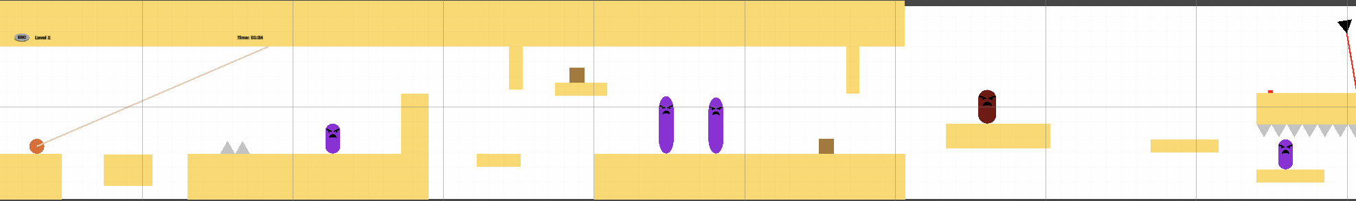

As a result, players who died at any point had to respawn at the very beginning, forcing them to replay the entire level regardless of their progress:

[Checkpoints_Beta Version.mov](https://drive.google.com/file/d/1SSakRdIMfk2Z_EQkA-eAqzlayNy-yHNZ/view?usp=sharing)

Current Version – Checkpoints Added

We have now added static checkpoints at key points in each level. In the example below from Level 1, players respawn closer to the puzzle they were attempting, significantly reducing unnecessary repetition:

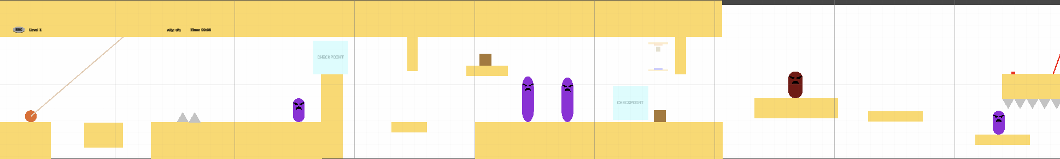

Here, you can see the updated behavior — after dying, the player now respawns at the most recent checkpoint rather than starting over from the beginning:

[Checkpoints_Gold Version.mov](https://drive.google.com/file/d/1kkw7JDOgOZWni_ueRahqngYhMj0L-Dkk/view?usp=sharing)

We believe this change will greatly reduce player frustration, maintain a stronger sense of progress, and create a more enjoyable, focused gameplay experience by allowing players to tackle challenges without the burden of repeating earlier sections.

##### Hypothesized Issue #2

Players struggle to use the portal mechanic comfortably and predictably/instinctively.

**Description**

While the portal mechanic is central to gameplay, many players struggled with orientation and control after traversing portals. Players often accidentally entered portals without intending to, leading to confusion, disorientation, and disruption in puzzle-solving flow. Some players also got stuck in rapid portal loops, where fast transitions between entry and exit portals caused repeated unintended teleportations, further disrupting gameplay and control.

**Significance**

The portal mechanic is a core differentiator of the game, and player comfort with it is critical to delivering a satisfying experience. If players cannot predict portal outcomes or maintain control after using portals, it risks turning an innovative mechanic into a source of confusion and frustration. Repeated unintended portal loops further disrupt gameplay flow, breaking immersion and causing players to lose trust in the mechanic. Mastery, predictability, and intuitive portal use are essential for sustaining puzzle engagement and player satisfaction.

**Feedback/Data points**

* Five players commented that they felt confused after using a portal and often lost track of their position when moving through multiple portals in quick succession.
* 15 players from a total of 69 players from playtesting reported that portals felt “too sensitive,” sometimes triggering unintended teleportation when near them.
* As seen in feedback and playtesting, around 15% players observed getting stuck in fast portal loops, bouncing between portals without regaining proper control.
* Stuck portal usage was observed across levels, with the “Ally Tutorial” level showing 54.8% stuck uses and the “Second Level” showing 36.5%, confirming that portal disorientation was not isolated to one level but was a broader problem.
* Levels with high stuck portal percentages correlated with lower level completion and higher player quit rates, reinforcing that poor portal control impacted progression.

**Potential Fixes**

1. Increase post-traversal momentum slightly to give players more reaction time and reduce instant portal re-entry.
2. Refine portal placement in level design to prevent back-to-back traversals that occur without player control.
3. Add a visual cue, such as a short glow or pulse, before a player teleports to improve anticipation and spatial awareness.
4. Introduce a brief cooldown (~0.2 seconds) on portal reactivation after exit to prevent players from immediately re-entering by accident.
5. Add a short slow-motion effect during portal traversal to help players orient themselves when entering or exiting.

**Implemented Solution**

We implemented a slight vertical momentum boost of 50% after every portal exit to give players more time to stabilize their movement and reduce the chances of accidental re-entry.

We can test the effectiveness of these adjustments by comparing stuck portal usage percentages and fast sequential traversal rates before and after the implementation, and by monitoring level completion and quit rates where portals are used extensively.

To illustrate the change, the following visuals compare player momentum after 11 portal traversals in the previous and current versions of the game:

Previous Version – Momentum After 11 Portal Traversals:

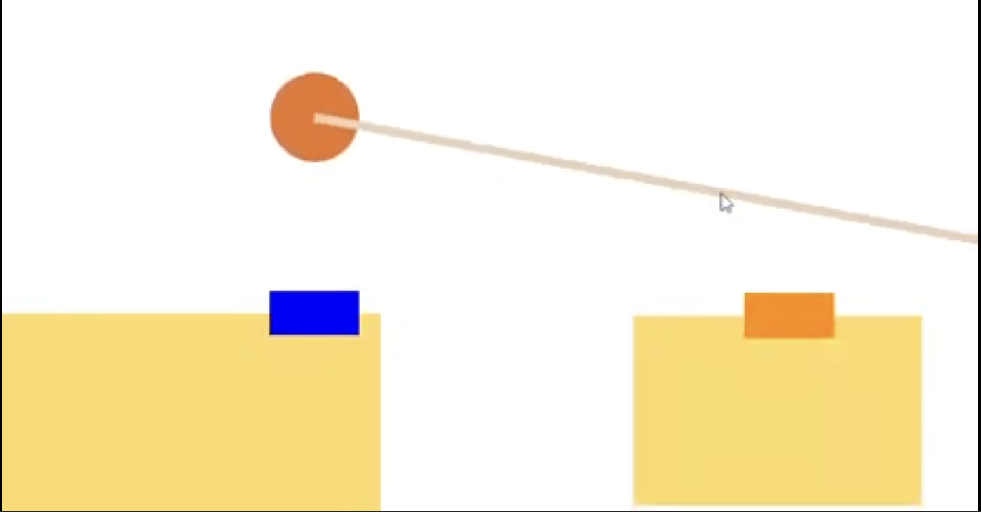

Watch full traversal sequence for previous version here:   
[Portal Traversal_Beta Version.mp4](https://drive.google.com/file/d/1_zYm3UsA-e6ET8DtK5aEVo9Z6v1hjaeH/view?usp=drive_link)

In the updated version, we increased vertical momentum by 50% after each portal traversal to give players more time to stabilize and make intentional decisions post-exit.

Current Version – Momentum After 11 Portal Traversals:

##### 

Watch full traversal sequence for current version here:  
[Portal Traversal_Gold Version.mp4](https://drive.google.com/file/d/1U8dVKLNb0-vkD-1LmNFtr68ei35kKKs2/view?usp=drive_link)

This adjustment is designed to reduce unintentional re-entry loops, improve post-portal control, and give players a clearer window to reorient and act. We believe this change will significantly enhance the fluidity and intuitiveness of the portal mechanic, especially in fast-paced traversal sequences.

##### Hypothesized Issue #3

Players are not able to understand and use the Ally mechanic effectively.

**Description**

The ally mechanic was introduced to deepen puzzle interactions and allow new forms of traversal and combat. However, many players struggled to recognize when they had an ally, how to use it, and what advantages it provided. This confusion reduced their ability to engage meaningfully with puzzles or combat scenarios designed around ally functionality.

**Significance**

The ally mechanic is another differentiator that adds strategic complexity and expands the puzzle design space. If players do not grasp its functionality or importance, they are likely to underutilize it, leading to frustration, confusion, and missed opportunities for engagement, especially in levels where ally use is mandatory for progression.

**Feedback/Data points**

* About 50% of players said they did not clearly understand how or when to use the ally mechanic.
* One out of every three players were often uncertain whether they currently had an ally captured or not.
* Out of 69 playtesters, 6 players felt the ally mechanic was completely useless, while 40 others felt it wasn’t important, largely because they didn’t realize its benefits.
* Only 30% of players successfully completed the Ally Tutorial, indicating major issues.
* Heatmaps show that 70% of deaths (48 out of 67) in the Ally Tutorial occurred in the mid-section, due to spikes — suggesting players did not realize they could use the ally to cross safely.
* Completion rate and first-attempt success data confirm that Ally Tutorial has one of the lowest first-attempt success rates (only ~21%), supporting the hypothesis that the mechanic was not understood or applied effectively.

**Potential Fixes**

1. Add more textual hints, visual explanations, and background elements to improve tutorialization for the Ally Tutorial level.
2. Introduce a HUD indicator showing whether the player currently has an ally captured.
3. Add animations for ally interactions, including capturing, releasing, and switching, to reinforce functionality.
4. Show a lightweight hint the first time an ally is captured to explain core abilities.
5. Design puzzles that are locked unless an ally is used, to emphasize the necessity and value of the mechanic.

**Implemented Solution**

We implemented several layered changes to improve player understanding of the ally mechanic. First, the Ally Tutorial was enhanced with more textual hints, environmental cues, and background storytelling to provide context. A HUD indicator was added to clearly show when a player has an ally captured. We also introduced animations to visually reinforce the moments of capturing or switching allies. Pop-up reminders were added to inform players that allies can walk over spikes or defeat enemies. Additionally, a lightweight tooltip now appears the first time an ally is captured to introduce their abilities.

We can measure the effectiveness of these solutions by tracking ally-specific action frequency (e.g., spike-walking, ally-based kills), monitoring retry counts on the Ally Tutorial level, and reviewing completion rates before and after implementation.

To demonstrate the changes, the following visuals show how we enhanced the understanding and usability of the ally mechanic:  
  
Previous Version – No Clear Ally Feedback

In the original design, there was no HUD indicator to show whether the player currently had an ally captured, and tutorials explaining ally abilities were minimal. Additionally, there were no animations to visually represent the capturing or releasing of an ally.

As a result, players were often unsure if they had an ally captured or how to strategically use it during puzzles and enemy encounters.

Below is an example from the earlier version of the Ally Tutorial, where the lack of HUD and animations contributed to player confusion:

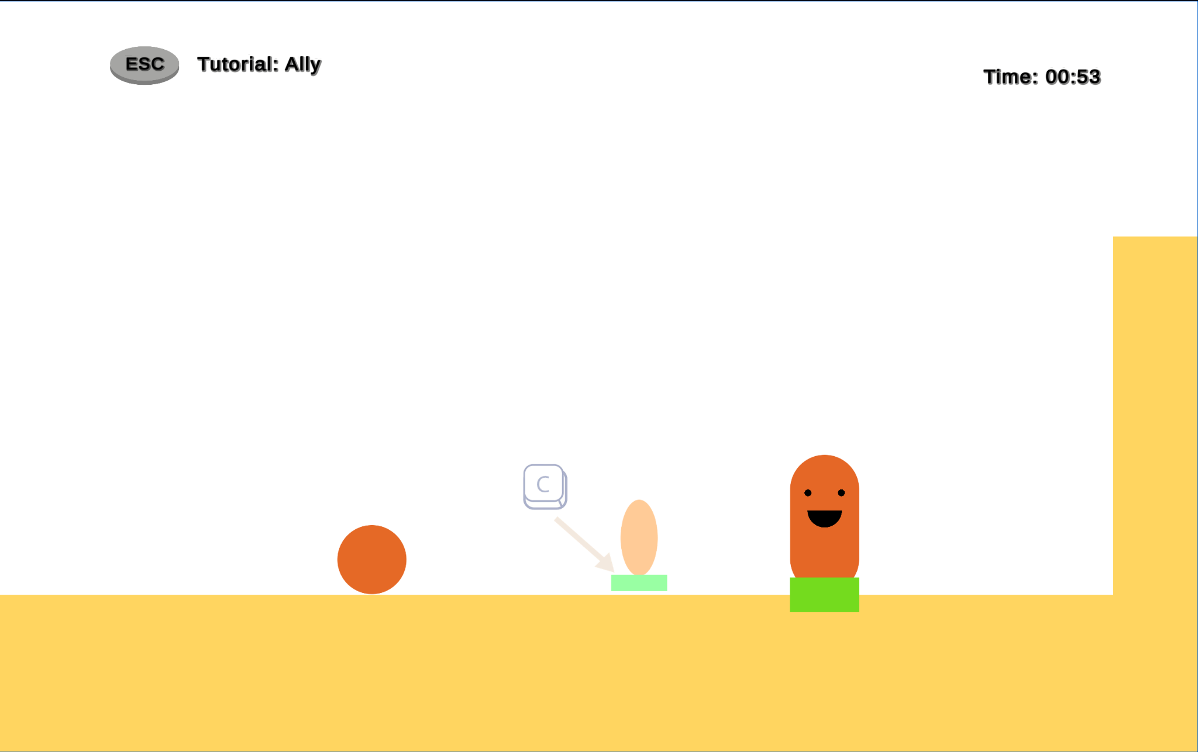

You can also observe this behavior in the original gameplay sequence:

[Ally Tutorial_Beta Version.mov](https://drive.google.com/file/d/1VnDeuSpcI624h4uf1TQHUXQq1Dk3kMPN/view?usp=sharing)

Current Version – HUD Indicator, Improved Tutorialization, and New Animations

In the updated version, we introduced a clear HUD indicator that shows when the player has successfully captured an ally, immediately removing any confusion about ally status. We also reworked the beginning of the Ally Tutorial level to better explain ally abilities, such as walking over spikes and defeating enemies, through improved environment design and brief on-screen text prompts.

Additionally, we added dedicated animations for capturing and releasing allies, making these actions visually distinct and easier for players to recognize. Together, these changes provide a much clearer and more intuitive experience for players learning to use the ally mechanic.

Below is an example from the updated Ally Tutorial level, showcasing the new HUD, improved tutorial elements, and animation effects:

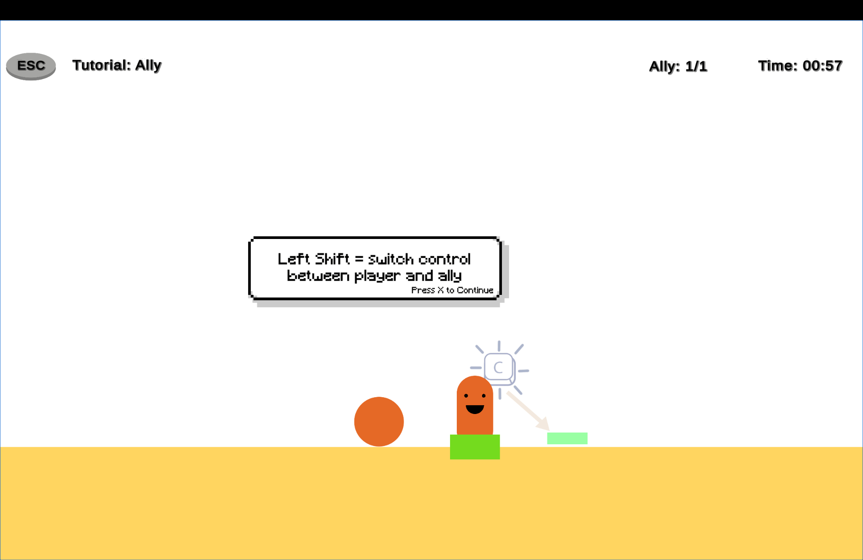

You can also view the complete updated gameplay sequence here:

[Ally Tutorial_Gold Version.mov](https://drive.google.com/file/d/1AQhmqP2klkDeqmG6Ot7l6gmGVGK_M8BA/view?usp=sharing)

We believe these improvements will significantly enhance players’ understanding and strategic use of the ally mechanic, leading to higher engagement, better puzzle-solving experiences, and a deeper sense of mastery as players progress through the levels.

##### Hypothesized Issue #4

Players struggle to grasp the functionality and purpose of the Mirror Gun mechanic.

**Description**

The Mirror Gun, introduced as a new puzzle-solving tool in Level 2, is intended to reflect portal shots and lasers, enabling players to access hidden or unreachable areas. However, many players did not understand how to use it effectively or why it was important. This led to confusion and accidental interactions— especially in the early stages of Level 2, where mirror-based puzzles are critical for progression.

**Significance**

The mirror mechanic is introduced at the start of Level 2 and is required for solving critical puzzles throughout the level. Since Level 2 is currently the final available stage, misunderstanding the mirror mechanic prevents players from finishing the game. Confusion around mirrors directly leads to a low completion rate for Level 2, creating frustration and an abrupt halt to player progression.

**Feedback/Data points**

* 36 players felt the mirror mechanic was unnecessary, and 3 explicitly described it as useless, indicating a significant number of players failed to grasp its utility.
* 19 out of 68 players reported that the jump in difficulty from Level 1 to Level 2 was too steep, with mirror-based puzzles being the primary cause of getting stuck early.
* Out of 47 total attempts in Level 2, enemies were defeated using lasers in only 8 runs, suggesting low comprehension or confidence in executing mirror-based solutions.
* Death analytics show that 74 out of 86 deaths in level 2 (nearly 90%) occurred specifically in mirror puzzle areas, confirming a major challenge point in the level.
* Playtest heatmaps and retry distributions reveal dense clusters of deaths and retries immediately after mirrors are introduced, reinforcing that players did not fully understand the mechanic’s function or interaction logic.

**Potential Fixes**

1. Design puzzles with multiple solution paths so that players who struggle with mirrors can still progress.
2. Add a short guided mirror puzzle at the beginning of Level 2 to introduce the mechanic in a low-pressure, tutorialized context.
3. Add interactive guidance near the early mirror puzzles that activates only when players appear to be struggling.
4. Add visual shine or shimmer to reflective surfaces to make them more noticeable and intuitively interactive.
5. Delay the introduction of the mirror mechanic until later in the game to avoid overwhelming players early in Level 2.

**Implemented Solution**

To help players understand the mirror mechanic more intuitively, we added a guided puzzle at the very beginning of Level 2. This short sequence introduces the concept of using mirror feature in a controlled, low-pressure setup.

Additionally, we included optional hint triggers that appear only if players remain near a mirror puzzle for an extended period, offering light guidance without interrupting the experience.

We’ll assess these changes by tracking early retry patterns, mirror usage rates, and improvements in Level 2 completion statistics.

To highlight the changes, the following visuals compare the original and updated implementations of the mirror mechanic in Level 2:

Previous Version – No Tutorial or Alternate Puzzle Paths

Mirrors were introduced abruptly in the original version of Level 2, without any tutorial or cues to guide the player. As a result, many players struggled to recognize their function, leading to confusion, frequent early deaths, and level abandonment.

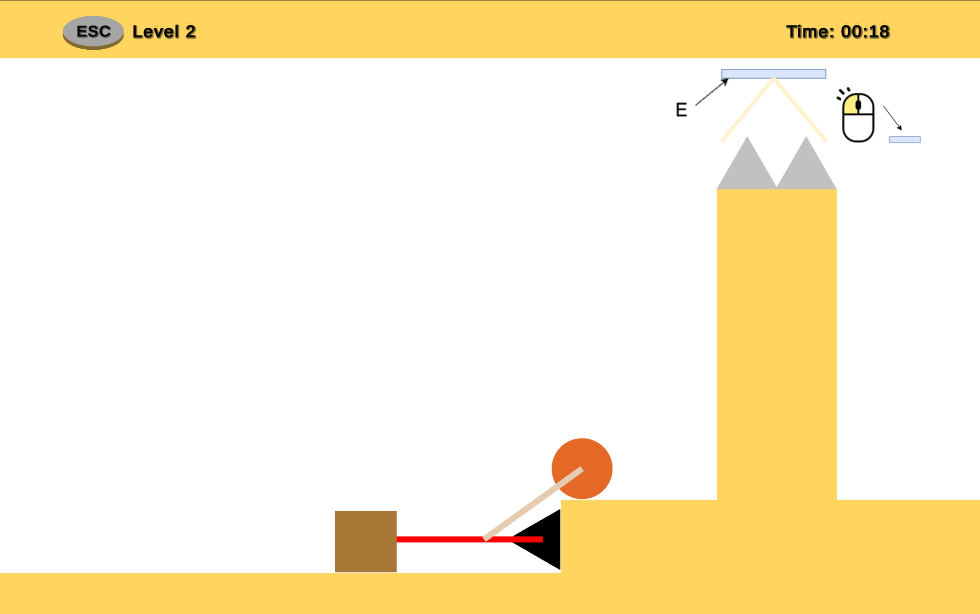

This led to confusion, a steep difficulty spike, and a high drop-off rate early in the level — with many players failing to progress past the first mirror-based challenge:

[Mirror Mechanic_Beta Version.mov](https://drive.google.com/file/d/1eJXOtCYR1J9sVYEQpCbOZOXktjq6DGrs/view?usp=sharing)

Current Version – Tutorialized Introduction and Puzzle Flexibility

Level 2 now begins with a simple tutorial puzzle that teaches players how to use mirrors clearly and effectively. The rest of the level includes now support multiple solutions, allowing players to approach challenges in different ways based on their understanding.

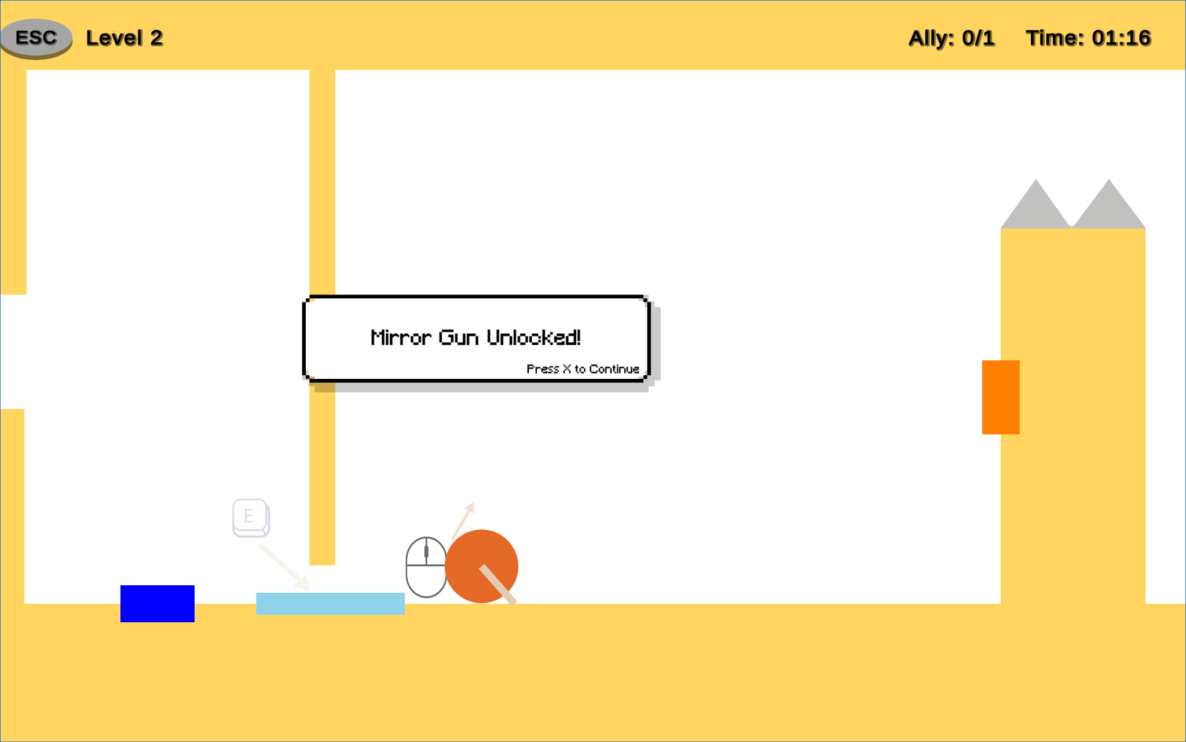

For players who linger too long near a mirror puzzle, optional contextual hints appear to offer subtle support without interrupting gameplay.

[Mirror Mechanic_Gold Version.mov](https://drive.google.com/file/d/1SBhO48ZAFhONiT21blKV91blJD_Pjw77/view?usp=sharing)

These updates are aimed at improving comprehension of the mirror mechanic while maintaining gameplay flow, reducing early abandonment, and increasing Level 2 completion rates.

# External References

*Link to any references (tutorials, assets, etc) from other sources used in your game here. Explicitly state how they are used.*

*Note: You get credit solely for what you have developed yourselves. Assets will not count towards the grade and* ***must*** *be mentioned below.*

*If external assets / code / tutorials are used without reference, you will incur negative consequences.*

|  |  |  |
| --- | --- | --- |
| **Name** | **Link** | **Usage** |
| *Hint box UI* | [*Unity UI Tutorial | An introduction*](https://www.youtube.com/watch?v=IuuKUaZQiSU&t=752s) | *Got inspiration for hint box aesthetic and used the free box sprite (hinting logic and code created by glados)* |
|  |  |  |
|  |  |  |

# Appendix

## Misc

*Other miscellaneous information if any.*